Chameleon Programmer’s Manual

Win32 platform

Technical Documentation & Related Topics for the WIN98/NT version (v 0.3 23/11/1998)

Epsilon Software

TABLE OF CONTENTS

1. Introduction 5
2. Win32 Infrastructure 6
3. The Chameleon source tree 8
Cmif/lib 8
Cmif/common 8
Cmif/editor 8
Cmif/player 8
Cmif/pylib 8
Cmif/Build/win32/Editor 8
Cmif/Win32/src 9
Python 9
4. Win32 modules overview 10
4.1 MainDialog 10
4.2 TopLevelDialog 10
4.3 HierarchyViewDialog 11
4.4 ChannelViewDialog 11
4.5 PlayerDialog 12
4.6 LayoutViewDialog 12
4.7 LinkEditDialog 13
4.8 AttrEditorDialog 13
4.9 AnchorEditorDialog 14
4. 10 ArcInfoDialog 14
4.11 NodeEdit 15
4.12 NodeInfoDialog 15
4.13 Views 16
4.14 ViewServer 16
4.15 Forms 17
4.16 FormServer 17
4.17 Layout Channel 18
4.18 DrawTk 18
4.19 patchlevel 19
4.20 NTVideoChannel 19
4.21 SoundChannel 20
4.22 PreferencesDialog 21
4.23 Help 21
4.24 HtmlChannel 22
5. C ++ Extensions 23
5.1 IG Module (General Information & Functions) 23
5.2 GraphBuilder Module (General Information & Functions) 25
5.3 HtmlWnd Module(General Information & Functions) 27
5.4 Afx Module(General Information & Functions) 28
5.5 Win32dc Module (General Information & Functions) 29
5.6 Win32rgn Module (General Information & Functions) 31
5.7 win32sdk Module (General Information & Functions) 33
5.8 win32toolbar Module Enchancements (General Information & Functions) 37
5.9 win32tooltip Module(General Information & Functions) 38
5.10 Win32win Module Enchancements (General Information & Functions) 39
6. Python source code 42
6.1 Description of Python code for COMMON (WIN32 specific) 42
SoundChannel module 42
NTVideoChannel module 43
HtmlChannel module 44
Help module 45
MidiChannel module 45
PreferencesDialog module 45
6.2 Description of Python code for GRINS (WIN32 specific) 47
MainDialog module 47
Patchlevel module 47
PlayerDialog module 47
TopLevelDialog module 48
usercmdui module 48
MenuTemplate module 48
wndusercmd module 49
6.3 Description of Python code for EDITOR (WIN32 specific) 50
AnchorEditDialog module 50
ArcInfoDialog module 51
AttrEditDialog module 52
ChannelViewDialog module 53
HierarchyViewDialog module 54
LayoutViewDialog module 54
LinkEditDialog module 54
MainDialog module 57
NodeEdit module 57
NodeInfoDialog module 58
Patchlevel module 60
PlayerDialog module 60
TopLevelDialog module 61
usercmdui module 61
Wndusercmd module 61
MenuTemplate module 61
6.4 Description of Python code for LIB (WIN32 specific) 62
Windowinterface module 62
win32ig module 62
win32mu module 62
wc module 64
win32menu module 64
ViewServer module 65
sysmetrics module 66
splash module 66
rbtk module 66
NodeInfoForm module 66
MainFrame module 69
GenWnd module 70
FormServer module 71
Font module 71
DrawTk module 72
DisplayList module 72
Components module 74
Cmifwnd module 77
ArcInfoForm module 78
AttrEditForm module 79
AppToplevel module 80
AppCon module 82
AnchorEditForm module 82
_SourceView module 84
_PreferencesDialog module 84
_LinkView module 85
_LayoutView module 87
_CmifView module 88
7. Third Party Tools/Libraries 90
7.1 General 90
7.2 Audio & Video Playback 90
7.3 Display of Images 90
7.4 Display of Html documents 90
7.5 INSTALLSHIELD 5 PROFESSIONAL (IS5 PRO) 90
Glossary 91
References 92

1. Introduction

The authoring environment (GRiNS editor) and the accompanying player (GRiNS player) support the development and rendering of hypermedia presentations in a variety of environments. The source documents supported are in the CMIF and SMIL declarative languages. The applications are implemented in the Python language as a combination of platform independent and platform dependent modules. The Python platform dependent modules are those responsible for the GUI of the applications and for media rendering.

Different platforms are also different in their windowing systems both from the programmer’s and the user’s point of view. The programmer has a different interface to call and different mechanisms in action to manage. The user expects from any GUI application to have the same look and feel as the popular applications on his platform. Often this is the look and feel enforced by the creator of the windowing system.
The differences between the platforms with respect to the programming interface to the drivers concern directly the programmers and only indirectly the users.

The porting task of the Chameleon applications to any platform can be divided into the following subtasks that can proceed in parallel and exploited by iterations:
- Design the appropriate user interface for the target platform. The user interface must have the look and feel of the hosting windowing system but without imposing any limitations to the system’s functionality.
- Implement the user interface and the missing mechanisms needed by the application. The user interface implementation is a long work but is rather straightforward. The real challenge for this task is the mechanisms needed by the application but not supported by the host platform.
- Implement the appropriate for the application interface to the drivers (implement media channels). Fill any missing functionality concerning media rendering required by the application.
- Improve/re-factor the interface between the core modules and the platform user interface without breaking any existing porting to other platforms. Make the interface more respective of platform peculiarities.

This document aims at providing technical information about the porting of the Chameleon applications to the win32 platform (NT4/Win98/Win95). This porting has followed in general the aforementioned subtask pattern. The target audience of this document includes programmers who may wish to extend or improve the tools and managers who are interested in the state of the tools and the technologies used. However in order to understand the contents of this document one has to have a good background in terms of the Chameleon hypermedia concepts and to have at least read the Chameleon Programmer’s Manual for the platform independent modules which provides the context for this manual.

The structure of this manual is as follows: Section 2 reviews the win32 infrastructure that enabled the Chameleon applications to be written in Python code. Section 3 describes the Chameleon source tree. Section 4 gives an overview of the win32-specific modules. In section 5 we delve into the details and explain every module, class and function ,concerning the C++ Extensions. In section 6 the Python source Code is described in detail since every module ,class and function ,is explained. The last section lists and describes third party tools and libraries used for the win32 development.

2. Win32 Infrastructure

In this section we review the win32 infrastructure that enables the development of the Chameleon applications in Python code. In the context of this manual, the C/C++ extension modules are considered the main infrastructure that concerns us. It is a design decision not to spread the applications logic between the pure Python modules and the extension modules written in C/C++.

The win32 platform is exposed to the developers as a set of APIs written in the C language. The last years this view has been enhanced by a set of components exposing richer interfaces in the form of COM components. Python can access C APIs functionality through win32-specific extension libraries. The Python interpreter the build in modules and its core libraries are fully functional on the win32 platform utilizing this way part of this functionality. The Pythonwin package contains a set of modules that export another small not GUI subset of this functionality to Python (see Python/extensions/win32/src PyWinTypes.dll, win32api.pyd, etc). The Win32Sdk module (see Python/extensions/pythonwin) we have developed enlarges this subset a little more and make it sufficient in combination with the other extension modules for the needs of the Chameleon applications.

The Microsoft Foundation Class Library (MFC) is a framework for programming in win32 platforms. It provides much of the code necessary for managing windows, menus and dialog boxes along with more advanced UI objects like toolbars, dialog bars and tab dialogs. It is a thin object oriented framework written in C++ with a very close mapping to the Windows API written in the C language. The library is not a complete replacement for the respective windows APIs. The win32 developer mixes calls to the class library freely with direct calls to the Windows API. And since the framework is written in C++, it's easy to extend or override the basic functionality it supplies. The MFC library is distributed both in source and binary form and is used extensively by developers to build the UI of their applications that target the win32 platform. The PythonWin package contains a library (win32ui see source Python/extensions/pythonwin) that exports an important subset of the MFC library to Python. This library beyond exporting MFC classes it implements the basic mechanisms for these classes to be useful in Python code (message handling and inheritance). To make this library sufficient for the development of the Chameleon applications we have enhanced some already exported classes and we have exported some new. The enhancements concern mainly the fundamental window class, the drawing device context class and the toolbar class. The new MFC classes we export through this library are the region class, the ToolTip class and the Afx utility class of global MFC functions.

Microsoft DirectShow is an architecture that controls and processes streams of multimedia data through custom or built-in filters on the Win32 platform. In addition to the architecture and the set of classes and interfaces to support it, DirectShow is also a run time that uses this architecture to enable users to play digital movies and sound encoded in various formats, including MPEG, AVI, MOV and WAV-formatted files. The DirectShow run time is a control (.ocx), called the ActiveMovie Control, and a set of dynamic-link libraries (DLLs) that enable you to play back supported media files. The DirectShow infrastructure can be accessed through the COM interfaces, the ActiveMovie Control, or media control interfaces (MCI).
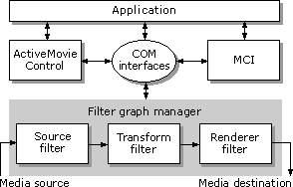

The COM interfaces are the more flexible way to access and control the DirectShow infrastructure. The module GraphBuilder (see cmif/win32/src/win32ext) that we have developed exports to Python a part of these interfaces that is sufficient to control the media drivers needed by the Chameleon applications. We have originally used the MCI interface for the same purpose and therefore there are extension modules that export this interface to Python but since they are not used any more they are not documented here.
An ActiveX control (or a COM object) is a reusable software component on the Win32 platforms that supports a wide variety of interfaces and can be customised to fit many software needs. ActiveX controls are designed for use both in ordinary windows that are control containers and on the Internet, in World Wide Web pages. An embedded ActiveX control can interact with the container by firing (sending) events to notify the container that an action has occurred. The module HtmlWnd (see cmif/win32/src/win32ext) that we have developed is a control container window that contains an Html ActiveX control. It is notified by the control about many events including navigation ones. And, if the navigation event is one of the Chameleon predefined events the container window in its turn notifies the Chameleon applications.
The native images on the Win32 platform are the bitmaps with the file name extensions .bmp or .dib. Every other image format must be converted to a bitmap in order to be displayed and be manipulated by the Win32 SDK. The Accusoft ImageGear library is one of the best such conversion libraries. The module IG (see cmif/win32/src/win32ext) we have developed exports a sufficient part of this library to support the Chameleon applications.
Since this section reviews the win32 infrastructure it should be noteworthy to mention two important functions of the Chameleon applications that are not supported by the win32 platform. The first one is that the build in paint/update mechanism for the win32-windows does not work properly for transparent windows, an attribute that is the default for the Chameleon documents. We have implemented a mechanism in Python code that solves this problem. The second is that multiple parallel sounds have limited support on the win32 platform. Parallel sounds are supported only for wave files through the DirectSound infrastructure. No solution has been given to this problem till now.

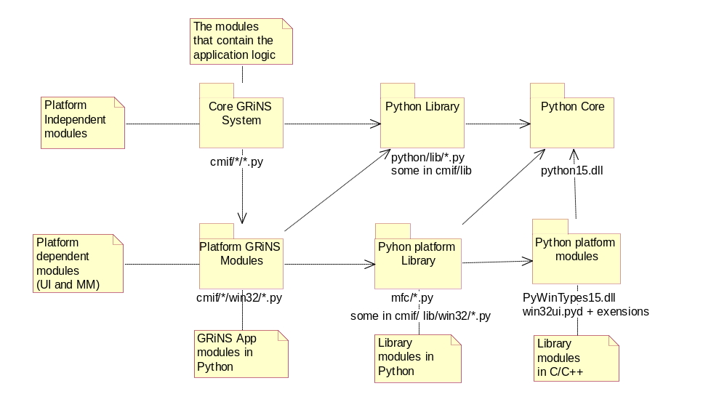

3. The Chameleon source tree

The Chameleon source tree is divided in a number of subfolders based on functionality and on platform. The tree can be inspected/edited and all of its subprojects been build by opening and using the Visual C++ 6 project ‘cmif extensions.dsw’ that can be found in cmif/win32/src folder. While viewing the source tree bear in mind that all of the application’s logic lies in the Python source code. The C/C++ modules even if they have been written to support the Chameleon applications, are general libraries with no application-specific logic and can be reused in other projects as they are.

Cmif/lib
The Python modules in this folder are platform independent and common to the editor and the player.

Cmif/Lib/win32
The modules in this folder contain the actual implementation of the win32 user interface. According to our design decision this is the only folder that is strongly platform specific. The other ‘win32’ folders use platform specific functionality through the windowinterface in the same way as the core system does.

Cmif/common
The Python modules in this folder are platform independent and common to the editor and the player. They are mainly Channel and Scheduler related.

Cmif/common/win32
The Python modules in this folder contain the definition of the NTVideoChannel, the SoundChannel and the HtmlChannel (and the alias MidiChannel). The preferences dialog PreferencesDialog and the Help utilities are also defined here. The other channels for the win32 platform use their platform independent versions found in the parent folder.

Cmif/editor
The python modules in this folder are platform independent and editor-specific

Cmif/Editor/win32
The modules in this folder contain the interfaces between the core modules in cmif/editor and their respective actual implementation defined in lib/win32. The modules in this folder use only the windowinterface module so they can be considered in a sense as platform independent. But, to be really platform independent some more editing and thought is needed.

Cmif/player
The python modules in this folder are platform independent and player-specific

Player/win32
The modules in this folder contain the interfaces between the core modules in cmif/player and their UI implementation defined in lib/win32. The modules in this folder use only the windowinterface module so they can be considered in a sense as platform independent. But, to be really platform independent some more editing and thought is needed.

Cmif/pylib
The python modules in this folder are replacement versions of modules that live in the standard python Lib folder.

Cmif/Build/win32/Editor
This folder contains a batch file (domkp.bat) and a project (GRiNSed.dsp) to make (freeze) the editor as a win32 executable. There is also a text file (Readme.txt) with instructions.
Cmif/Build/win32/Player
This folder contains a batch file (domkp.bat) and a project (GRiNS.dsp) to make (freeze) the player as a win32 executable. There is also a text file (Readme.txt) with instructions.

Cmif/Win32/src
This folder contains the Visual C++ 6 project ‘cmif extensions.dsw’ that builds everything related to the Chameleon applications

cmif\win32\src\GRiNSRes
Contains the resources for the editor and the player. The project ‘GRiNSRes.dsp’ can be used to build the resources. At run time the resources live in GRiNSRes.dll

cmif\win32\src\win32ext
Contains c++ win32-specific extension modules. The extension modules are general library modules and, according to our design decision, they don’t contain any application’s logic. They’re essentially 3 extension modules in this folder. The IG module that exports Accusoft ImageGear Library to Python. The GraphBuilder module that exports part of the DirectShow SDK. And, the HtmlWnd that exports a window capable to contain an Html Control and receive and dispatch notifications from this control. The other c++ extension modules that we have build belong naturally to Python/extensions/pythonwin and their sources can be found there.

Python
This folder (and its subfolders except subfolder ‘extensions’) contains the C source for the Python interpreter and its build in modules

Python/extensions/win32
This folder contains c/c++ extension modules for Python.
It contains a set of modules that export to Python a small but important not GUI related subset of the win32 SDK. (PyWinTypes.dll, win32api.pyd, etc)

Python/extensions/pythonwin
This folder contains c/c++ extension modules for Python.
The folder contains a Windowing framework: A library (win32ui.pyd) that exports to Python the more important classes of the MFC library. It also implements the basic mechanisms for these classes to be useful in Python code (message handling and inheritance). We have enhanced some classes exported by win32ui and added some new. Enhanced classes: PyCWnd, PvCFrameWnd,PyMDIFrameWnd, PyDC, PyCToolbar New classes: PyCRgn, PyCTooltip New modules: Afx, Win32Sdk

Python/extensions/pythonwin/pywin/mfc
This folder contains Python modules for win32.
They contain essentially thin wrappers for some of the MFC classes exported by the win32ui library.

4. Win32 modules overview

4.1 MainDialog

There is only one instance of the MainDialog per application. The MainDialog constructor creates an MDIFraneWnd with a toolbar and a menu. The application level commands New, Open and Exit
are enabled. When there are documents open there is a one to one correspondence between an MDIFrameWnd and a document.
An MDIFrameWnd without a document is assigned to the first document that will be opened
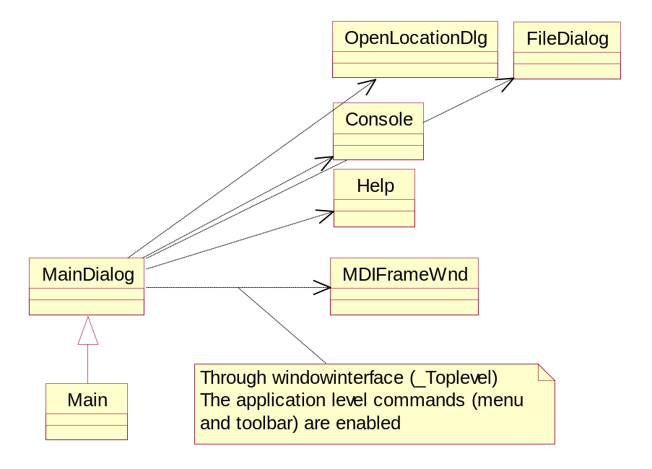

4.2 TopLevelDialog

There is one to one corespondance between a TopLevelDialog instance and a document, and a TopLevelDialog instance with an MDIFrameWnd. The document level commands are enabled. This class has acces to the document and can display its various views and its source

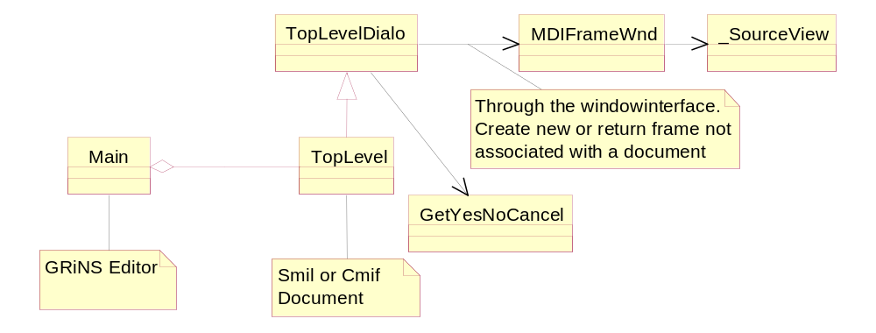

4.3 HierarchyViewDialog

The HierarchyViewDialog is the interface between the HierarchyView platform independent class and its implementation class _HierarchyView in lib/win32/_HierarchyView.py

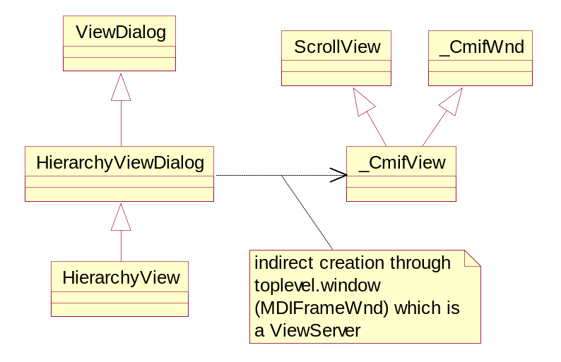

4.4 ChannelViewDialog

The ChannelViewDialog is the interface between the ChannelView platform independent class and its implementation class _ChannelView in lib/win32/_ChannelView.py

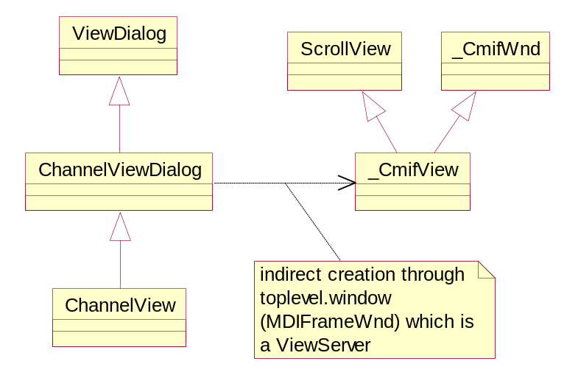

4.5 PlayerDialog

A PlayerDialog instance manages commands related to play. The instance indirectly passes information to the windows interface through the get_adornments method which is called by the channel module.

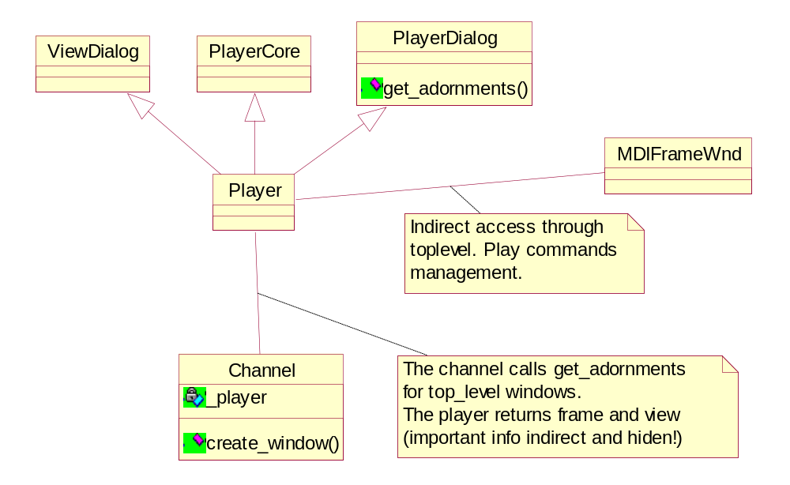

4.6 LayoutViewDialog

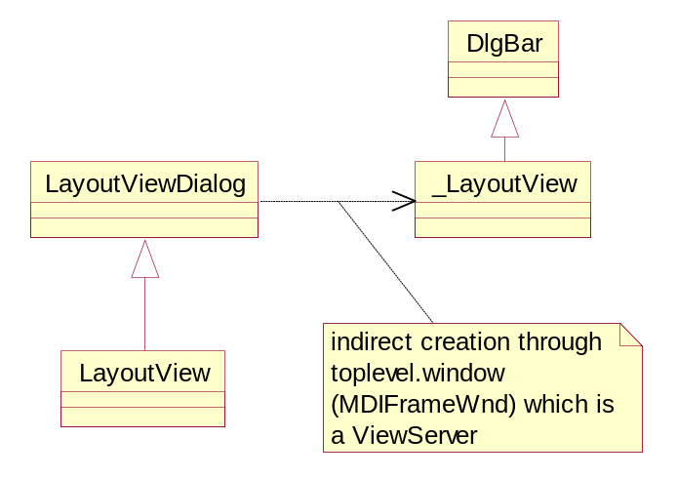
The LayoutViewDialog is the interface between the LayoutView platform independent class and its implementation class _LayoutView in lib/win32/_LayoutView.

4.7 LinkEditDialog

The LinkEditDialog is the interface between the LinkEdit platform independent class and its implementation class LinkForm in lib/win32/LinkForm.

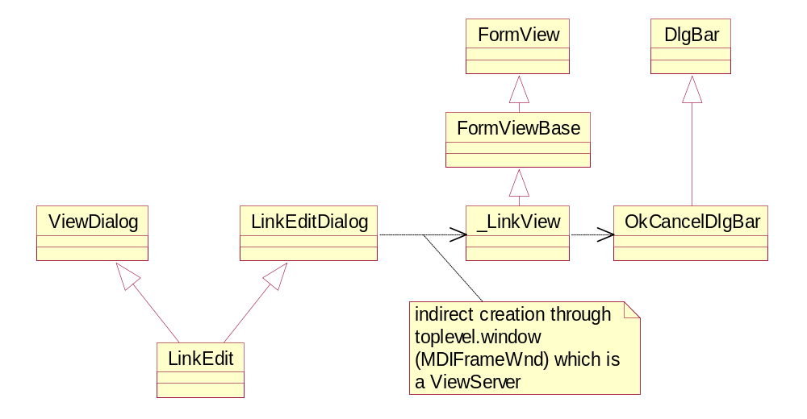

4.8 AttrEditorDialog

This class represents the interface between the AttrEditor platform independent class and its implementation AttrEditorForm in lib/win32/AttrEditorForm.py which implements the actual dialog.

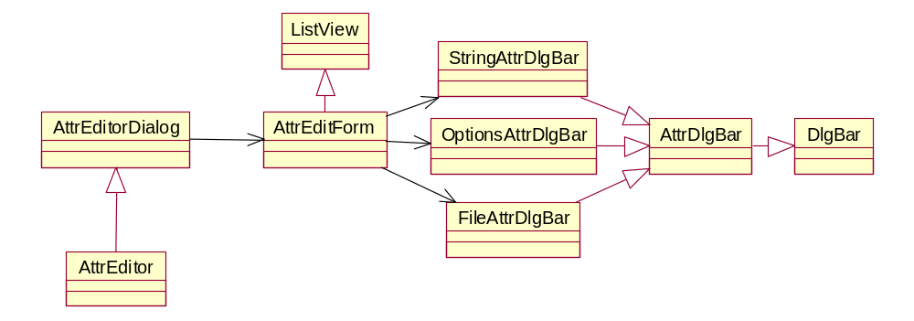

4.9 AnchorEditorDialog

The AnchorEditorDialog is the interface between the AnchorEditor platform independent class and its implementation AnchorEditorForm in lib/win32/AnchorEditForm.py

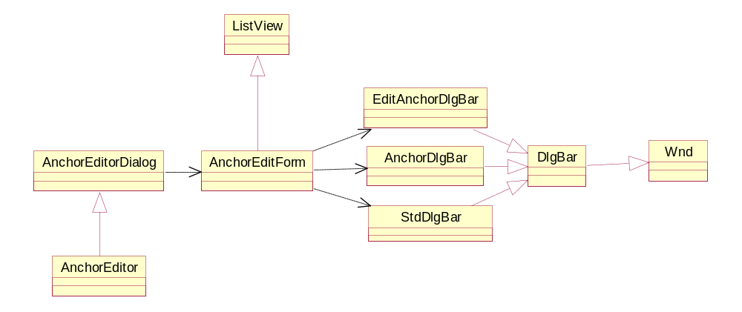

4. 10 ArcInfoDialog

The ArcInfoDialog is the interface between the ArcInfo platform independent class and its implementation ArcInfoForm in lib/win32/ArcInfoForm.py

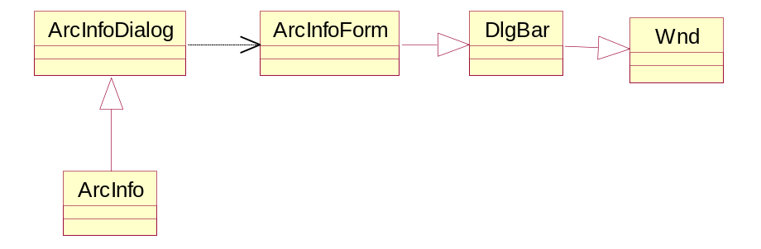

4.11 NodeEdit

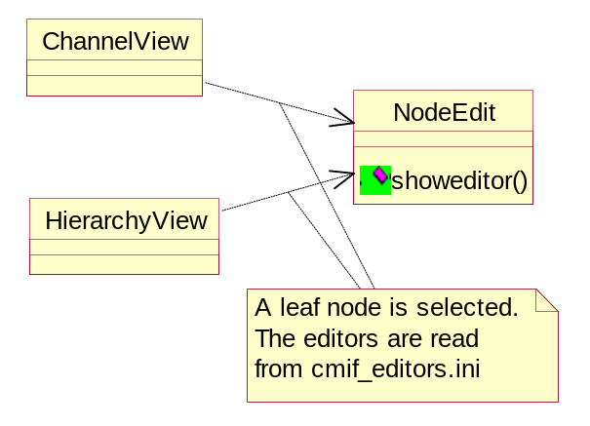

4.12 NodeInfoDialog

The NodeInfoDialog is the interface between the NodeInfo platform independent class and its implementation NodeInfoForm in lib/win32/NodeInfoForm.

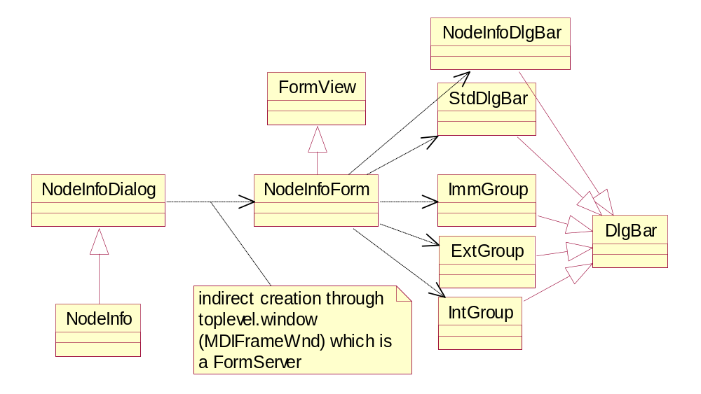

4.13 Views

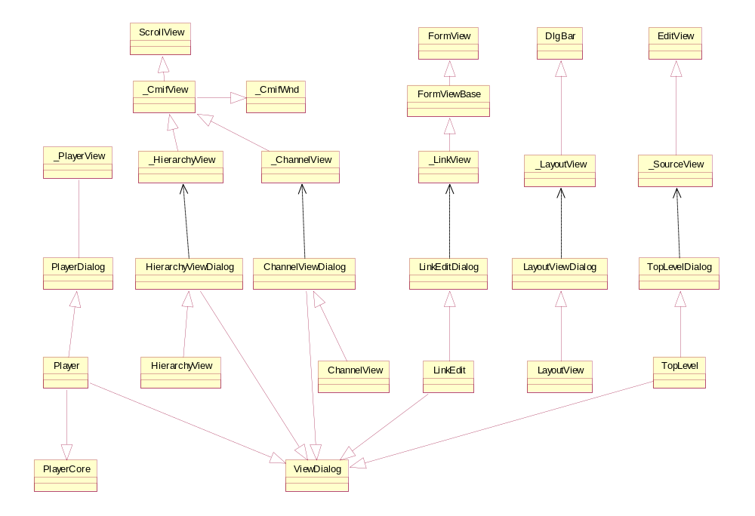

4.14 ViewServer

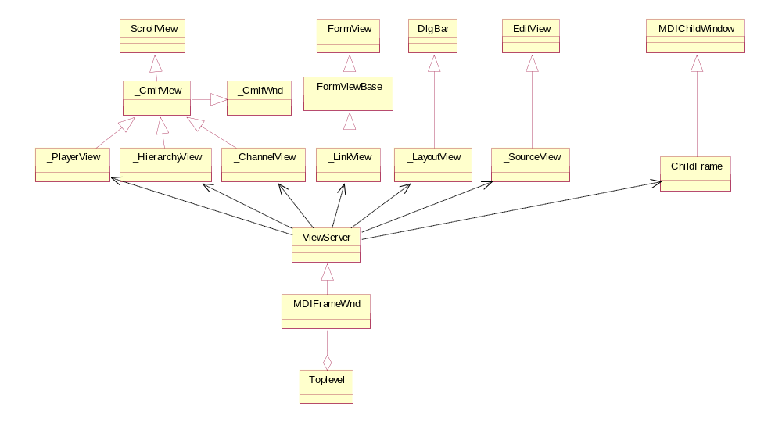

4.15 Forms

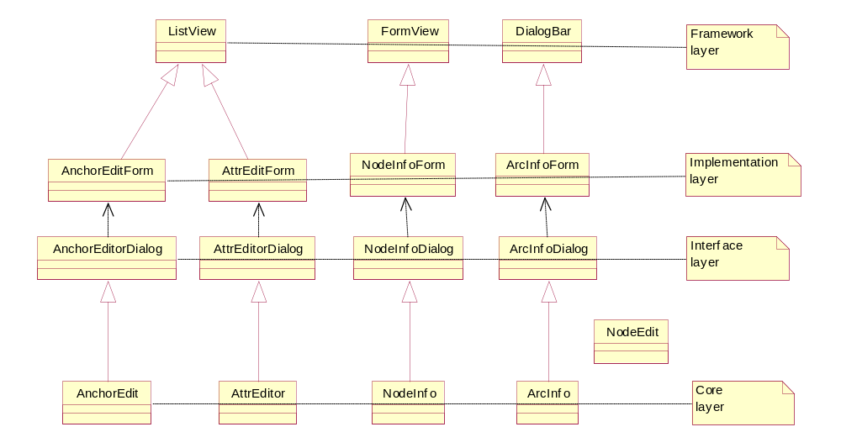

4.16 FormServer

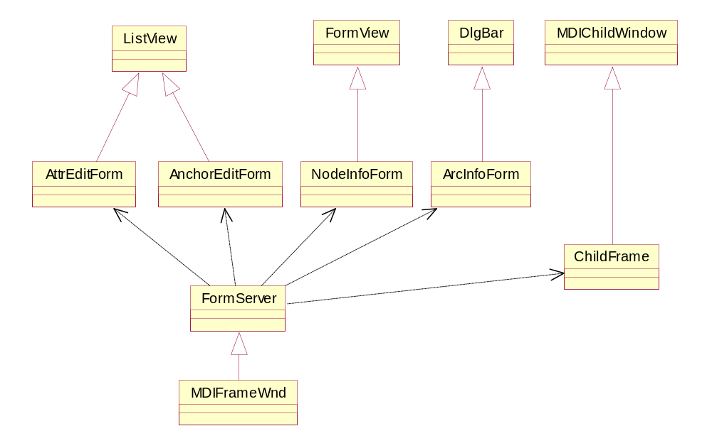

4.17 Layout Channel

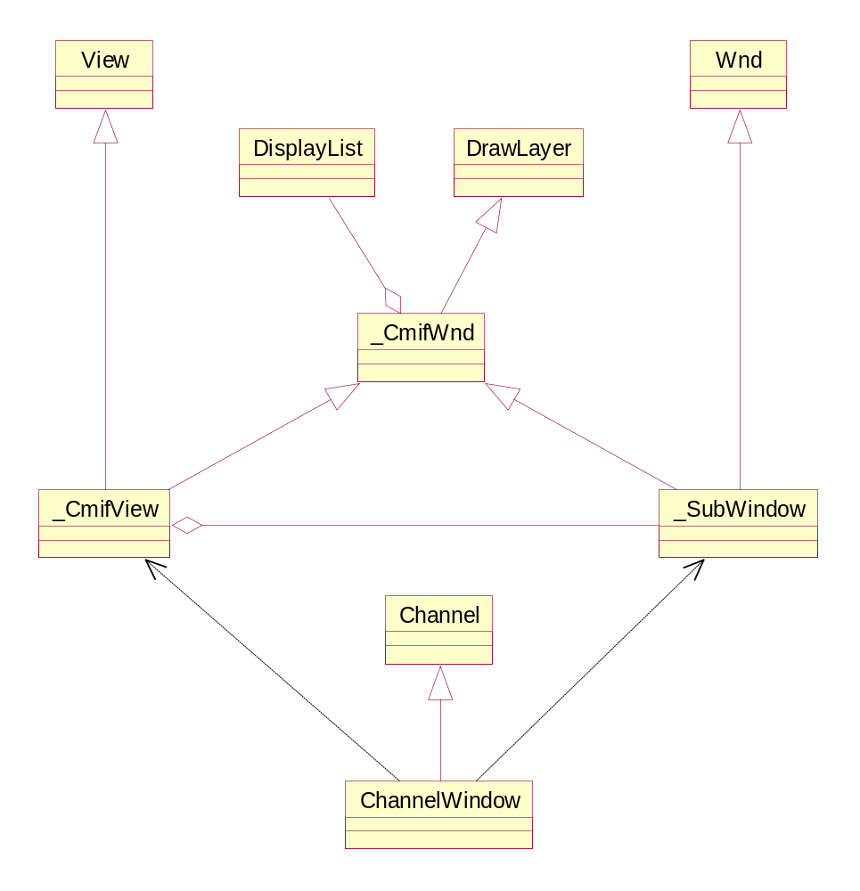

4.18 DrawTk

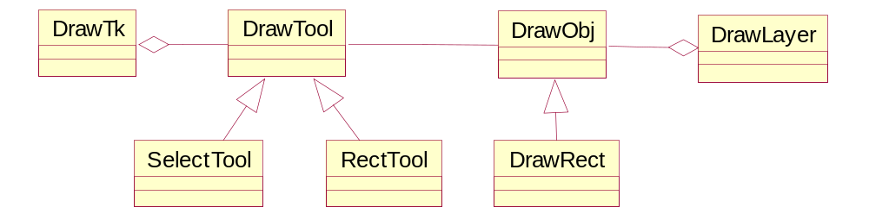

4.19 patchlevel

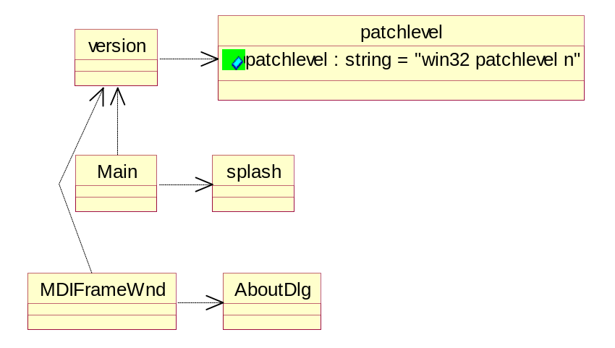

4.20 NTVideoChannel

The NTVideoChannel extends the ChannelWindow (although it repeats the ChannelWindowAsync implementation)

Nothing beyond the standard interface is required from the window by this channel.

In this module ue use an object called GraphBuilder that supports the interface:

interface IGraphBuilder:
def RenderFile(self,fn):return 1

def Run(self):pass
def Stop(self):pass
def Pause(self):pass

def GetDuration(self):return 0
def SetPosition(self,pos):pass
def GetPosition(self,pos):return 0

def SetVisible(self,f):pass
def SetWindow(self,w):pass

We have implemented such an object using the win32 DirectShow Sdk
We get the module from the module server by calling:
DirectShowSdk=win32ui.GetDS()
and from the module returned, we request an object with the above interface
with the call
builder=DirectShowSdk.CreateGraphBuilder()

Note that the same object is used for the SoundChannel and MidiChannel

For more on the DirectShow architecture see MS documentation.

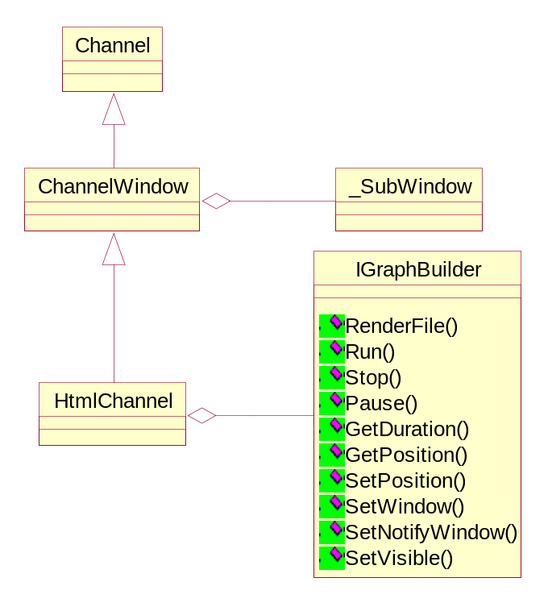

4.21 SoundChannel

The SoundChannel extends Channel (although it repeats the ChannelAsync implementation) In this module ue use an object called GraphBuilder that supports the interface:

interface IGraphBuilder:
def RenderFile(self,fn):return 1

def Run(self):pass
def Stop(self):pass
def Pause(self):pass

def GetDuration(self):return 0
def SetPosition(self,pos):pass
def GetPosition(self,pos):return 0

def SetNotifyWindow(self,w):pass

We have implemented an object that supports this interface by using the win32 DirectShow Sdk.
The C++ module that exports to Python this object is GraphBuilder.cpp
in thre folder cmif/win32/src/win32ext.
We get access to the this module from the win32ui which acts as a module server in this context by the call:
DirectShowSdk=win32ui.GetDS()
and request an object with the above interface with the call builder=DirectShowSdk.CreateGraphBuilder()

Note that the same object is used for the NTVideoChannel.
The MidiChannel is an alias to the SoundChannel.

For more on the DirectShow architecture see MS documentation.

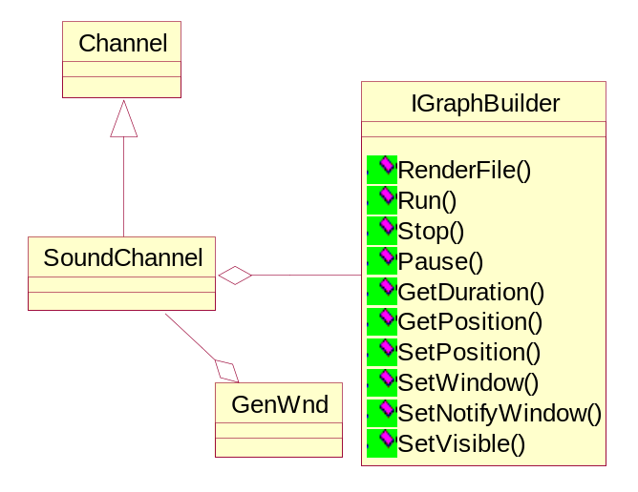

4.22 PreferencesDialog

This PreferencesDialog is the interface between the Preferences platform independent class and its implementation _PreferencesDialog in lib/win32/_PreferencesDialog.py.

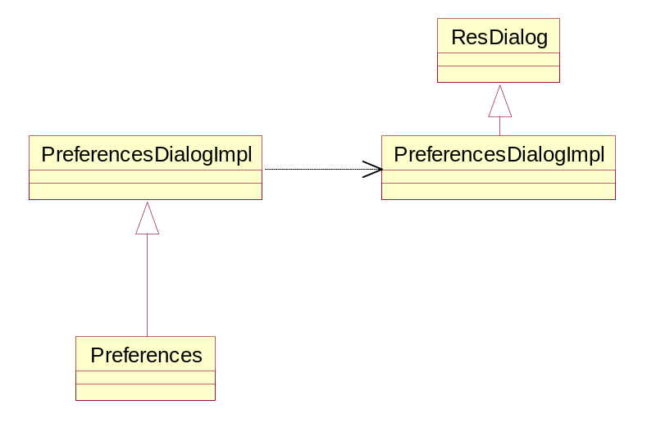

4.23 Help

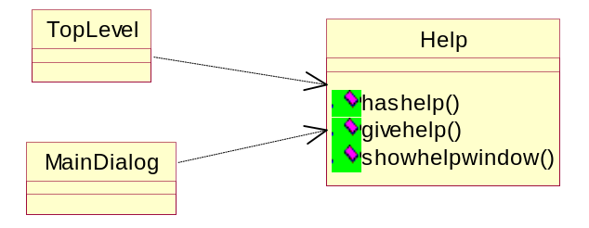

4.24 HtmlChannel

The HtmlChannel extends the ChannelWindow

For this channel to work the window must support beyond the standard interface
the following interface:

interface IHtmlWnd:
def RetrieveUrl(self,url):pass
def DestroyHtmlCtrl(self):pass
def setanchorcallback(self,cbanchor):pass

The window or an agent of the window is supposed to call back the HtmlChannel's callback set by the setanchorcallback method when a cmif: anchor is fired.

The _SubWindow defined in lib/win32/_CmifView.py supports this interface

Note:
For not local files we get the url by calling the channel's method getfileurl(node) and pass it directly through RetrieveUrl.
For local files we follow the Internet Explorer convention of passing the absolute local filename through RetrieveUrl.

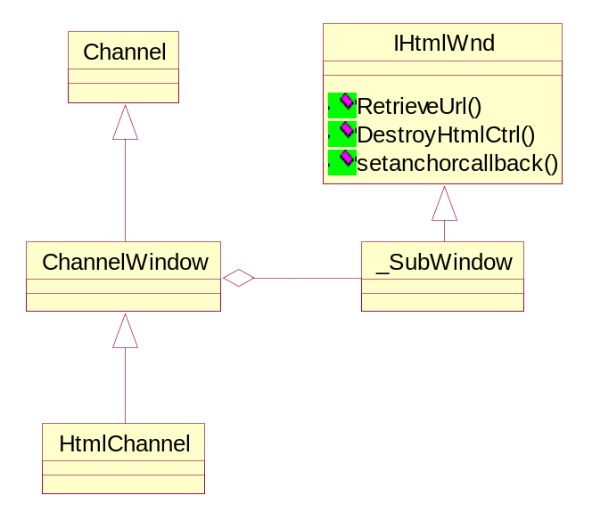

5. C ++ Extensions

5.1 IG Module (General Information & Functions)

Access : win32ui.Getig( )
Location : <TARGETDIR>/win32/src/win32ext
Source filename : ig.cpp
Purpose/Content/Description : Does the export of ImageGear’ s functions to the python code.

static PyObject* ig_load_file(PyObject *self, PyObject *args)
Description/Role :Loads an image file into memory, creating a DIB for the image as it does so. The handle which ImageGear assigns for this image is returned to you in argument lphIGear. The file named by filename may be in any format recognized by ImageGear.
Parameters : A pointer to a python object that contains the filename (you may include path with filename) of image file to load into memory.
Returned result : A python object encapsulating the handle for the image.
Called from python code as : load_file( )

static PyObject* ig_image_dimensions_get(PyObject *self, PyObject *args)
Description/Role : This function will return the width, height, and number of bits per pixel, from the DIB of the image.
Parameters : A pointer to a python object that contains the handle of the image.
Returned result : A python object encapsulating the width, height, and number of bits per pixel.
Called from python code as : image_dimensions_get( )

static PyObject* ig_display_transparent_set(PyObject *self, PyObject *args)
Description/Role : Sets a transparency color for image , and enables / disables transparency for this image. If transparency is enabled, then the transparent color will be “invisible” (or “see through”). An image already in the window before this image is displayed, will still be visible where this color appears in image
Parameters : A pointer to a python object that contains a tuple of the following values (a) the handle of image, (b) three RGB parameters specifying the color to be transparent and (c)a flag indicating whether the transparency is enabled or not.
Returned result :None
Called from python code as : display_transparent_set( )

static PyObject* ig_palette_entry_get(PyObject *self,PyObject *args)
Description/Role : Obtains from image‘s DIB palette, the palette entry.
Parameters : A pointer to a python object that contains (a) the handle of the image and (b) the palette entry to get, 0 to 255.
Returned result : A python object that contains the three color values of the palette entry.
Called from python code as : palette_entry_get( )

static PyObject* ig_device_rect_set(PyObject *self, PyObject *args)
Description/Role : Tells ImageGear where upon the display device, or within the window if a window is being displayed to, the image rectangle of the image is to be displayed. The image rectangle is mapped to the device rectangle set by calling this function.
The device rectangle you set is permitted to extend beyond the area available for display (for example, beyond the boundaries of the window client area). In this case, the image rectangle will be clipped. Only the portion falling within the valid display area will be displayed.
Parameters : A pointer to a python object that contains (a) the handle of the image and (b) a tuple declaring the rectangle on device, or within window, where this image’s image rectangle is to be displayed.
Returned result : None
Called from python code as : device_rect_set( )

static PyObject* ig_display_desktop_pattern_set(PyObject *self, PyObject *args)
Description/Role : Establishes the pattern (including its foreground and background colors) to use for the unfilled areas when image is displayed not completely filling its window or device rectangle.
Parameters : A pointer to a python object that contains (a) the handle of the image (b) a flag indicating whether the transparency is enabled or not (c) a tuple specifying the RGB components of the color to use for the foreground of the pattern (d) a tuple specifying the RGB components of the color to use for the background of the pattern
Returned result : None
Called from python code as : display_desktop_pattern_set( )

static PyObject* ig_ip_crop(PyObject *self, PyObject *args)
Description/Role : Crops an image to a rectangle that you specify, discarding pixels that fall outside the rectangle.
Parameters : A pointer to a python object that contains (a) the handle of the image (b) a tuple declaring the rectangle on device, or within window, where this image’s image rectangle is to be displayed.
Returned result : None
Called from python code as : ip_crop( )

static PyObject* ig_display_image(PyObject *self, PyObject *args)
Description/Role : Displays the image with all display attributes that are currently in effect, on the device or window indicated.
Parameters : A pointer to a python object that contains (a)the handle of the image (b) the handler to the device context (DC).
Returned result : None
Called from python code as : display_image( )

static PyObject* ig_image_delete(PyObject *self, PyObject *args)
Description/Role : This function undefines the handle of the image, and frees the memory of the associated structure. This function also frees the memory associated with the image’s DIB, if ImageGear allocated the DIB memory. If ImageGear did not allocate the DIB memory, the DIB continues to exist and it is the responsibility of your application to free this memory when done with it.
Parameters : A pointer to a python object that contains the handle of the image.
Returned result : None
Called from python code as : image_delete( )

5.2 GraphBuilder Module (General Information & Functions)

Access : win32ui.CreateGraphBuilder( )
Location : <TARGETDIR>/win32/src/win32ext
Source filename : GraphBuilder.cpp
Purpose/Content/Description : Exports to Python the interface IGraphBuilder and indirectly other interfaces related to the DirectShow Infrastructure. The indirectly exposed interface is sufficient to control a media stream (sound and video)

PyObject *GraphBuilderCreator::Create(PyObject *self, PyObject *args)
Description/Role : Creates an instance of a GraphBuilder (a wrapper object to the COM interface IGraphBuilder)
Parameters : No Arguments
Returned result : A GraphBuilder object that is a wrapper to the COM interface IGraphBuilder
Called from python code as : CreateGraphBuilder( )

static PyObject* py_release(PyObject *self, PyObject *args)
Description/Role : Releases the interface associated with the GraphBuilder
Parameters : No Arguments
Returned result : None
Called from python code as : Release( )

static PyObject* py_render_file(PyObject *self, PyObject *args)
Description/Role : Renders the media file passed as argument
Parameters : The filename to parse (string)
Returned result : None
Called from python code as : RenderFile( )

static PyObject* py_run(PyObject *self, PyObject *args)
Description/Role : Runs (starts playing) the rendered stream
Parameters : No Arguments
Returned result : None
Called from python code as :Run( )

static PyObject* py_stop(PyObject *self, PyObject *args)
Description/Role : Stops the rendered media stream
Parameters : No Arguments
Returned result : None
Called from python code as :Stop( )

static PyObject* py_pause(PyObject *self, PyObject *args)
Description/Role : Pauses the rendered media stream
Parameters : No Arguments
Returned result : None
Called from python code as : Pause( )

static PyObject* py_get_duration(PyObject *self, PyObject *args)
Description/Role : Gets the duration (in msec) of the rendered file
Parameters : No Arguments
Returned result :The duration in msecs
Called from python code as : GetDuration( )

static PyObject* py_get_position(PyObject *self, PyObject *args)
Description/Role : Gets the current sample position (in msec) within the stream
Parameters : No Arguments
Returned result :The position within the stream in msecs
Called from python code as : GetPosition( )

static PyObject* py_set_position(PyObject *self, PyObject *args)
Description/Role : Sets to sample position (in msec) within the stream
Parameters :The position in msec
Returned result :None
Called from python code as : SetPosition( )

static PyObject* py_set_visible(PyObject *self, PyObject *args)
Description/Role : Sets the visible property to the value passed as argument (only for video)
Parameters : The visible flag
Returned result : None
Called from python code as : SetVisible( )

static PyObject* py_set_window(PyObject *self, PyObject *args)
Description/Role : Sets the owner and notification window (only for video)
Parameters : A PyCWnd object and optionaly the message id for notifications
Returned result : None
Called from python code as : SetWindow( )

static PyObject* py_set_window_position(PyObject *self, PyObject *args)
Description/Role : Sets thewindow position(only for video)
Parameters : The window rectangle
Returned result : None
Called from python code as : SetWindowPosition( )

static PyObject* py_get_window_position(PyObject *self, PyObject *args)
Description/Role : Gets the window position(only for video)
Parameters : No Arguments
Returned result : The window position as (left,top,width,height)
Called from python code as : GetWindowPosition( )

static PyObject* py_set_window_null(PyObject *self, PyObject *args)
Description/Role : Sets the owner window to Null (only for video)
Parameters : No Arguments
Returned result : None
Called from python code as : SetWindowNull( )

static PyObject* py_set_notify_window(PyObject *self, PyObject *args)
Description/Role : Sets the window that will receive stream notification messages
Parameters : A PyCWnd object and optionaly the message id for notifications
Returned result : None
Called from python code as : SetNotifyWindow( )

static PyObject* py_is_complete_event(PyObject *self, PyObject *args)
Description/Role : Checks if the stream has been completed
Parameters : No Arguments
Returned result : Not zero if completed
Called from python code as : IsCompleteEvent( )

5.3 HtmlWnd Module(General Information & Functions)

Access : win32ui.CreateHtmlWnd( )
Source filename : HtmlWnd.cpp
Purpose/Content/Description : Exports a window capable to host an Html control and receive notifications from it.

CHtmlWnd* PyCHtmlWnd::GetHtmlWndPtr(PyObject *self)
Description/Role : Static mapping helper between c++ obj and python obj ,internal function that returns a pointer to a CHtmlWnd fron a Python pointer to a PyCHtmlWnd
Parameters : A PyCHtmlWnd object
Returned result : The coresponding CHtmlWnd object
Called from python code as : Internal

PyObject * py_create_html_wnd(PyObject *self, PyObject *args)
Description/Role : Creates the CHtmlWnd object
Parameters : No Arguments
Returned result : A PyCHtmlWnd object
Called from python code as : CreateHtmlWnd( )

static PyObject * py_create_window(PyObject *self, PyObject *args)
Description/Role : Creates the actual window
Parameters : (a)The class ID for the window, or None ,(b) The title for the window, or None ,(c)The style for the window,(d)The size and position of the window, (e) The parent window of the new window,(f) The control's ID, (g) A CreateContext object.
Returned result : None
Called from python code as : CreateWindow( )

static PyObject * py_navigate(PyObject *self, PyObject *args)
Description/Role : Navigates to url
Parameters : The url to navigate to
Returned result : None
Called from python code as : Navigate( )

static PyObject * py_get_foreign_url(PyObject *self, PyObject *args)
Description/Role : Returns the foreign Url
Parameters : No Arguments
Returned result : The foreign Url
Called from python code as : GetForeignUrl( )

static PyObject *py_create_html_ctrl(PyObject *self, PyObject *args)
Description/Role : Creates the Html control
Parameters : No Arguments
Returned result : None
Called from python code as : CreateHtmlCtrl( )

static PyObject *py_destroy_html_ctrl(PyObject *self, PyObject *args)
Description/Role : Destroys the Html control
Parameters : No Arguments
Returned result : None
Called from python code as : DestroyHtmlCtrl( )

5.4 Afx Module(General Information & Functions)

Access : You access this module with the call: Afx=win32ui.GetAfx() , the returned object is this module.To call the afformentioned function AfxGetMainWnd from this module you call: wnd=Afx.GetMainWnd()
Location : python/Extensions/Pythonwin
Source filename : Afx.cpp
Purpose/Content/Description : Exports to Python the global MFC functions. These functions according to an MFC convention start with the prefix Afx. For example AfxGetMainWnd is a global MFC function returning the application's main window.

PyObject * afx_get_mainwnd(PyObject *self, PyObject *args)
Description/Role : Returns the application's main window (for not OLE server applications)
Parameters : No Arguments
Returned result : A PyCWnd or an object derived from PyCWnd
Called from python code as : GetMainWnd( )

PyObject * afx_get_app(PyObject *self, PyObject *args)
Description/Role : Retrieves the application object. There will only ever be one application object per application.
Parameters : No Arguments
Returned result : The application objext as a PyCWinApp object
Called from python code as : GetApp( )

static PyObject * afx_register_wnd_class(PyObject *self, PyObject *args)
Description/Role : Registers a window class.
Parameters : A pointer to a python object that contains (a) the Windows class style or combination of styles (b) the handler of the cursor (c) the handler of the Brush and (d) the handler of the icon
Returned result : A null-terminated string containing the registered class name.
Called from python code as : RegisterWndClass( )

static PyObject * afx_ole_init(PyObject *self, PyObject *args)
Description/Role : Initializes the OLE DLLs.
Parameters : No Arguments
Returned result : None
Called from python code as : OleInit( )

static PyObject * afx_enable_control_container(PyObject *self, PyObject *args)
Description/Role : A call to this function enables support for containment of OLE controls
Parameters : No arguments
Returned result : None
Called from python code as : EnableControlContainer( )

static PyObject * afx_post_quit_message(PyObject *self, PyObject *args)
Description/Role : Posts a WM_QUIT message to the thread's message queue and returns immediately
like the PostQuitMessage but it also unloads com/ole lib
Parameters : The ExitCode(int)
Returned result : None
Called from python code as : PostQuitMessage( )

5.5 Win32dc Module (General Information & Functions)

Access : Call window method GetDC( )
Location : python/Extensions/Pythonwin
Source filename : Win32dc.inc
Purpose/Content/Description : Enhancements to the PyCDC class needed by the Chameleon applications

static PyObject *ui_dc_select_object_from_handle(PyObject *self, PyObject *args)
Description/Role : Selects an object into the device context.
Parameters : The object to select.
Returned result : The handle of the previous GDI object
Called from python code as : SelectObjectFromHandle( )

static PyObject * ui_dc_framerect_from_handle(PyObject *self, PyObject *args)
Description/Role : Draws a border around the rectangle specified by rect
Parameters : A tuple that specifies the bounding rectangle, in logical units and a handle to the brush to use.
Returned result : None
Called from python code as : FrameRectFromHandle( )

static PyObject * ui_dc_intersect_clip_rect(PyObject *self, PyObject *args)
Description/Role : Creates a new clipping region by forming the intersection of the current region and the rectangle specified
Parameters : A tuple that specifies the bounding rectangle, in logical units.
Returned result :The region type as integer
Called from python code as : IntersectClipRect( )

static PyObject * ui_dc_set_poly_fill_mode(PyObject *self, PyObject *args)
Description/Role : Sets the polygon-filling mode.
Parameters : The new origin in device units.
Returned result : The previous PolyFillMode as integer
Called from python code as : SetPolyFillMode( )

static PyObject * ui_dc_polyline (PyObject *self, PyObject *args)
Description/Role : Draws a Polyline.
Parameters : A python point list.
Returned result : None
Called from python code as : Polyline( )

static PyObject * ui_dc_offset_window_org(PyObject *self, PyObject *args)
Description/Role : Modifies the coordinates of the window origin relative to the coordinates of the current window origin.
Parameters : The new origin offset.
Returned result : The previous origin as a tuple (x,y)
Called from python code as : OffsetWindowOrg( )

static PyObject * ui_dc_offset_viewport_org(PyObject *self, PyObject *args)
Description/Role : Modifies the coordinates of the viewport origin relative to the coordinates of the current viewport origin
Parameters : The new origin offset.
Returned result : The previous viewport origin as a tuple (x,y)
Called from python code as : OffsetViewportOrg( )

static PyObject * ui_dc_select_clip_rgn(PyObject *self, PyObject *args)
Description/Role : Selects the given region as the current clipping region for the device context
Parameters : The rgn object.
Returned result : The return value specifies the region's complexity (integer)
Called from python code as : SelectClipRgn( )

static PyObject * ui_dc_rectangle(PyObject *self, PyObject *args)
Description/Role : Draws a rectangle using the current pen. The interior of the rectangle is filled using the current brush.
Parameters : A tuple containing the rectangle coordinates
Returned result : None
Called from python code as : Rectangle( )

static PyObject * ui_dc_draw_text(PyObject *self, PyObject *args)
Description/Role : Formats text in the given rectangle
Parameters :A string , rectangle coordinates and optionally the format.
Returned result : Height of text in pixels
Called from python code as : DrawText( )

5.6 Win32rgn Module (General Information & Functions)

Access : win32ui.CreateRgn( )
Location : python/Extensions/Pythonwin
Source filename :win32rgn.cpp
Purpose/Content/Description : It exports to Python the MFC GDI class CRgn.

CRgn *PyCRgn::GetRgn(PyObject *self)
Description/Role : Helper function that returns a CRgn object given a Python object
Parameters : A Python PyCRgn object
Returned result : A CRgn object
Called from python code as : GetRgnBox( )

PyObject * PyCRgn::create(PyObject *self, PyObject *args)
Description/Role : Creates a new rgn object.
Parameters : No arguments
Returned result : A PyCRgn object
Called from python code as : CreateRgn( )

PyObject * PyCRgn::create_rect_rgn(PyObject *self, PyObject *args)
Description/Role : Initializes a region to a rectangle
Parameters : A pointer to a python object that contains the coordinates of the rectangular
Returned result : Success or failure flag (BOOL)
Called from python code as : CreateRectRgn( )

PyObject * PyCRgn::combine_rgn(PyObject *self, PyObject *args)
Description/Role : Creates a new GDI region by combining two existing regions. The regions are combined as specified by nCombineMode.
Parameters : A pointer to a python object that contains the two regions and the combination mode
Returned result : Success or failure flag (BOOL)
Called from python code as : CombineRgn( )

PyObject * PyCRgn::copy_rgn(PyObject *self, PyObject *args)
Description/Role : Copies the region defined by pRgnSrc into the CRgn object
Parameters : A pointer to a python object that contains a region
Returned result : Success or failure flag (BOOL)
Called from python code as : CopyRgn( )

PyObject * PyCRgn::get_rgn_box(PyObject *self, PyObject *args)
Description/Role : Retrieves the coordinates of the bounding rectangle of the CRgn object.
Parameters : No Arguments
Returned result : Returns the coordinates of the bounding rectangle
Called from python code as : GetRgnBox( )

PyObject * PyCRgn::delete_object(PyObject *self, PyObject *args)
Description/Role : Deletes the attached Windows GDI Rgn object from memory by freeing all system storage associated with the Windows GDI object.
Parameters : NoArguments
Returned result : None
Called from python code as : DeleteObject( )

PyObject * PyCRgn::get_safe_handle(PyObject *self, PyObject *args)
Description/Role : Retrieves the handle to the attached Windows GDI object; otherwise NULL if no object is attached.
Parameters : No Arguments
Returned result : The handle to the object
Called from python code as : GetSafeHandle( )

static PyObject * get_last_result(PyObject *self, PyObject *args)
Description/Role : A helper function to query class for success or failure of the last operation
Parameters : A pointer to a python object that
Returned result : The last operation's success or failure flag (BOOL)
Called from python code as : GetLastResult( )

5.7 win32sdk Module (General Information & Functions)

Access : You access this module with the call: win32sdk=win32ui.Getwin32sdk() , the returned object is this module
Location : python/Extensions/Pythonwin
Source filename : win32sdk .cpp
Purpose/Content/Description : Exports to python part of the win32 SDK needed by the chameleon application

PyObject * sdk_create_brush(PyObject *self, PyObject *args)
Description/Role : Creates a brush .
Parameters : A pointer to a python object that contains (a)the brush style (b)the brush color and (c)the brush hatching.
Returned result : Returns the handler of the created brush.
Called from python code as : CreateBrush( )

static PyObject * sdk_create_pen(PyObject *self, PyObject *args)
Description/Role : Creates a pen.
Parameters : A pointer to a python object that contains (a)the pen style (b) the pen width (c) the pen color
Returned result : Returns the handle to the created pen
Called from python code as : CreatePen( )

PyObject * sdk_create_font_indirect(PyObject *self, PyObject *args)
Description/Role : Creates a font from a dictionary of font properties and returns its handle.
Parameters : A pointer to a python object that contains (I )font properties dictionary and (ii) the character set
Returned result :Returns the handler of the font.
Called from python code as : CreateFontIndirect( )

static PyObject * sdk_delete_object(PyObject *self, PyObject *args)
Description/Role : Deletes a GDI object from its handle.
Parameters : A pointer to a python object that contains the object handle.
Returned result : None
Called from python code as : DeleteObject( )

static PyObject * sdk_get_desktop_window(PyObject *self, PyObject *args)
Description/Role : Returns the DesktopWindow
Parameters : No arguments
Returned result : Returns the Desktop as a PyCWnd object
Called from python code as : GetDesktopWindow( )

static PyObject * sdk_get_stock_object(PyObject *self, PyObject *args)
Description/Role : The GetStockObject function retrieves a handle to one of the predefined stock pens, brushes, fonts, or palettes.
Parameters : A pointer to a python object that contains the type of stock object.
Returned result : Returns the handler of the object
Called from python code as : GetStockObject( )

static PyObject * sdk_get_rgb_values(PyObject *self, PyObject *args)
Description/Role : Retrieves the values for each color.
Parameters : A pointer to a python object that contains the color
Returned result : Returns the RGB values.
Called from python code as : GetRGBValues( )

static PyObject * sdk_begin_defer_window_pos(PyObject *self, PyObject *args)
Description/Role : It allocates memory for a multiple-window position structure.
Parameters : A pointer to a python object that the number of the windows
Returned result : Returns the handle to the structure
Called from python code as : BeginDeferWindowPos( )

static PyObject * sdk_defer_window_pos(PyObject *self, PyObject *args)
Description/Role:Updates the specified multiple-window position structure for the specified window.
Parameters : A pointer to a python object that contains (a) the handle to the internal structure (b)the handle of the window (c) the placement-order handle (d) the horizontal position (e) the vertical position (f) the width (g) the height and (i) the window-positioning flags
Returned result : A handle to the DeferWindowPos structure
Called from python code as : DeferWindowPos( )

static PyObject * sdk_end_defer_window_pos(PyObject *self, PyObject *args)
Description/Role: Simultaneously updates the position and size of one or more windows in a single screen-refreshing cycle.
Parameters : A pointer to a python object that contains the handle to the defer window position structure
Returned result : None
Called from python code as : EndDeferWindowPos( )

PyObject * sdk_post_message(PyObject *self, PyObject *args)
Description/Role: Posts a message to a window.
Parameters : A pointer to a python object that contains (a)the handle of destination window (b) the ID of the message to send (c) the wParam for the message (d) the lParam for the message
Returned result : Nonzero value if it succeeds
Called from python code as : PostMessage( )

PyObject * sdk_send_message(PyObject *self, PyObject *args)
Description/Role: Sends a message to a window.
Parameters : A pointer to a python object that contains (a)the handle of destination window (b) the ID of the message to send (c) the wParam for the message (d) the lParam for the message
Returned result : The return value (a long) specifies the result of the message processing and depends on the message sent.
Called from python code as : SendMessage( )

PyObject * sdk_send_message_ls(PyObject *self, PyObject *args)
Description/Role: Sends a message to a window. A special version for Python with LPARAM as string
Parameters : A pointer to a python object that contains (a)the handle of destination window (b) the ID of the message to send (c) the wParam for the message (d) the lParam for the message
Returned result : The return value (a long) specifies the result of the message processing and depends on the message sent.
Called from python code as : SendMessageLS( )

PyObject * sdk_send_message_rs(PyObject *self, PyObject *args)
Description/Role: Sends a message to a window. A special version for Python that returns a string
Parameters : A pointer to a python object that contains (a)the handle of destination window (b) the ID of the message to send (c) the wParam for the message (d) the lParam for the message
Returned result : A string
Called from python code as : SendMessageRS( )

static PyObject * sdk_set_cursor(PyObject *self, PyObject *args)
Description/Role: Establishes the cursor shape.
Parameters : A pointer to a python object that contains the handler of the cursor.
Returned result : A handle to the previous cursor
Called from python code as : SetCursor( )

static PyObject * sdk_ load_standard_cursor (PyObject *self, PyObject *args)
Description/Role: Loads the specified predefined cursor resource
Parameters : A pointer to a python object that contains the id of the cursor.
Returned result : Returns the handler of the loaded cursor
Called from python code as : LoadStandardCursor( )

static PyObject * sdk_ show_cursor (PyObject *self, PyObject *args)
Description/Role: Specifies whether the internal display counter is to be incremented or decremented.
Parameters : A pointer to a python object that contains the boolean variable to indicate whether the internal display counter is to be incremented or decremented.
Returned result : The return value specifies the new display counter.
Called from python code as : ShowCursor( )

static PyObject * sdk_ get_cursor (PyObject *self, PyObject *args)
Description/Role: Retrieves the handle to the current cursor.
Parameters : A pointer to a python object that contains
Returned result : Returns the handler of the current cursor
Called from python code as : GetCursor( )

static PyObject * sdk_ is_window(PyObject *self, PyObject *args)
Description/Role: Determines whether the specified window handle identifies an existing window.
Parameters : A pointer to a python object that contains the handler of the window
Returned result : Returns the boolean variable to indicate whether the specified window handle identifies an existing window.
Called from python code as : IsWindow( )

static PyObject * sdk_ set_class_long (PyObject *self, PyObject *args)
Description/Role: Sets class attributes
Parameters : A pointer to a python object that contains (a) the handler of the window (b) the index of value to change and (c) the new value.
Returned result : The old class long value (style) for the attribute.
Called from python code as : SetClassLong( )

static PyObject * sdk_ show_window (PyObject *self, PyObject *args)
Description/Role: Sets the specified window's show state.
Parameters : A pointer to a python object that contains (a) the handler of the window and (b) the show mode
Returned result : None
Called from python code as : ShowWindow( )

static PyObject * sdk_ get_dlg_item (PyObject *self, PyObject *args)
Description/Role: Returns the window handle of the given control.
Parameters : A pointer to a python object that contains (I)the handle to the window dialog and (ii) the id of the control
Returned result : Returns a handle to the given control.
Called from python code as : GetDlgItem( )

static PyObject * sdk_ enable_window (PyObject *self, PyObject *args)
Description/Role: Enables or disables mouse and keyboard input to the specified window or control
Parameters : A pointer to a python object that contains (a) the handler of the window (b) a boolean variable to enable or disable mouse and keyboard input to the specified window or control
Returned result : If the window was previously disabled, the return value is nonzero.
Called from python code as : EnableWindow( )

static PyObject * sdk_ create_window_ex (PyObject *self, PyObject *args)
Description/Role: Creates an overlapped, pop-up, or child window with an extended style
Parameters : A pointer to a python object that contains (a) the extended style of the window being created (b) the class ID for the window( may not be None) (c) the title for the window, or None (d) the style for the window (e)a tuple containing the size and position of the window (f) the handle of the parent window of the new window (g) the menu or a child-window identifier (h)the pointer to CreateParams
Returned result : Returns the handler of the window.
Called from python code as : CreateWindowEx( )

static PyObject * sdk_ get_window_rect (PyObject *self, PyObject *args)
Description/Role: Returns the screen coordinates of the window rectangle
Parameters : A pointer to a python object that contains the handler of the window.
Returned result : Returns the screen coordinates of the window rectangle
Called from python code as : GetWindowRect ( )

static PyObject * sdk_ set_window_pos (PyObject *self, PyObject *args)
Description/Role: Sets the windows position information.
Parameters : A pointer to a python object that contains (a)the handler of the window to set its position (b) the handler hwnd, else one of the win32con.HWND_* constants (c) the new position of the window (d) the window positioning flags.
Returned result : None
Called from python code as : SetWindowPos( )

static PyObject * sdk_ intersect_rect (PyObject *self, PyObject *args)
Description/Role: Calculates the intersection of two source rectangles.
Parameters : A pointer to a python object that contains (a) a tuple containing the coordinates of the first source rectangle and (b) a tuple containing the coordinates of the other source rectangle.
Returned result : Returns the intersection rectangle and a flag indicating whether they intersect or not
Called from python code as : IntersectRect( )

static PyObject * sdk_get_tick_count(PyObject *self, PyObject *args)
Description/Role: Retrieves the number of milliseconds that have elapsed since the system was started
Parameters : No arguments
Returned result : Returns the number of milliseconds that have elapsed since the system was started
Called from python code as : GetTickCount( )

static PyObject * sdk_ crack_nmhdr (PyObject *self, PyObject *args)
Description/Role: Parses the NMHDR structure.
Parameters : A pointer to a python object that contains
Returned result : Returns (a) the handle to the control sending a message (b) the identifier of the control sending a message and (c) the notification code. This member can be a control-specific notification code or it can be one of the common notification codes.
Called from python code as : CrackNMHDR( )

static PyObject * sdk_parse_drawitemstruct(PyObject *self, PyObject *args)
Description/Role: Parses the drawitemstructure
Parameters : A pointer to a python object that contains the pointer to the draw structure
Returned result : The handle to the DC
Called from python code as : ParseDrawItemStruct( )

static void* newalloc(char *strid,PyObject *fields)
Description/Role: Allocates a win32 structure
Parameters : The string id of the structure
Returned result : The pointer to the allocated structure
Called from python code as : Internal Function

static PyObject * sdk_new(PyObject *self, PyObject *args)
Description/Role: Allocates and initializes a win32 structure
Parameters : The string id of the structure and the data fields
Returned result : A pointer to the structure
Called from python code as : New( )

static PyObject * sdk_delete(PyObject *self, PyObject *args)
Description/Role:Deletes a previously allocated object
Parameters : The pointer to the object
Returned result : None
Called from python code as : Delete( )

5.8 win32toolbar Module Enchancements (General Information & Functions)

Access : win32ui. CreateToolBar( )
Location : python/Extensions/Pythonwin
Source filename : win32toolbar.cpp
Purpose/Content/Description : Supports the chameleon application.

static PyObject *PyCToolBar_AllocateButtons(PyObject *self, PyObject *args)
Description/Role : Allocates empty buttons. Should be a special case of SetButtons
Parameters : Number of buttons to allocate(int)
Returned result : None
Called from python code as : AllocateButtons( )

static PyObject *PyCToolBar_SetButtonInfo(PyObject *self, PyObject *args)
Description/Role : Sets the button's command ID, style, and image number.
Parameters : A python object that contains (a)the Index of the button or separator whose information is to be set, (b) the value to which the button’s command ID is set, (c) the new button style and (d) the new index for the button’s image within the bitmap
Returned result : None
Called from python code as : SetButtonInfo( )

static PyObject *PyCToolBar_GetToolTips(PyObject *self, PyObject *args)
Description/Role : Returns the associated tooltips control
Parameters : No arguments
Returned result : A PyCToolTipCtrl object.
Called from python code as : GetToolTips( )

static PyObject *PyCToolBar_SetToolTips(PyObject *self, PyObject *args)
Description/Role : Sets the tooltips control
Parameters : The ToolTipCtrl ctrl to be set.
Returned result : None
Called from python code as : SetToolTips( )

static PyObject *PyCToolBar_SetBarStyle(PyObject *self, PyObject *args)
Description/Role : Sets the toolbar part of style
Parameters : The toolbar style to set
Returned result : None
Called from python code as : SetBarStyle( )

5.9 win32tooltip Module(General Information & Functions)

Access : win32ui. CreateToolTipCtrl( )
Location : python/Extensions/Pythonwin
Source filename : win32tooltip.cpp
Purpose/Content/Description : Exports to the python the CToolTipCtrl

PyObject * PyCToolTipCtrl_create(PyObject *self, PyObject *args)
Description/Role : Creates a ToolTipCtrl object
Parameters : No Arguments
Returned result : A PyCToolTipCtrl object
Called from python code as : CreateToolTipCtrl( )

static PyObject * PyCToolTipCtrl_create_window(PyObject *self, PyObject *args)
Description/Role : Creates the actual control.
Parameters : A pointer to a python object that contains (a) the parent window of the control (b) The style for the control.
Returned result : None
Called from python code as : CreateWindow( )

static PyObject * PyCToolTipCtrl_update_tip_text(PyObject *self, PyObject *args)
Description/Role : Updates the tool tip text for a control’s tools.
Parameters : A pointer to a python object that contains (a)the text for the tool (b)the window of the tool and (c)the id of the tool.
Returned result : None
Called from python code as : UpdateTipText( )

static PyObject * PyCToolTipCtrl_add_tool(PyObject *self, PyObject *args)
Description/Role : Adds a tool to tooltip control .
Parameters : A pointer to a python object that contains (a)the window of the tool (b)the text for the tool (c)the default rectangle and (d) the id of the tool.
Returned result : None
Called from python code as : AddTool( )

5.10 Win32win Module Enchancements (General Information & Functions)

Access : Call window method CreateWnd( )
Location : python/Extensions/Pythonwin
Source filename : Win32win.inc
Purpose/Content/Description : Enhancements to the PyCWnd, PyCFrameWnd, PyCMDIFrameWnd and PyCMDIChildWnd class

static PyObject * ui_window_get_window_long(PyObject *self, PyObject *args)
Description/Role : The function retrieves the 32-bit (long) value at the specified offset into the extra window memory of a window.
Parameters : The index of the window.
Returned result : The style of the attribute requested
Called from python code as : GetWindowLong( )

static PyObject * ui_window_set_window_long(PyObject *self, PyObject *args)
Description/Role : The function sets a 32-bit (long) value at the specified offset into the extra window memory of a window.
Parameters : The attribute id and the style
Returned result : The previous style of the attribute
Called from python code as : SetWindowLong( )

static PyObject * ui_window_screen_to_client_rect(PyObject *self, PyObject *args)
Description/Role : Converts the screen coordinates of a given rectangle on the display to client coordinates.
Parameters : The coordinates to convert (a tuple of the screen coordinates)
Returned result : A tuple of the converted client coordinates
Called from python code as : ScreenToClientRect( )

static PyObject * ui_window_client_to_screen_rect(PyObject *self, PyObject *args)
Description/Role : Converts the client coordinates of a given rectangle on the display to screen coordinates. The new screen coordinates are relative to the upper-left corner of the system display. This function assumes that the given rectangle is in client coordinates.
Parameters : A tuple of the client coordinates.
Returned result : The tuple of the corresponding screen coordinates
Called from python code as : ClientToScreenRect( )

static PyObject * ui_lock_window_update(PyObject *self, PyObject *args)
Description/Role : Disables drawing in the given window
Parameters : No Arguments
Returned result : None
Called from python code as : LockWindowUpdate( )

static PyObject * ui_unlock_window_update(PyObject *self, PyObject *args)
Description/Role : Unlocks a window that was locked with LockWindowUpdate
Parameters : No Arguments
Returned result : None
Called from python code as : UnlockWindowUpdate( )

static PyObject * ui_window_get_window_dc (PyObject *self, PyObject *args)
Description/Role : Gets the windows current DC object.
Parameters : No Arguments
Returned result : The pointer to the DC or error if it could not get the DC for the window
Called from python code as : GetWindowDC( )

static PyObject * ui_window_get_dc_ex(PyObject *self, PyObject *args)
Description/Role : Gets the windows current DC object with extended caps.
Parameters : A region and the dc attributes
Returned result : The dc object
Called from python code as : GetDCEx( )

static PyObject * ui_window_is_window(PyObject *self, PyObject *args)
Description/Role : Determines whether the specified window handle identifies an existing window or not
Parameters : No Arguments
Returned result : A boolean indicating whether the specified window handle identifies an existing window or not
Called from python code as : IsWindow( )

static PyObject * ui_window_map_window_points(PyObject *self, PyObject *args)
Description/Role : Converts (maps) a set of points from the coordinate space of a window to the coordinate space of another window.
Parameters : A pointer to a PyCWnd object and a list of point tuples
Returned result : A list of the mapped points from the coordinate space of the CWnd to the coordinate space of another window.
Called from python code as : MapWindowPoints( )

static PyObject * ui_window_get_parent_owner(PyObject *self, PyObject *args)
Description/Role : Returns the most immediate parent or owner window that is not a child window .
Parameters : No Arguments
Returned result :The most immediate parent or owner window that is not a child window .
Called from python code as : GetParentOwner( )

static PyObject * ui_window_set_timer(PyObject *self, PyObject *args)
Description/Role : Installs a system timer
Parameters :A timer id and a period
Returned result : The handle to the timer
Called from python code as : SetTimer( )

static PyObject * ui_window_kill_timer(PyObject *self, PyObject *args)
Description/Role : Kills a system timer
Parameters : The timer id
Returned result : A flag indicating whether the timer succesfully killed or not
Called from python code as : KillTimer( )

static PyObject * ui_window_is_kind_of_mdi_child_wnd(PyObject *self, PyObject *args)
Description/Role : Returns true if the window is a kind of MDIChildWnd
Parameters : None
Returned result : A boolean
Called from python code as : IsKindOfMDIChildWnd( )

PyObject * ui_window_run_modal_loop(PyObject *self, PyObject *args)
Description/Role :Special version of the message loop
Parameters : Flags that control the message loop
Returned result : Returns the exit code of the loop.
Called from python code as : RunModalLoop( )

PyObject * ui_window_end_modal_loop(PyObject *self, PyObject *args)
Description/Role :Ends the modal loop
Parameters : The exit code to be returned
Returned result : None
Called from python code as : EndModalLoop( )

PyObject ui_create_frame(PyObject *self, PyObject *args)
Description/Role : Creates a Frame window.
Parameters : No Arguments
Returned result : The window object (not the OS window) created. An exception is raised if an error occurs.
Called from python code as : CreateFrame( )

static PyObject * PyCFrameWnd_create(PyObject *self, PyObject *args)
Description/Role : Creates the actual window for the PyCFrameWnd object.
Parameters : (a) The window class name, or None ,(b) The window title, (c) The window style ,(d) The default rectangle, (e) The parent window ,(f) A tuple representing a CREATECONTEXT structure,(g) The string id for the menu and (h) The extended style of the window being created.
Returned result : None
Called from python code as : Create( )

static PyObject * PyCFrameWnd_load_frame2(PyObject *self, PyObject *args)
Description/Role : Creates the actual window for the PyCFrameWnd object and loads its resources.
Parameters : (a) The Id of the resources (menu, icon, etc) for this window ,(b)The window style. Note -1 implies win32con.WS_OVERLAPPEDWINDOW\|win32con.FWS_ADDTOTITLE ,(c) The parent of the window, or None,(d) An object passed to the OnCreateClient for the frame,
Returned result : None
Called from python code as : LoadFrame2( )

static PyObject * PyCFrameWnd_pre_create_window(PyObject *self, PyObject *args)
Description/Role : Calls the underlying MFC PreCreateWindow method.
Parameters : A tuple representing a CREATESTRUCT structure.
Returned result : The created structure
Called from python code as : PreCreateWindow( )

static PyObject * ui_mdi_frame_get_mdi_client( PyObject *self, PyObject *args)
Description/Role : Returns the MDI client window
Parameters : No Arguments
Returned result : The MDI client window
Called from python code as : GetMDIClient( )

static PyObject * ui_mdi_frame_mdi_activate( PyObject *self, PyObject *args)
Description/Role : Activates an MDI child window
Parameters : A PyCWnd object.
Returned result : None
Called from python code as : MDIActivate( )

PyObject * ui_mdi_child_window_get_mdi_frame(PyObject *self, PyObject *args)
Description/Role : Returns the MDI parent frame
Parameters : No Arguments
Returned result : The MDI parent frame
Called from python code as : GetMDIFrame( )

6. Python source code

6.1 Description of Python code for COMMON (WIN32 specific)

SoundChannel module

Filename : SoundChannel.py
Location : <TARGETDIR>/common
Purpose/Content/Description : Contains a class that undertakes to playback audio files.The SoundChannel extends Channel (although it repeats the ChannelAsync implementation) .In this module we use an object called GraphBuilder that supports the interface:
interface IGraphBuilder:
def RenderFile(self,fn):return 1
def Run(self):pass
def Stop(self):pass
def Pause(self):pass
def GetDuration(self):return 0
def SetPosition(self,pos):pass
def GetPosition(self,pos):return 0
def SetNotifyWindow(self,w):pass
We have implemented such an object using the win32 DirectShow Sdk .You get access to the module from the module server by calling: DirectShowSdk=win32ui.GetDS( ) and request an object with the above interface with the call builder=DirectShowSdk.CreateGraphBuilder( )
Note that the same object is used for the NTVideoChannel. The MidiChannel is an alias to SoundChannel
For more on the DirectShow architecture see MS documentation.
Class SoundChannel(Channel):This class provides the methods for opening, playing and closing sound files. Inherits from the Channel class. Although, this may not seem logical from the end user's perspective (as nothing is displayed in a window), it is understandable in a programming sense, because this channel needs a window to receive messages relevant to the sound's playback.
def __init__(self, name, attrdict, scheduler, ui): Initializes the SoundChannel instance by invoking the Channel's constructor. In addition data members pertaining to it are also initialized.Particularly ,builders for DirectShow Graph are initialized , a general and the sceduler notification mechanism is initialised and the main thread monitoring fiber identification is included .
def __repr__(self): Debugging function used to print the Channel instance.
def do_hide(self): Hides the Sound Channel instance.
def destroy(self): Destroys the Sound Channel instance freeing the corresponding resources.
def do_arm(self, node, same=0): Arms the SoundChannel node. Makes the filename of the audio file known to the class instance, and sends an ARMDONE message.
def play(self, node): Opens and plays the audio file. Contains also code pertaining to Channel channels which is actually not used.
def do_play(self, node):Does the actual play.
def _stopplay(self): It is scheduler callback, at end of duration
def stopplay(self, node): Stops the playback of the file (permanently), by erasing the audio information held in memory.
def setpaused(self, paused):Used to pause or resume the playback of the audio file (according to the pause parameter). Toggles between pause and run
def OnGraphNotify(self,params): Capture end of media.
def OnMediaEnd(self):Response function to media end notification from the GraphBuilder
def islocal(self,url):Returns true if the file is local and false otherwise.
def toabs(self,url):For local files it returns the absolute path .If the url is remote ,it returns unchanged.
def on_idle_callback(self): The main thread calls periodically this function to monitor channel.
def is_callable(self): If this function returns true the on_idle_callback(self) is called.
def register_for_timeslices(self): Helper function to register the channel for time slices
def unregister_for_timeslices(self): Helper function to unregister the channel for time slices

NTVideoChannel module

Filename : NTVideoChannel.py
Location : <TARGETDIR>/common
Purpose/Content/Description : Contains the VideoChannel class. This is the piece of software that undertakes to playback video files. The NTVideoChannel extends the ChannelWindow (although it repeats the ChannelWindowAsync implementation) .Nothing beyond the standard interface is required from the window by this channel. In this module ue use an object called GraphBuilder that supports the interface:
interface IGraphBuilder:
def RenderFile(self,fn):return 1
def Run(self):pass
def Stop(self):pass
def Pause(self):pass
def GetDuration(self):return 0
def SetPosition(self,pos):pass
def GetPosition(self,pos):return 0
def SetVisible(self,f):pass
def SetWindow(self,w):pass
We have implemented such an object using the win32 DirectShow Sdk .We get the module from the module server by calling: DirectShowSdk=win32ui.GetDS( ) and from the module returned, we request an object with the above interface with the call builder=DirectShowSdk.CreateGraphBuilder( )
Note that the same object is used for the SoundChannel and MidiChannel
For more on the DirectShow architecture see MS documentation.

Class VideoChannel(ChannelWindow): This class provides the methods for opening, playing and closing files of various video formats (see section 4). Inherits from the ChannelWindow class.
def __init__(self, name, attrdict, scheduler, ui): Initializes the VideoChannel instance by invoking the Channel's Window constructor. In addition data members pertaining to it are also initialized. Particularly,builders for DirectShow Graph are initialized , a general and the sceduler notification mechanism is initialised and the main thread monitoring fiber identification is included .
def __repr__(self): Debugging function used to print the Channel instance.
def do_show(self, pchan): Shows the channel.
def do_hide(self): Hides the Video Channel instance.Provides the current channelWindow.do_hide implementation.
def destroy(self): Destroys the window freeing the corresponding system resources.
def do_arm(self, node, same=0):Arms the VideoChannel node
def play(self, node):Opens and plays the VideoChannel.
def do_play(self, node): Does the actual play.
def arm_display(self,node): Prepares the display list
def __stop(self):Internal function to avoid repeating the same sequence of stop commands
def _stopplay(self): Scheduler callback, at end of duration
def stopplay(self, node): Part of stop sequence
def setpaused(self, paused): Toggles between pause and run.
def OnGraphNotify(self,params): Capture end of media
def OnMediaEnd(self): Response function to media end notification from the GraphBuilder
def defanchor(self, node, anchor, cb):Called when a cmif anchor is fired
def islocal(self,url): Returns true if the file is local and false otherwise.
def toabs(self,url): For local files it returns the absolute path .If the url is remote ,it returns unchanged.
def on_idle_callback(self): Provides the user interface delays management
def is_callable(self): If this function returns true the on_idle_callback(self) is called.
def register_for_timeslices(self): Helper function to register the channel for time slices
def unregister_for_timeslices(self): Helper function to unregister the channel for time slices

HtmlChannel module

Filename : HtmlChannel.py
Location : <TARGETDIR>/common
Purpose/Content/Description : Contains functions and the HtmlChannel class that undertakes to display html files. The HtmlChannel extends the ChannelWindow .For this channel to work the window must support beyond the standard interface the following interface:
interface IHtmlWnd:
def RetrieveUrl(self,url):pass
def DestroyHtmlCtrl(self):pass
def setanchorcallback(self,cbanchor):pass
The window or an agent of the window is supposed to call back the HtmlChannel's callback set by the setanchorcallback method when a cmif: anchor is fired.
The _SubWindow defined in lib/win32/_CmifView.py supports this interface Note: For not local files we get the url by calling the channel's method getfileurl(node) and pass it directly through RetrieveUrl.
For local files we follow the Internet Explorer convention of passing the absolute local filename
through RetrieveUrl.

Class HtmlChannel(Channel.ChannelWindow):Provides the methods for displaying html documents specified by a url. Inherits from the ChannelWindow class.
def __init__(self, name, attrdict, scheduler, ui): Initializes the class members that pertain to the HtmlChannel and calls the corresponding function of the parent class
def __repr__(self): Debugging function that print the Channel instance.
def do_hide(self): Hides the Video Channel instance.Provides the current channelWindow.do_hide implementation.
def destroy(self):Destroys the window freeing the corresponding system resources.
def do_arm(self, node, same=0): Retrieves the contents of the Html document to be retrieved, and finds out the url to be retrieved
def do_play(self, node): Uses the corresponding function of Htmlex.pyd to actually retrieve the document, identified during the arming process.
def stopplay(self, node): In this version, performs nothing but calling the respective parent's method.
def islocal(self,url): Returns true if the file is local and false otherwise.
def toabs(self,url): For local files it returns the absolute path .If the url is remote ,it returns unchanged.
def updatefixedanchors(self, node): Updates the fixed anchors
def defanchor(self, node, anchor, cb): Ovverides the parent's method for defining anchors, as anchors are not defined with the standard way, but using the html content.
def cbform(self, widget, userdata, calldata):
def cbcmifanchor(self, href, list): This is the callback function invoked whenever a cmif anchor is followed (structured <a>cmif:Somedest</a>). In such a case this callback activates the node(s) indicated ny the specific cmif anchor.
def findanchortype(self, name): Assistant function that searches the anchorlists to find the type of an anchor using its name
def fixanchorlist(self, node):
def www_jump(self, href, method, enctype, list): This stuff has little to do with CMIF , it implements a general www browser

def addquery(href, list):Utility function
def encodequery(query): Utility function
def encodestring(s): Utility function

Help module

Filename : Help.py
Location : <TARGETDIR>/common
Purpose/Content/Description : Contains functions that provides the interface for Help Window . This is far too stateful. The interface should be changed into an object that is kept in the main object. We keep it like this for now to stay compatible with the Windows version.
Interface: (1) optionally call sethelpdir(dirname) with a directory name argument; (2) if the user presses a Help button, call showhelpwindow( ); (3) or call givehelp(topic) to show help on a particular subject.
When the help window is already open, it is popped up.
For win32 this module is a utility module that supplies a standard interface to the application in order to utilize context sensitive help in html form. The core system recognizes that the application has a help
system by calling the function hashelp( ). It displays context sensitive help by calling the function givehelp(topic) and the index by calling the function showhelpwindow( ) or givehelp('index')
The old documentation was in hlp form but for the current version the documentation must be converted to the html format.

def hashelp( ):Help existence indicator.
def sethelpdir(dirname):Sets the help base directory
def fixhelpdir():Sets the path to the local help directory if it exists.
def givehelp(topic):Called by the core system to display help for the topic.
def showhelpwindow():Called when Help button is pressed
def islocal(url): Url parsing to pass browser control
def toabs(url):Returns the filename

MidiChannel module

Filename : MidiChannel.py
Location : <TARGETDIR>/common
Purpose/Content/Description : Functions as an alias to the sound channel.

PreferencesDialog module

Filename : PreferencesDialog.py
Location : <TARGETDIR>/common
Purpose/Content/Description : Contains the class PreferencesDialog to implement the dialog for the Preferences window. The actual dialog is implemented by PreferencesDialog class in lib/win32/_PreferencesDialog.py .This PreferencesDialog class defined in this module is the interface between the Preferences platform independent class and its implementation.

Class PreferencesDialog: Creates the Preferences dialog.
def __init__(self, title):.Creates the dialog window, but does not display it yet Arguments (no defaults): title -- string to be displayed as window title
def close(self): Closes the PreferencesDialog window.
def show(self): Shows the PreferencesDialog window.
def hide(self): Hides the PreferencesDialog window.
def pop(self): Pop ups the window bringing it to the top

Interface methods
def setstringitem(self, item, value): Sets the value of a string type attribute.
def getstringitem(self, item): Gets the value of a string type attribute.
def getstringnames(self):Gets the all the attributes that are of string type
def setintitem(self, item, value): Sets the value of an integer type attribute.
def getintitem(self, item): Gets the value of an integer type attribute.
def getintnames(self): Gets the all the attributes that are of integer type
def setboolitem(self, item, value): Sets the value of a bool type attribute.
def getboolitem(self, item): Gets the value of a bool type attribute.
def getboolnames(self): Gets the all the attributes that are of bool type

Callback functions. These functions should be supplied by the user of this class (i.e., the class that inherits from this class).
def cancel_callback(self):Called when `Cancel' button is pressed.
def reset_callback(self):Called when `Restore' button is pressed.
def ok_callback(self):Called when `OK' button is pressed.

6.2 Description of Python code for GRINS (WIN32 specific)

MainDialog module

Filename : MainDialog.py
Location : <TARGETDIR>/grins
Purpose/Content/Description : Contains a class that implements the dialog for the main window.

Class MainDialog:Consists of four choices and three callback functions.The choices are labeled `New', `Open Location...', `Open File...', and `Exit'. If either of the Open choices is selected, a dialog window asks for a URL or a file name respectively, and if one is selected,the callback self.open_callback is called with the selected location (always passed in the form of a URL).If the New choice is selected, the callback self.new_callback is called without arguments. If the Exit choice is selected, the callback self.close_callback is called without arguments. Also, if the dialog window is closed in some other way, the callback self.close_callback is also called.
For win32 there is only one instance of the MainDialog class per application. The MainDialog constructor creates an MDIFraneWnd with a toolbar and menu. The application level commands Open and Exit are enabled. When there are documents open there is a one to one correspondance between an MDIFrameWnd and a document. The MDIFrameWnd created is reused by the first document that will be opened. The only case that the 1:1 corespondance between an MDIFrameWnd and a document is not valid is when the application has no open documents
def __init__(self, title): Creates the dialog window (non-modal, so does not grab the cursor) and pop it up (i.e. display it on the screen).
Arguments (no defaults):title -- string to be displayed as window title.
def open_callback(self):Called when Open button is pressed.
def __ccallback(self): Called when Close button is pressed
def __tcallback(self): Called when OpenURL button is pressed
def __openfile_callback(self):Called when OpenFile buton is pressed
def __filecvt(self, filename):Converts the file relative to the current directory
def console_callback(self):Called by user to show the debug menu.

Patchlevel module

Filename : patchlevel.py
Location : <TARGETDIR>/grins
Purpose/Content/Description : Contains the subversion of the application in the format <platform> patchlevel <number>

PlayerDialog module

Filename : PlayerDialog.py
Location : <TARGETDIR>/grins
Purpose/Content/Description : Contains a class that implements the Dialog for the Player control panel.
The PlayerDialog is a window that displays VCR-like controls to control the player plus an interface to turn channels on and off and an interface to turn options on and off.
For win32 a PlayerDialog instance manages commands related to play. This instance indirectly passes information to the windows interface through the get_adornments method called by the channel module.

Class PlayerDialog: Implements the Dialog for the Player control panel.
def __init__(self, coords, title):Initializes the class
def preshow(self): If anything has to be done before showing the channels do it here.
def topcommandlist(self, list):Sets the top command list
def close(self):Closes the window freeing all the corresponding resources
def __create(self):Creates the channels giving the coordinates
def show(self): Shows the window creating it
def hide(self):Hides the window
def settitle(self, title):Sets the title of the window
def setchannels(self, channels):Sets the channels
def setchannel(self, channel, onoff):Sets the channel situation
def setstate(self, state):Sets the state
def getgeometry(self):Does nothing for the time being
def get_adornments(self, channel): Called by the channel to retrieve the adorments which are passed to the window interface

TopLevelDialog module

Filename : TopLevelDialog.py
Location : <TARGETDIR>/grins
Purpose/Content/Description : Contains a class that implements the dialog for the toplevel window.
There is one to one corespondance between a TopLevelDialog instance and a document, and a TopLevelDialog instance with an MDIFrameWnd. The document level commands are enabled. This class has acces to the document and can display its source view.

Class TopLevelDialog: Implements the dialog for the toplevel window.
def show(self):Shows the window.
def hide(self): Closes the window.
def showsource(self, source):Shows the source of the window
def showsource_(self, source):Shows the source of the open document
def __set_close_sensitive(self, sensitive): CLOSE is the first entry in commandlist.If sensitive includes CLOSE otherwise exclude CLOSE

usercmdui module

Filename : usercmdui.py
Location : <TARGETDIR>/grins
Purpose/Content/Description : Associates identifiers to commands.For commands that have toolbar icons the identifiers are predefined. For the rest are assigned identifiers continously starting from the first avalaible value. This value is taken from grinsRC and is automatically updated by the resource editor.
This module creates and exports a map from cmd classes to CommandUI instances that contain the identifier and the cascade commands ranges.
def get_cascade(id): Returns the cascade command range.
Class CommandUI: Associates identifiers to commands.
def __init__(self,cmdcl,cat=None,dispstr=None,iduc=None,sep=0):Initializes the class.

MenuTemplate module

Filename : MenuTemplate.py
Location : <TARGETDIR>/grins
Purpose/Content/Description : Contains the specification for player menu in the following Grammar:
entry: <simple_entry> | <sep_entry> | <dyn_cascade_entry> | <CASCADE_ENTRY>
simple_entry: (ENTRY | TOGGLE, LABEL, SHORTCUT, ID)
sep_enty: (SEP,)
dyn_cascade_entry: (DYNAMICCASCADE, LABEL, ID)
cascade_entry: (CASCADE,LABEL,menu_spec_list)
menubar_entry: (LABEL,menu_spec_list)
menu_spec_list: list of entry
menubar_spec_list: list of menubar_entry
menu_exec_list: (MENU,menu_spec_list)
where ENTRY, TOGGLE, SEP, CASCADE, DYNAMICCASCADE are type constants.
LABEL and and SHORTCUT are strings ID is either an integer or an object that can be maped to an integer

wndusercmd module

Filename : wndusercmd.py
Location : <TARGETDIR>/grins
Purpose/Content/Description : Contains extensions to usercmd classes specific to the win32 ui. Specifically commands for windows arrangement, the about command and the select charset command.

6.3 Description of Python code for EDITOR (WIN32 specific)

AnchorEditDialog module

Filename : AnchorEditDialog.py
Location : <TARGETDIR>/editor
Purpose/Content/Description : Contains a class that implements the window dialog for the anchor editor. This window displays two lists from which the user can choose an item. In both cases, the current selection must be indicated. In the case of the the types list, there is always a selected item which is not editable. Also, after creation, this list doesn't change (although which item is selected might). It may be that some entries from the types list are not currently selectable. It may also be that the type list and the accompanying label is not shown. The other list is the list of anchors. This list is much more dynamic. The user can select one item in the list, and under certain condition, edit the value. Also, entries can be added or deleted dynamically.
Apart from these two lists, there are 8 buttons, some of which may be made insensitive (or hidden) under program control. The buttons are `Cancel', `Restore', `Apply', `OK', `New', `Edit...', `Delete', and `Export...'. These buttons form two groups. New, Edit, Delete, and Export work on the anchors, whereas Cancel, Restore, Apply, and OK work on the whole dialog. This means that the two sets should be visually separate. There are callbacks for all these buttons.
For win32 this class represents the interface between the AnchorEditor platform independent class and its implementation AnchorEditorForm in lib/win32/AnchorEditForm.py which implements the actual dialog.

Class AnchorEditorDialog: Implements the window dialog for the anchor editor. This window displays two lists from which the user can choose an item. In both cases, the current selection must be indicated.
def __init__(self, title, typelabels, list, initial): Creates the dialog window (non-modal, so does not grab the cursor) and pop it up (i.e. display it on the screen).
Its arguments (no defaults)are (I) a title ,the string to be displayed as window title(II)the typelabels ,the list of strings in the old dialog,these are the options after the Type: label(the initial selection is unspecified (III)a list of strings, the list of anchors that should be displayed initially and (IV)the value initial (0 <= initial < len(list) or None)which is the index of the element in list which should have the focus (no element selected if None)
def close(self): Closes the dialog and free resources and delete some attributes so that GC can collect them.
def pop(self): Pops the dialog window to the foreground.
def settitle(self, title): Sets (change) the title(string to be displayed as new window title) of the window.

Interface to the composite part of the window.This part consists of just a single label (piece of text) which can be hidden or shown.The text in the label can be changed at run time and is initially just `Composite:'.
def composite_hide(self): Hides the composite part of the dialog.
def composite_show(self): Shows the composite part of the dialog.
def composite_setlabel(self, label): Sets the composite label(string to display)

Interface to the type_choice part of the dialog. This is a part of the dialog that indicates to the user which of a list of strings is currently selected, and it gives the user the possibility to choose another item. In Motif this is implemented as a so-called OptionMenu.It should be possible to hide or deactivate this part of the window.
def type_choice_hide(self): Hides the type choice part of the dialog.
def type_choice_show(self): Shows the type choice part of the dialog.
def type_choice_setchoice(self, choice): Sets the current choice(index in the list of choices that is to be the current choice).
def type_choice_getchoice(self): Returns the current choice (the index into the list).
def type_choice_setsensitive(self, pos, sensitive): Makes a choice sensitive or insensitive.The arguments(no defaults)are:pos ,the index of the choice to be made (in)sensitive and sensitive ,a boolean indicating whether to make sensitive or insensitive.

Interface to the selection area. The selection area consists of a list of strings with the possibility to select one of these strings, and to edit the value of the selected string. In some cases, the string should not be editable (see below). If a string is selected a callback should be called; if the string is edited, another callback should be called.
def selection_seteditable(self, editable): Makes the selected string editable or not.
def selection_setlist(self, list, initial): Sets the list of strings.
The arguments (no defaults)are a list ,list of strings
And initial ( 0 <= initial < len(list) or None ) which is the index of the element in list which should be the selected item (no element is selected if None).
def selection_setselection(self, pos): Sets the selection to the item indicated with the argument (no defaults) pos ( 0 <= pos < len(list) or None)that is the index of the item to be selected.
def selection_getselection(self): Returns the index of the currently selected item.The return value is the index of the currently selected item, or None if no item is selected.
def selection_append(self, item): Appends an item to the end of the list.Which item is selected after the element is added is undefined. The list which was given to selection_setlist or __init__ (whichever was last) is modified.
def selection_gettext(self): Returns the string value of the currently selected item.When no item is selected, the behavior is undefined. [ This method is called in the id_callback to get the new value of the currently selected item. ]
def selection_replaceitem(self, pos, item): Replaces the indicated item with a new value.The arguments (no defaults)are the pos ( 0 <= pos < len(list) ) the index of the item that is to be changed and the item that is the string to replace the item with.The list which was given to selection_setlist or __init__ (whichever was last) is modified.
def selection_deleteitem(self, pos): Deletes the indicated item from the list with thea argument (no defaults)pos ( 0 <= pos < len(list) )that is the index of the item to be deleted.The list which was given to selection_setlist or __init__ (whichever was last) is modified.

Interface to the various button.
def edit_setsensitive(self, sensitive): Makes the `Edit' button (in)sensitive.
def delete_setsensitive(self, sensitive): Makes the `Delete' button (in)sensitive.
def export_setsensitive(self, sensitive): Makes the `Export...' button (in)sensitive.

Callback functions.These functions should be supplied by the user of this class (i.e., the class that inherits from this class).
def cancel_callback(self): Called when `Cancel' button is pressed.
def restore_callback(self): Called when `Restore' button is pressed.
def apply_callback(self): Called when `Apply' button is pressed.
def ok_callback(self): Called when `OK' button is pressed.
def add_callback(self): Called when `Add' button is pressed.
def edit_callback(self): Called when `Edit...' button is pressed.
def delete_callback(self): Called when `Delete' button is pressed.
def export_callback(self): Called when `Export...' button is pressed.
def anchor_callback(self): Called when a new selection is made in the list.
def id_callback(self): Called when the name of the current selection is changed.
def type_callback(self): Called when a new type is selected.

ArcInfoDialog module

Filename : ArcInfoDialog.py
Location : <TARGETDIR>/editor
Purpose/Content/Description : Contains a class that implements the dialog for the ArcInfo editor. The ArcInfoDialog consists of two option menus (lists of strings of which exactly one item is selected): the source list and the destination list. The contents of these lists are dynamically determined, but don't change during the life time of a dialog window. There are no callbacks associated with these lists, but it must be possible to get and set the current selection. Furthermore, there should be an interface in which a floating point number in the range 0 .. 100 can be specified. (Only two digits of precision are required, so whole numbers if >= 10, one decimal if less than 10 but >= 1, two decimals if less than 1.) For this interface there is also no callback. [ In X this is implemented as a slider, but that is not required. ] Lastly, there are four buttons `Cancel', `Restore', `Apply', and `OK'. For these buttons there are callback.
For win32 this class represents the interface between the ArcInfo platform independent class and its implementation ArcInfoForm in lib/win32/ArcInfoForm.py which implements the actual dialog.

Class ArcInfoDialog: implements the dialog for the ArcInfo editor.
def __init__(self, title, srclist, srcinit, dstlist, dstinit, delay): Creates the dialog window (non-modal, so does not grab the cursor) and pops it up (i.e. displays it on the screen).The arguments (no defaults)are (I)a title that is the string to be displayed as window title (II)a srclist that is the list of strings (III)a srcinit( 0 <= srcinit < len(srclist) )that is the initial selection of srclist (IV)a dstlist that is the list of strings (V)a dstinit ( 0 <= dstinit < len(dstlist) )that is the initial selection of dstlist and (VI)a delay ( 0.0 <= delay <= 100.0 )that is the initial value of the floating point value

Interface methods
def close(self): Closes the dialog and free resources.
def is_closed(self):Returns true if the window is closed and false otherwise
def settitle(self, title): Sets (change) the title of the window. The argument (no defaults)title is the string to be displayed as new window title.

Interface to the source list.
def src_setpos(self, pos): Sets the current selection in the source list.The argument (no defaults)pos ( 0 <= pos < len(srclist) )is the requested position
def src_getpos(self): Returns the current selection in the source list.

Interface to the destination list.
def dst_setpos(self, pos): Set the current selection in the destination list.The argument (no defaults)pos ( 0 <= pos < len(srclist) )is the requested position
def dst_getpos(self): Returns the current selection in the destination list.

Interface to the delay value.
def delay_setvalue(self, delay): Sets the value of the delay field.
The argument (no defaults)delay ( 0.0 <= delay <= 100.0 )is the new value of the delay.
def delay_getvalue(self): Returns the current value of the delay.Returns the delay with an accuracy of 2 digits.

Callback functions.These functions should be supplied by the user of this class (i.e., the class that inherits from this class).
def cancel_callback(self): Called when `Cancel' button is pressed.
def restore_callback(self): Called when `Restore' button is pressed.
def apply_callback(self): Called when `Apply' button is pressed.
def ok_callback(self): Called when `OK' button is pressed.

AttrEditDialog module

Filename : AttrEditDialog.py
Location : <TARGETDIR>/editor
Purpose/Content/Description : Contains classes that implements the dialog for the attribute editor. The Attribute editor dialog consists of four buttons that are always present (`Cancel', `Restore', `Apply', and `OK'), and a row of attribute editor fields. The number and type of these fields are determined at run time, but there are only a limited number of different types. The fields are represented by instances of sub-classes of the AttrEditorDialogField. A list of these instances is passed to the constructor of the AttrEditorDialog class.
Each of the attribute editor fields has a label with the name of the attribute, an interface to edit the value (the interface depends on the type of the value), and a `Reset' button. There are two callbacks associated with an attribute editor field, one to get help, and one that is called when the `Reset' button is pressed. There are also some methods to get and set the current value of the attribute.
The base class of the AttrEditorDialogField class must provide some methods also.
For win32 this class represents the interface between the AttrEditor platform independent class and its implementation AttrEditorForm in lib/win32/AttrEditorForm.py which implements the actual dialog.

Class AttrEditorDialog: Creates the AttrEditor dialog.
def __init__(self, title, attriblist): Creates the dialog window (non-modal, so does not grab the cursor) and pop it up (i.e. display it on the screen).The arguments (no defaults)are (I)the title that is the string to be displayed as the window title and (II)the attriblist that is the list of instances of subclasses of AttrEditorDialogField
def close(self): Closes the dialog and free resources.
def pop(self): Pops the dialog window to the foreground.
def settitle(self, title): Sets (change) the title of the window. The title is the string to be displayed as new window title

Callback functions.These functions should be supplied by the user of this class (i.e., the class that inherits from this class).
def cancel_callback(self):Does nothing.
def restore_callback(self): Does nothing.
def apply_callback(self): Does nothing.
def ok_callback(self): Does nothing.

Class AttrEditorDialogField: Creates the widgets for this attribute.
def attach_ui(self, form): Sets the context for this attribute. (internal method)Arguments (no defaults):form -- instance of AttrEditorForm
def close(self): Close the instance and free all resources.
def getvalue(self): Returns the current value of the attribute.The return value is a string giving the current value.
def setvalue(self, value): Sets the current value of the attribute .The value is the string giving the new value.
def recalcoptions(self): Recalculates the list of options and set the value.

Methods to be overridden by the sub class.
def gettype(self): Returns the type of the attribute as a string.Valid types are:option ( attribute value is one of a fixed set of values), file (attribute is a file name ,an interface to a file dialog is a good idea), string ( attribute is a string),int (attribute is a string representing an integer),float ( attribute is a string representing a float).
`option' and `file' must be handled differently from the others, the others can all be handled as a string.An attribute field of type option' must have a getoptions method that returns a list of strings giving all the possible values.

An attribute field of type `file' may invoke a callback browser_callback that pops up a file browser.
def getlabel(self): Returns the label for the attribute field.
def getcurrent(self): Returns the current value of the attribute as a string.
def reset_callback(self): Callback called when the `Reset' button is pressed.
def help_callback(self): Callback called when help is requested.

ChannelViewDialog module

Filename : ChannelViewDialog.py
Location : <TARGETDIR>/editor
Purpose/Content/Description : Contains classes that implements the dialog for the ChannelView.
For win32 this class represents the interface between the ChannelView platform independent class and its implementation class _ChannelView in lib/win32/_ChannelView.py which implements the actual view.

Class ChannelViewDialog(ViewDialog): Implements the dialog for the ChannelView.
def __init__(self):Initializes the class
def show(self, title):Shows the dialog window
def hide(self, *rest):Closes the window freeing all the corresponding resources.
def setcommands(self, commandlist, title):Sets the command list and the dynamic list
def settoggle(self, command, onoff):Toggles betweenon and off

HierarchyViewDialog module

Filename : HierarchyViewDialog.py
Location : <TARGETDIR>/editor
Purpose/Content/Description : Contains the HierarchyViewDialog that implements the dialog for Hierarchy view.For win32 this class represents the interface between the HierarchyView platform independent class and its implementation class _HierarchyView in lib/win32/_HierarchyView.py which implements the actual view.

Class HierarchyViewDialog(ViewDialog): Implements the dialog for Hierarchy view.
def __init__(self):Initializes the class.
def helpcall(self):Calls the Help window for HierarchyView
def show(self): Shows the dialog window
def hide(self, *rest):Closes the window freeing the corresponding resources
def fixtitle(self):Composes and sets the proper title of the Hierarchy view window
def settoggle(self, command, onoff):Toggles between on and off
def setcommands(self, commandlist):Sets the commands

LayoutViewDialog module

Filename : LayoutViewDialog.py
Location : <TARGETDIR>/editor
Purpose/Content/Description : Contains the class LayoutViewDialog that implements the dialog for the Layout view.For win32 this class represents the interface between the LayoutView platform independent class and its implementation class _LayoutView in lib/win32/_LayoutView.py which implements the actual view.

Class LayoutViewDialog: Implements the dialog for the Layout view.
def __init__(self):Initializes the class
def createviewobj(self):Creates the view object.
def destroy(self):Destroys the dialog window
def show(self):Shows the dialog window
def is_showing(self): Returns 1 if there is window and 0 otherwise.
def hide(self): Hides the dialog window
def assertwndcreated(self):Checks whether the window is window and if not it creates the window
def setlayoutlist(self, layouts, cur):The core should be corected but in order to proceed let fill the hole here
def setchannellist(self, channels, cur):Sets the channel list
def setotherlist(self, channels, cur):Sets the lists of the channels not bellonging to the current layout
def layoutname(self):Returns the selected layout name .
def setwaiting(self):Sets the wait cursor
def setready(self):Removes the wait cursors
def setcommandlist(self, commandlist):Sets the command list
def asklayoutname(self, default):Asks the layout name
def askchannelnameandtype(self, default, types):Asks the channel name and type
def __okchannel(self, ok = 0):Called when the user selects channel .

LinkEditDialog module

Filename : LinkEditDialog.py
Location : <TARGETDIR>/editor
Purpose/Content/Description : Contains a class that implements the dialog for LinkEditor. The LinkEditDialog is a window that dsiplays three lists from which the user can select an item. It is best if the lists are shown side by side, in which case the left and right lists display lists of anchors, and the middle list a list of links between the anchors. The middle and right list may be hidden (but for completeness there is
also an interface to show or hide the left list). For the left and right lists, there are menus, and all three lists are headed by a label. The label of the left and right lists can be changed under program control. With the lists are also associated some buttons that may or may not be sensitive. When a list is not displayed, the
buttons and label should not be displayed either (or at least not be sensitive). The menus should always be available.
The button labels for the left and right lists are `Push focus' and `Anchor editor...'; the button labels for the middle list are `Add...', `Edit...', and `Delete'.
There is also an edit group consisting of a list of which one item isa lways selected (can be implemented as a Motif Option menu) and two buttons `OK' and `Cancel'. The edit group may be hidden. The list menus are specified through the constructor method as lists of tuples. The tuples consist of a string (the label of the menu entry) and another tuple. This latter tuple consists of the callback funtion and the argument tuple.
All buttons have callbacks associated with them. The callbacks for the buttons belonging to the left and right lists are the same. In order to be able to distinguish them, arguments must be passed to the constructor which are passed on to the callback for these buttons. All other callbacks are called without arguments.
For win32 this class represents the interface between the LinkEdit platform independent class and its implementation class LinkForm in lib/win32/LinkForm.py which implements the actual dialog.

Class LinkEditDialog: Creates the LinkEditor dialog.
def __init__(self, title, dirstr, typestr, menu1, cbarg1, menu2, cbarg2): Creates the dialog window (non-modal, so does not grab the cursor) but do not pop it up (i.e. do not display it on the screen).The arguments (no defaults)are :
(I)the title that is the string to be displayed as window title
(II)the dirstr that is the list of strings used as menu labels for the link direction menu in the edit group
(III)menu1 that is the list of tuples , the menu for the left list(IV) cbarg1 that is any object , argument passed on to callbacks related to the left list (V)menu2 that is a list of tuples , the menu for the right list and (VI)cbarg2 that is any object,argument passed on to callbacks related to the right list.
def is_showing(self): Returns whether dialog is showing.
def show(self): Shows the dialog.
def assertcreated(self): Needed because core-code supposes that wnd has been created as an os object but it isn't before self.show
def hide(self): Hides the dialog.
def close(self):Closes the dialog.
def settitle(self, title): Sets (change) the title of the window.Title is the string to be displayed as new window title.
def setcursor(self, cursor): Sets the cursor to a named shape.Cursor is the string giving the name of the desired cursor shape.

Interface to the left list and associated buttons.
def lefthide(self): Hides the left list with associated buttons.
def leftshow(self): Shows the left list with associated buttons.
def leftsetlabel(self, label): Sets the label for the left list.Label is the string , the label to be displayed.
def leftdellistitems(self, poslist):Deletes items from left list.Poslist is the list of integers ,the indices of the items to be deleted.
def leftdelalllistitems(self): Deletes all items from the left list.
def leftaddlistitems(self, items, pos): Adds items to the left list.Items are a list of strings , the items to be added and pos is (integer) the index of the item before which the items are to be added (-1: add at end)
def leftreplacelistitem(self, pos, newitem): Replaces an item in the left list.Pos is the index of the item to be replaced and newitem (string)is the new item
def leftselectitem(self, pos): Selects an item in the left list.Pos is an integer ,the index of the item to be selected.
def leftgetselected(self): Returns the index of the currently selected item or None.
def leftgetlist(self): Returns the left list as a list of strings.
def leftmakevisible(self, pos): Maybe scroll list to make an item visible.Pos is the index of item to be made visible.
def leftbuttonssetsensitive(self, sensitive): Makes the left buttons (in)sensitive.Sensitive is boolean indicating whether to make sensitive or insensitive

Interface to the right list and associated buttons.
def righthide(self): Hides the right list with associated buttons.
def rightshow(self): Shows the right list with associated buttons.
def rightsetlabel(self, label): Sets the label for the right list.Label is the label to be displayed.
def rightdellistitems(self, poslist): Deletes items from right list.Poslist is a list of integers , the indices of the items to be deleted.
def rightdelalllistitems(self): Deletes all items from the right list.
def rightaddlistitems(self, items, pos): Adds items to the right list.Items is a list of strings ,the items to be added and pos is an integer , the index of the item before which the items are to be added (-1: add at end)
def rightreplacelistitem(self, pos, newitem): Replaces an item in the right list.Pos is the index of the item to be replaced and newitem (string)is the new item.
def rightselectitem(self, pos): Selects an item in the right list.Pos is an integer , the index of the item to be selected.
def rightgetselected(self): Return the index of the currently selected item or None.
def rightgetlist(self): Returns the right list as a list of strings.
def rightmakevisible(self, pos): Maybe scrolls list to make an item visible.Pos is the index of item to be made visible.
def rightbuttonssetsensitive(self, sensitive): Makes the right buttons (in)sensitive.Sensitive is a boolean indicating whether to make sensitive or insensitive

Interface to the middle list and associated buttons.
def middlehide(self): Hides the middle list with associated buttons.
def middleshow(self): Shows the middle list with associated buttons.
def middledelalllistitems(self): Deletes all items from the middle list.
def middleaddlistitems(self, items, pos): Adds items to the middle list.
Arguments (no defaults):items is a list of strings , the items to be added and pos an integer , the index of the item before which the items are to be added (-1: add at end).
def middleselectitem(self, pos): Selects an item in the middle list.Arguments (no defaults):pos is an integer , the index of the item to be selected.
def middlegetselected(self): Returns the index of the currently selected item or None.
def middlemakevisible(self, pos): Maybe scrolls list to make an item visible.Arguments (no defaults):pos is the index of item to be made visible.
def addsetsensitive(self, sensitive): Makes the Add button (in)sensitive.Arguments (no defaults):sensitive is a boolean indicating whether to make sensitive or insensitive.
def editsetsensitive(self, sensitive): Makes the Edit button (in)sensitive.Arguments (no defaults):sensitive is a boolean indicating whether to make sensitive or insensitive
def deletesetsensitive(self, sensitive): Makes the Delete button (in)sensitive.Arguments (no defaults):sensitive is a boolean indicating whether to make sensitive or insensitive

Interface to the edit group.
def editgrouphide(self): Hides the edit group.
def editgroupshow(self): Shows the edit group.
def oksetsensitive(self, sensitive): Makes the Ok button (in)sensitive.Arguments (no defaults):sensitive ia a boolean indicating whether to make sensitive or insensitive.
def cancelsetsensitive(self, sensitive): Makes the Cancel button (in)sensitive.Arguments (no defaults):sensitive is a boolean indicating whether to make sensitive or insensitive
def linkdirsetsensitive(self, pos, sensitive): Makes an entry in the link dir menu (in)sensitive.Arguments (no defaults):pos is the index of the entry to be made (in)sensitive sensitive -- boolean indicating whether to make and sensitive or insensitive
def linkdirsetchoice(self, choice): Sets the current choice of the link dir list.Arguments (no defaults):choice is the index of the new choice
def linkdirgetchoice(self): Returns the current choice in the link dir list.
def linktypesetsensitive(self, pos, sensitive): Makes an entry in the link type menu (in)sensitive.Arguments (no defaults):pos is the index of the entry to be made (in)sensitive and sensitive iis a boolean indicating whether to make sensitive or insensitive
def linktypesetchoice(self, choice): Sets the current choice of the link type list.Arguments (no defaults):choice is the index of the new choice
def linktypegetchoice(self): Returns the current choice in the link type list.

Callback functions.These functions should be supplied by the user of this class (i.e., the class that inherits from this class).
def delete_callback(self): Called when `Delete' button is pressed.
def linkdir_callback(self): Called when a new link direction entry is selected.
def linktype_callback(self): Called when a new link type entry is selected.
def ok_callback(self): Called when `OK' button is pressed.
def cancel_callback(self): Called when `Cancel' button is pressed.
def show_callback(self, client_data): Called when a new entry in the left or right list is selected.
def anchoredit_callback(self, client_data): Called when the left or right `Anchor editor...' button is pressed.
def anchor_browser_callback(self, client_data): Called when the left or right `Push focus' button is pressed.
def link_new_callback(self): Called when the `Add...' button is pressed.
def link_edit_callback(self): Called when the `Edit...' button is pressed.
def link_delete_callback(self): Called when the `Delete' button is pressed.
def link_browser_callback(self): Called when a new selection is made in the middle list.

MainDialog module

Filename : MaindDialog.py
Location : <TARGETDIR>/editor
Purpose/Content/Description : Contains a class that implements the dialog for the main window. This is a very simple dialog, it consists of four choices and three callback functions. The choices are labeled `New', `Open Location...', `Open File...', and `Exit'. If either of the Open choices is selected, a dialog window
asks for a URL or a file name respectively, and if one is selected, the callback self.open_callback is called with the selected location (always passed in the form of a URL). If the New choice is selected, the callback self.new_callback is called without arguments. If the Exit choice is selected, the callback self.close_callback is called without arguments. Also, if the dialog window is closed in some other way, the callback self.close_callback is also called.
For win32 there is only one instance of the MainDialog class per application. The MainDialog constructor creates an MDIFraneWnd with a toolbar and menu. The application level commands New, Open and Exit are enabled. When there are documents open there is a one to one correspondance between an MDIFrameWnd and a document. The MDIFrameWnd created is reused by the first document that will be opened.

Class MainDialog: Implements the dialog for the main window.
def __init__(self, title): Creates the dialog window (non-modal, so does not grab the cursor) and pop it up (i.e. display it on the screen).
Arguments (no defaults):title is the string to be displayed as window title.
def open_callback(self):Called when the open button is pressed.
def __ccallback(self):Called when Close button is pressed
def __tcallback(self): Called when button is pressed
def __openfile_callback(self):Function called when Open file button is pressed
def __filecvt(self, filename): Called when Close button is pressed
def console_callback(self): Called when Close button is pressed
def help_callback(self, params=None): Function called when the Help button is pressed

NodeEdit module

Filename : NodeEdit.py
Location : <TARGETDIR>/editor
Purpose/Content/Description :For win32 it is a utility module that enables node context editing with editors that the user specifies in cmif_editors.ini It is mostly platform independent. Only the form of the cmd to issue and the actual os call differs.

def _inventname(ch): Invents file name from channel name.
def _do_convert(node, fn): Converts immediate node to external.

Class _Convert: Enables node context editing with editors that the user specifies in cmif_editors.ini
def __init__(self, node):Initializes the class
def convert(self, file):Converts the file

def _merge(f, filename): Merges editors file into data structures
def _showmenu(menu, filename): Shows (modal) editor choice dialog.
def InitEditors():Initialize the module.
def showeditor(node): Shows the editor (or selector) for a given node.
def test():Simple test program. Only tests editor file parsing.

NodeInfoDialog module

Filename : NodeInfoDialog.py
Location : <TARGETDIR>/editor
Purpose/Content/Description : Contains a class that creates the NodeInfo dialog. There are three different types of NodeInfo dialogs. Only one of these can be displayed at any one time, but it must be possible to
switch between the three. This is always done under program control.Apart from the variable part, there is also a constant part. This constant part is described first, the three different variable parts are described after that.
The constant part of the dialog consists of the following items:
- An editable text field with a `Name:' label. There is no callback associated with this text field, but it must be possible to read the text.
- A list of items of which one is always selected, and which does not change over time. There is a label `Type:' associated with this list. When the user changes the current selection, a callback must be called. Also, it must be possible to set the current selection under program control.
- A list if items of which one is always selected, but which can be changed under program control. When the user changes the current selection, a callback must be called. Also, it must be possible to set the current selection under program control.
- Buttons, each with their own callback: `Cancel', `Restore', `Apply', `OK', `Node attr...', `Channel attr...', and `Anchors...'.
The three variable parts are known as external, immediate, and interior. A description of each follows.
The external part consists of an interface to show and select a file name (actually: a URL) and a button `Edit contents...'. [ In Motif,there is an editable text field and a `Browser...' button. ] When the file name is changed, a callback is called. There is also a callback for the browser button (although that could conceivably be changed so that the browser is called from within NodeInfoDialog instead of from the parent class).
The immediate part consists of an editable text area. There are no callbacks associated with this text area, but it must be possible to read the text.
The internal part consists of a list of items. It must be possible to select one item and get the selection programmatically. There must be an interface to 'open' the selection (double clicking, `Open...' button, whatever) at which time a callback is called.
For win32 this class represents the interface between the NodeInfo platform independent class and its implementation NodeInfoForm in lib/win32/NodeInfoForm.py which implements the actual dialog.

Class NodeInfoDialog: Creates the NodeInfo dialog.
def __init__(self, title, channelnames, initchannel, types, inittype,
name, filename, children, immtext): Creates the dialog window (non-modal, so does not grab the cursor) and pop it up (i.e. display it on the screen).
Arguments (no defaults):title -- string to be displayed as window title , channelnames -- list of strings, one of which is always selected , initchannel -- 0 <= initchannel < len(channelnames),the initial selection of the channelnames , types -- list of strings (one of which is always selected) , inittype -- 0 <= inittype < len(types) -- the initial selection of the types , name -- string ,the initial value for the name field , filename -- string, the initial value for the file name field, to be displayed as the file name in the exterior part , children--list of strings--the list of strings to be displayed in the interior part , immtext -- list of strings or a single string with embedded linefeeds -- the text to be displayed in the immediate part.
def close(self): Closes the dialog and free resources.
def pop(self): Pops the dialog window to the foreground.
def settitle(self, title): Sets (change) the title of the window. Arguments (no defaults):title -- string to be displayed as new window title.

Interface to the list of channel names.This part consists of a label and a list of strings of which one is always the current selection. Only one element of the list needs to be visible (the current selection) but it must be possible to choose from the list.
def setchannelnames(self, channelnames, initchannel): Sets the list of strings and the initial selection.Arguments (no defaults):
channelnames -- list of strings , initchannel -- 0 <= initchannel < len(channelnames) --the initial selection.
def getchannelname(self): Gets the string which is the current selection.
def askchannelname(self, default):Called to display a dialog and retrieve the channel name and type

Interface to the list of node types.This part consists of a label and a list of strings of which one is always the current selection. Only one element of the list needs to be visible (the current selection) but it must be possible to choose from the list.
def settypes(self, types, inittype): Sets the list of strings and the initial selection.Arguments (no defaults):types -- list of strings ,
inittype -- 0 <= inittype < len(types) -- the initial selection
def gettype(self): Gets the string which is the current selection.
def settype(self, inittype): Sets the current selection.Arguments (no defaults):inittype -- 0 <= inittype < len(types) -- the new current selection

Interface to the name field.This part consists of an editable text field.
def setname(self, name): Sets the value of the name field.Arguments (no defaults):name -- string
def getname(self): Returns the current value of the name field.

The following methods choose between the three variable parts. One of the parts is active (the others need not be shown), and when one of the parts is made the active part,the others are automatically made inactive (possibly hidden).
In Motif, this is done by using the same screen area for the three parts.
def imm_group_show(self): Makes the immediate part visible.
def int_group_show(self): Makes the interior part visible.
def ext_group_show(self): Makes the external part visible.

Interface to the external part. This part consists of a text field with a URL (with or without the protocol, and if without protocol, absolute or relative) and a `Browser...' button which triggers a callback function.
def setfilename(self, filename): Sets the value of the filename (URL).
Arguments (no defaults):filename -- string giving the URL
def getfilename(self): Returns the value of the filename text field.

Interface to the interior part.This part consists of a list of strings and an interface to select one item in the list.
def setchildren(self, children, initchild): Sets the list of children.
Arguments (no defaults):children -- list of strings ,
initchild -- 0 <= initchild < len(children) or None --the initial selection (no selection igf None)
def getchild(self): Returns the index of the current selection or None.

Interface to the immediate part.This part consists of an editable text area. There are no callbacks.
def settext(self, immtext): Sets the current text.Arguments (no defaults): immtext -- list of strings or a single string with embedded linefeeds
def gettext(self): Returns the current text as one string.
def gettextlines(self): Returns the current text as a list of strings.

Callback functions.These functions should be supplied by the user of this class (i.e., the class that inherits from this class).
def cancel_callback(self):Does nothing.
def restore_callback(self): Does nothing.
def apply_callback(self): Does nothing.
def ok_callback(self): Does nothing.
def channel_callback(self): Does nothing.
def type_callback(self): Does nothing.
def attributes_callback(self): Does nothing.
def chattrs_callback(self): Does nothing.
def anchors_callback(self): Does nothing.
def file_callback(self): Does nothing.
def conteditor_callback(self): Does nothing.
def browser_callback(self): Does nothing.
def openchild_callback(self): Does nothing.

Patchlevel module

Filename : pathlevel.py
Location : <TARGETDIR>/editor
Purpose/Content/Description: For win32 ,contains the subversion of the application in the format <platform> patchlevel <number>

PlayerDialog module

Filename : PlayerDialog.py
Location : <TARGETDIR>/editor
Purpose/Content/Description : Contains a class that implements the Dialog for the Player control panel. The PlayerDialog is a window that displays VCR-like controls to control the player plus an interface to turn channels on and off and an interface to turn options on and off.
For win32 the PlayerDialog instance manages commands related to play. This instance indirectly passes information to the windows interface through the get_adornments method called by the channel module.

Class PlayerDialog: Implements the Dialog for the Player control panel
def __init__(self, coords, title):Create the dialog window (non-modal, so does not grab the cursor) but do not pop it up (i.e. do not display it on the screen).Arguments (no defaults):coords -- the coordinates (x, y, width, height) of the control panel in mm , title -- string to be displayed as window title
def close(self):Closes the dialog and free resources.
def show(self, subwindowof=None):Shows the control panel.
def hide(self):Hide the control panel.
def settitle(self, title):Sets (change) the title of the window.
Arguments (no defaults):title -- string to be displayed as new window title.
def setchannels(self, channels):Sets the list of channels.Arguments (no defaults):channels -- a list of tuples (name, onoff) where name is the channel name which is to be presented to the user, and onoff indicates whether the channel is on or off (1 if on, 0 if off)
def setchannel(self, channel, onoff):Sets the on/off status of a channel.
Arguments (no defaults): channel -- the name of the channel whose status is to be set onoff -- the new status
def setstate(self, state):Sets the playing state of the control panel.
Arguments (no defaults): state -- the new state:
STOPPED -- the player is in the stopped state
PLAYING -- the player is in the playing state
PAUSING -- the player is in the pausing state
def getgeometry(self):Gets the coordinates of the control panel.The return value is a tuple giving the coordinates (x, y, width, height) in mm of the player control panel.
def get_adornments(self, channel):Called by the channel to retrieve the adorments which are passed to the window interface

TopLevelDialog module

Filename : TopLevelDialog.py
Location : <TARGETDIR>/editor
Purpose/Content/Description : Contains a class that implements the dialog for the toplevel window.For win32 there is one to one corespondance between a TopLevelDialog instance and a document, and a TopLevelDialog instance with an MDIFrameWnd. The document level commands are enabled. This class has acces to the document and can display its various views and its source

Class TopLevelDialog: Implements the dialog for the toplevel window.
def __init__(self): Initializes the class.
def show(self):Shows the dialog window.
def hide(self):Hides the dialog window.
def setbuttonstate(self, command, showing):Sets the state of the buttons (showinng or not showing)
def showsource(self, source):Shows the source of thedocument
def mayclose(self):Called when the document is dirty to as kthe user to save or not

usercmdui module

Filename : usercmdui.py
Location : <TARGETDIR>/editor
Purpose/Content/Description : Associates identifiers to commands.For commands that have toolbar icons the identifiers are predefined. For the rest are assigned identifiers continously starting from the first avalaible value. This value is taken from grinsRC and is automatically updated by the resource editor. This module creates and exports a map from cmd classes to CommandUI instances that contain the identifier and the cascade commands ranges.
def get_cascade(id):Returns the cascade commands ranges
Class CommandUI:Helper class to associate the identifiers to commands.

Wndusercmd module

Filename : wndusercmd.py
Location : <TARGETDIR>/editor
Purpose/Content/Description : Contains extensions to usercmd classes specific to win32 plarform. Specifically defines commands for windows arrangement, the about command and the select charset command.

MenuTemplate module

Filename : MenuTemplate.py
Location : <TARGETDIR>/editor
Purpose/Content/Description : Contains the specification for player menu in the following Grammar:
entry: <simple_entry> | <sep_entry> | <dyn_cascade_entry> | <CASCADE_ENTRY>
simple_entry: (ENTRY | TOGGLE, LABEL, SHORTCUT, ID)
sep_enty: (SEP,)
dyn_cascade_entry: (DYNAMICCASCADE, LABEL, ID)
cascade_entry: (CASCADE,LABEL,menu_spec_list)
menubar_entry: (LABEL,menu_spec_list)
menu_spec_list: list of entry
menubar_spec_list: list of menubar_entry
menu_exec_list: (MENU,menu_spec_list)
where ENTRY, TOGGLE, SEP, CASCADE, DYNAMICCASCADE are type constants.
LABEL and and SHORTCUT are strings
ID is either an integer or an object that can be maped to an integer

6.4 Description of Python code for LIB (WIN32 specific)

Windowinterface module

Filename : windowinterface.py
Location : <TARGETDIR>/lib
Purpose/Content/Description : Provides the entry points for the core system and the other ../win32 folders

def beep( ) : Beeps the system’s microphone using an operating system’s call
def lopristarting():Does nothing.

win32ig module

Filename : win32ig.py
Location : <TARGETDIR>/lib
Purpose/Content/Description : Contains the ImageLib class which offers to other modules image decompression and display facilities. To achieve this it loads and uses the ig module that exports the Accusoft Image Gear library

Class ImageLib: Offers to other modules image decompression and display facilities.
def __init__(self) :Initializes the class
def __del__(self) : Delete resources
def load(self ,filename) :Returns the image loading the filename .Must be used absolute filenames ,
temporary files for gif and cash for gif conversion.
def size(self,img) : Returns the dimensions of the image.
def render(self,hdc,bgcolor,mask, img, src_x, src_y,dest_x, dest_y, width, height,rcKeep): Causes a WM_PAINT message to be sent to the window so as to force its repainting (also prepare for painting, end painting).
def destroy(self,img): Destroys image (release resources)
def toabs(self,filename): Returns the absolute filename
def assertGifMediaWriteable(self,filename): Returns true if the file is writable

win32mu module

Filename : win32mu.py
Location : <TARGETDIR>/lib
Purpose/Content/Description : Contains simple classes utilities and function utilities that simplify the process of working with win32 structures The classes defined here are:
Point: (x,y)
Size: (cx,cy)
Rect : (left,top,right,bottom)
SizeRect: (x,y,width,height)
Win32Msg: cracks win32 messages into meaningful parts
CreateStruct: simplifies win32 CREATESTRUCT manipulation

Class Point
def __init__(self,p=(0,0)): Initialises any Point object.
def tuple(self): Returns the point coordinates in a tuple.
def iseq(self,other):Equalizes a point to another point.
def subtr(pt1,pt2):Returns the diference between two points
Class Size
def __init__(self,s=(0,0)): Initializes any Size object.
def tuple( ):Returns a tuple of the size coordinates.
Class Rect
def __init__(self,r=(0,0,0,0)):Initializes the class.
def tuple(self): Returns the Rectangle coordinates in a tuple
def tuple_ps(self):Returns the diference.
def pos(self):Returns the position of the rectangular
def rb_pos(self): ):Returns the right and bottom coordinates
def size(self): Returns the size of the rectangular
def width(self): Returns the width of the rectangle
def height(self): Returns the height of the rectangle
def setRect(self,l,t,r,b): Sets the rectangle coordinates
def setToRect(self,other):Sets the rectangle to another
def normalizeRect(self): Normalizes the rectangle
def isRectEmpty(self): Returns 1 if the rectangle is empty and 0 otherwise
def intersect(rc1,rc2): Finds the intersection of to rectangles
def moveByPt(self,pt):Moves the point
def iseq(self,other): Returns 1 if the rectangle is equal to an other rectangle and 0 otherwise.
def inflateRect(self,cx,cy):Inflates the rectangle
def isPtInRect(self,point): Returns 1 if a point resides in the rectungle and 0 otherwise.

Class SizeRect
def __init__(self,r=(0,0,0,0)): Initializes the rectangle coordinates

Class Win32Msg
def __init__(self,params): Class constructor. Calls base constructors
def LOWORD_wParam(self): Returns the LOWORD of wParam.
def HIWORD_wParam(self): Returns the HIWORD of wParam.
def LOWORD_lParam(self): Returns the LOWORD of LParam.
def HIWORD_lParam(self): Returns the HIWORD of LParam.

Class CreateStruct
def __init__(self,csd): Class constructor. Calls base constructors
def pos(self):Returns the position
def size(self):Returns the size of the struct

def PtInRect(rc,pt):Indicates whether the point is in a rectangle
def roundi(x): Returns x rounded

Class Pen
def __init__(self,style=win32con.PS_INSIDEFRAME,size=Size((1,1)),color=(0,0,0)): Initializes a Pen object with attributes style , size and color

Class Brush
def __init__(self,style=win32con.BS_SOLID,color=(192,192,192), hash=win32con.HS_HORIZONTAL): Initializes a Brush object with attributes style , hash and color
def RGB(l): Returns the three color values.
def DrawLine(dc,l,rgb=(0,0,0),width=1,style=win32con.PS_SOLID): Draws a line of a specific color values , width and style on a window.
def FillPolygon(dc,pts,rgb): Fills in a Polygon with a specified color.The parameters are the points which determine the polygon and the fill in color
def DrawRectanglePath(dc,rc):Draws the rectangle path
def FrameRect(dc,rc,rgb):Sets the rectangle frame
def DrawRectangle(dc,rc,rgb,st): Draws a rectangle of a specific color on a window
def DrawWndRectangle(wnd,rc,rgb,st):Draws the window rectangle
def SetTransparent(wnd,enable): Sets the window transparent if enable is 1 and not tranparent otherwise.
def DrawLines(dc,ll,rgb):Draws a series of lines by connecting a number of specified points.

wc module

Filename : wc.py
Location : <TARGETDIR>/lib
Purpose/Content/Description : Defines in one place the creation attributes and styles of the win32 controls (edit,button,etc) in order to simplify the process of creating controls in other modules

Class WndClass: Base class for controls creation classes
def __init__(self, **kwargs): Class constructor. Calls base constructors

Class EDIT(WndClass): Edit control creation class
def __init__(self,style=0,exstyle=0): Class constructor. Calls base constructors

Class BUTTON(WndClass): Button control creation class
def __init__(self,style=0,exstyle=0): Class constructor. Calls base constructors

Class PUSHBUTTON(BUTTON): PushButton control creation class for left justification init with style BS_LEFTTEXT
def __init__(self,style=0,exstyle=0): Class constructor. Calls base constructors

Class RADIOBUTTON(BUTTON): RadioButton control creation class to change order of text and control init with BS_RIGHT (BS_LEFT is the default)
def __init__(self,style=0,exstyle=0): Class constructor. Calls base constructors

Class AUTOCHECKBOX(BUTTON): CheckBox control creation class
def __init__(self,style=0,exstyle=0): Class constructor. Calls base constructors

def createwnd(wc,name,pos,size,parent,id): Create a window from its control class

win32menu module

Filename : win32menu.py
Location : <TARGETDIR>/lib
Purpose/Content/Description : Contains the definition of the Menu class that extends the PyCMenu. The PyCMenu class exports to Python the MFC class CMenu which is a wrapper class for win32 nenus.
The purpose of this class is to facilitate the creation and manipulation of menus by offering functionality at
a higher level. This class creates menus given a list of items in one of the following formats:

1. menu specification grammar:
Contains the specification for player menu in the following Grammar:
entry: <simple_entry> | <sep_entry> | <dyn_cascade_entry> | <CASCADE_ENTRY>
simple_entry: (ENTRY | TOGGLE, LABEL, SHORTCUT, ID)
sep_enty: (SEP,)
dyn_cascade_entry: (DYNAMICCASCADE, LABEL, ID)
cascade_entry: (CASCADE,LABEL,menu_spec_list)
menubar_entry: (LABEL,menu_spec_list)
menu_spec_list: list of entry
menubar_spec_list: list of menubar_entry
menu_exec_list: (MENU,menu_spec_list)
where ENTRY, TOGGLE, SEP, CASCADE, DYNAMICCASCADE are type constants.
LABEL and and SHORTCUT are strings .ID is either an integer or an object that can be maped to an integer
2. Menu functions available through the underline win32 object
AppendMenu|Appends a new item to the end of a menu. Python can specify the state of the menu item by setting values in nFlags.
DeleteMenu|Deletes the specified menu item.
EnableMenuItem|Enables, disables, or dims a menu item.
GetHandle|Returns the menu object's underlying hMenu.
GetMenuItemCount|Determines the number of items in a menu.
GetMenuItemID|Returns the item ID for the specified item in a pop-up menu.
GetMenuString|Returns the string for a specified menu item.
GetSubMenu|Returns a submenu.
InsertMenu|Inserts an item into a menu.
ModifyMenu|Modify an item in a menu.
TrackPopupMenu|Creates a popup menu anywhere on the screen.

Class Menu: Exports to Python the MFC class CMenu which is a wrapper class for win32 nenus.
The purpose of this class is to facilitate the creation and manipulation of menus by offering functionality at
a higher level.
def __init__(self,type='menu'): Class constructor. Calls base constructors
def __del__(self): Deletes the underlying win32 object
def __getattr__(self, attr): Makes this object as an extension of the underline win32 object.
def create_from_menu_spec_list(self,list,cb_obj2id=None): Creates menu from a <menu_spec_list>
def create_from_menubar_spec_list(self,list,cb_obj2id=None): Creates menu from a <menubar_spec_list>
def _create_toplevel_menu(self,menu,list): Creates toplevel menubar from a <menubar_spec_list> and returns a <menu_exec_list>
def _create_menu(self,menu,list): Creates menu from a <menu_spec_list> and appends remaining to self <menu_exec_list>

Cascade menus management
def get_cascade_menu(self,clid):Gets the cascade menu
def clear_cascade(self,clid):Clears the cascade menu
def clear_cascade_menus(self):Clears all the cascade menus
def AppendPopup(self,submenu,str):Appends a popup menu
def AppendMenuEx(self,str,pos): Appends a menu item and checks for a breaks
def FloatMenu(self,wnd,x,y): Dispalys popup menu

def _create_menu(menu, list, menuid, cbdict, acc = None): Creates menu from a callback_menu_spec_list . Member of menu but for convenience (and history) defined outside the class

ViewServer module

Filename : ViewServer.py
Location : <TARGETDIR>/lib
Purpose/Content/Description : Implements a server for views apropriate to the architecture chosen.
The other modules request from this server a view using a standard interface.
The purpose of this module is to simplify the application's MainFrame and to isolate dependencies between the implementations of the views and the modules that use them.

Class ChildFrame(window.MDIChildWnd): The ChildFrame purpose is to host the views in its client area
def __init__(self,view=None,decor=None): Class constructor. Calls base constructors
def Create(self, title, rect = None, parent = None, maximize=0): Creates the OS window
def PreCreateWindow(self, csd): Changes the window style before creation
def onMdiActivate(self,params): Called by the framework when this is activated or deactivated
def OnCreateClient(self, cp, context): Creates view (will be created by default if)
def setview(self,viewclass,id=None): Sets the view from the argument view class
def OnClose(self): Responses to user close command .The user is closing the wnd directly
def InitialUpdateFrame(self, doc, makeVisible): Called by the framework after the window has been created
def getMDIFrame(self): Returns the parent MDIFrameWnd
def GetUserCmdId(self,cmdcl): Returns the cmd class id

Class ViewServer: This class implements a View Server. Any client can request a view by identifing the view by its string id
def __init__(self,context): Class constructor. Calls base constructors
def newview(self,x, y, w, h, title, units = appcon.UNIT_MM, adornments=None,canvassize=None, commandlist=None, strid='cmifview_'): Creates and initialize a new view object
def newviewobj(self,strid): Creates a new view object
def showview(self,view,strid): Shows the view passed as argument
def createview(self,strid): Creates the view with strin id
def _newviewobj(self,viewno): Creates the view with view number
def getviewno(self,strid): Returns the view number
def frameview(self,view,viewno): Creates the child frame that will host this view
def getviewframe(self,strid): Returns the child frame that hosts this view .Returns None if not exists
def hosted(self,viewno): Returns the hosted attribute of this view (dialog bar or view)
def add_common_interface(self,viewobj,viewno): Adds to the view interface some common attributes

sysmetrics module

Filename : sysmetrics.py
Location : <TARGETDIR>/lib
Purpose/Content/Description : Contains utilities that retrieve system metrics and execute any related modifications between the measure units.

splash module

Filename : splash.py
Location : <TARGETDIR>/lib
Purpose/Content/Description : Contains the interface to create and destroy the splash screen displayed atapplication startup. The actual implementation class of the splash is SplashDlg in lib/win32/components.py .It consists of just two simple functions.

def splash(arg=0,version=None): Creates and display the splash screen
def unsplash():Destroys the splash screen

rbtk module

Filename :rbtk.py
Location : <TARGETDIR>/lib
Purpose/Content/Description : Contains a class that provides the fuctionality of the rb toolkit

Class _rbtk: Provides the fuctionality of the rb toolkit
def __init__(self):Initializes the class.
def create_box(self, msg, callback, box = None): Called by the core system to create or resize a box
def notifyListener(self,key,params): Notifyies the toolkit about mouse and paint messages
def in_create_box_mode(self): Returns true if we are in create box mode
def set_create_box_mode(self,f): Set/remove create box mode
def get_box_modal_wnd(self): Returns the modal window while in create box mode

NodeInfoForm module

Filename : NodeInfoForm.py
Location : <TARGETDIR>/lib
Purpose/Content/Description : Implements the NodeInfo dialog for the win32 platform according to the specifications represented by the interface class NodeInfoDialog in editor/win32/NodeInfoDialog.py

Class DlgBar(window.Wnd,ControlsDict): Base class for dialog bars
def __init__(self): Class constructor. Calls base constructors
def create(self,frame,resid,align=afxres.CBRS_ALIGN_BOTTOM): Creates the OS window
def show(self):Shows the dialogbar
def hide(self):Hides the dialog bar
def set_cbd(self,cbd): Sets callback

Class NodeInfoDlgBar(DlgBar): Main toolbar with Name,Type and Channel controls
def __init__(self): Class constructor. Calls base constructors
def create(self,parent,cbd): Create the OS window,associate controls with ids, and hook commands
def call(self,cbid): Calls the callback
def OnName(self,id,code): Responses to name change
def OnType(self,id,code): Responses to type change
def OnChannel(self,id,code): Responses to channel change

Class StdDlgBar(DlgBar): A standard dialog bar with a row of buttons (OK,Cancel,Restore,etc)
def __init__(self): Class constructor. Calls base constructors
def create(self, parent,cbd=None): Creates the OS window,associate controls with ids, and hook commands
def call(self,k): Callsthe callback with key
def onCmd(self,id,code): Responses to commands
def enable(self,strid,f): Enables/dissables control

Class ImmGroup(DlgBar): Implementation of the Immediate Group
def __init__(self): Class constructor. Calls base constructors
def create(self, parent,cbd=None): Creates the OS window,associate controls with ids

Interface to the immediate part. This part consists of an editable text area. There are no callbacks.
def settext(self, immtext): Sets the current text.Arguments (no defaults): immtext -- list of strings or a single string with embedded linefeeds.
def gettext(self): Returns the current text as one string.
def gettextlines(self): Returns the current text as a list of strings.

Class ExtGroup(DlgBar): Implementation of the External Group
def __init__(self): Class constructor. Calls base constructors
def create(self, parent,cbd=None): Creates the OS window, and hook commands
def OnBrowse(self,id,code): Responses to button browse
def OnCallEditor(self,id,code): Responses to button CallEditor
def OnURL(self,id,code): Responses to Url change

Interface to the external part. This part consists of a text field with a URL (with or without the protocol, and if without protocol, absolute or relative) and a `Browser...' button which triggers a callback function.
def setfilename(self, filename): Sets the value of the filename (URL).Arguments (no defaults):
filename -- string giving the URL
def getfilename(self): Returns the value of the filename text field.

Class IntGroup(DlgBar): Implementation of the Internal Group
def __init__(self): Class constructor. Calls base constructors
def create(self, parent,cbd=None): Creates the OS window, and hook commands
def OnOpenChild(self,id,code): Responses to button open

Interface to the interior part. This part consists of a list of strings and an interface to select one item in the list.
def setchildren(self, children, initchild): Sets the list of children. Arguments (no defaults):
children -- list of strings , initchild -- 0 <= initchild < len(children) or None --the initial selection (no selection igf None)
def getchild(self): Returns the index of the current selection or None.

Class FormViewBase(docview.FormView,ControlsDict): Base class for NodeInfoForm
def __init__(self,doc,id): Class constructor. Calls base constructors

Class NodeInfoForm(FormViewBase): Implementation of the NodeInfoDialog needed by the core system
def __init__(self,doc): Class constructor. Calls base constructors
def OnInitialUpdate(self): Called after the window has been created. It creates the helper bars
def fitbars(self): Adjust dimensions to fit size to bars
def onActivate(self,f): Called by the framework when this view is activated/deactivated
def close(self): Called by the core to close this window
def settitle(self,title):Sets the title.
def show(self):Shows the dialog window
def pop(self): Brings the window in front of peers
def hide(self):Hides the window
def OnClose(self): The parent frame delegates the responcibility to us we must decide what to do (OK,Cancel,..) interpret it as a Cancel for now (we should ask, save or not)
def call(self,k): Calls the callback with key
def do_init(self, title, channelnames, initchannel, types, inittype,
name, filename, children, immtext, adornments):Create the NodeInfo dialog.Create the dialog window (non-modal, so does not grab the cursor) and pop it up (i.e. display it on the screen).
Arguments (no defaults): title -- string to be displayed as window title , channelnames -- list of strings, one of which is always selected , initchannel -- 0 <= initchannel < len(channelnames) --the initial selection of the channelnames , types -- list of strings, one of which is always selected , inittype -- 0 <= inittype < len(types) -- the initial selection of the types , name -- string, the initial value for the name field , filename -- string, the initial value for the file name field, to be displayed as the file name in the exterior part ,
children -- list of strings -- the list of strings to be displayed in the interior part , immtext -- list of strings or a single string with embedded linefeeds -- the text to be displayed in the immediate part
def setdata(self): Displays the data
def enable_cbs(self): Enables the callbacks

Interface to the list of channel names. This part consists of a label and a list of strings of which one is always the current selection. Only one element of the list needs to be visible (the current selection) but it must be possible to choose from the list.
def setchannelnames(self, channelnames, initchannel): Sets the list of strings and the initial selection.
Arguments (no defaults): channelnames -- list of strings , initchannel -- 0 <= initchannel < len(channelnames) -- the initial selection
def getchannelname(self): Gets the string which is the current selection.

Interface to the list of node types. This part consists of a label and a list of strings of which one is always the current selection. Only one element of the list needs to be visible (the current selection) but it must be possible to choose from the list.
def settypes(self, types, inittype): Sets the list of strings and the initial selection.Arguments (no defaults):
types -- list of strings , inittype -- 0 <= inittype < len(types) -- the initial selection.
def gettype(self): Gets the string which is the current selection.
def settype(self, inittype): Sets the current selection. Arguments (no defaults) : inittype -- 0 <= inittype < len(types) -- the new current selection

Interface to the name field. This part consists of an editable text field.
def setname(self, name): Sets the value of the name field. Arguments (no defaults): name -- string
def getname(self): Returns the current value of the name field.

The following methods choose between the three variable parts. One of the parts is active (the others need not be shown), and when one of the parts is made the active part, the others are automatically made inactive (possibly hidden). In Motif, this is done by using the same screen area for the three parts.
def imm_group_show(self): Makes the immediate part visible.
def int_group_show(self): Makes the interior part visible.
def ext_group_show(self): Makes the external part visible.

MainFrame module

Filename : MainFrame.py
Location : <TARGETDIR>/lib
Purpose/Content/Description : The main class in this module is the MDIFrameWnd.There is one to one corespondance between an MDIFrameWnd instance and a document, and between a document to a TopLevelDialog instance. When the application has open documents an instance of an MDIFrameWnd represents visually the open document.
When there no documents open the MDIFrameWnd just holds the toolbar and the menu and represents visualy the application and its main control panel.
The main purpose of an MDIFrameWnd instance is to provide controls to the user (the menu and the toolbars) and visualy confine the document's views and other windows
The Multiple Document Interface (MDI) is a specification for applications that handle multiple documents or views in MS Windows. This specification has also an operating system support. When you create an MDI window the operating system recognizes the fact and delivers to the application a standard set of messages concerning mainly the parent-child structure, the windows menu and the child activation.
There is an MFC wrapper class for an MDI window, the CMDIFrameWnd. Objects of this class are exported to python through the win32ui pyd as objects of type PyMDIFrameWnd.
The MDIFrameWnd defined in this module inherits from this class.
MDIFrameWnd decoration:
Main Menu: contains application level commands, document level commands and active view commands.
It contains also dynamic submenus depending on the document and the active view.
Dynamic Toolbar with states: Player,Editor no doc,Editor with doc Optionally a DialogBar with tabs to activate open childs (dissabled in the current version)
Class GRiNSToolbar(window.Wnd):Creates the toolbar for grins
def __init__(self, parent): Class constructor. Calls base constructors

Class GRiNSDlgBar(window.Wnd):Create the dialog bar for GRiNS
def __init__(self, parent): Class constructor. Calls base constructors

def getid(self):Returns the id of the bar
def sizeto(self,w,h):Resizes the bar to the specified coordinates
def settab(self,ix):Sets the tab

Class MDIFrameWnd(window.MDIFrameWnd,cmifwnd._CmifWnd,ViewServer)
def __init__(self): Class constructor. Calls base constructors
def create(self,title): Creates the OS window and set the toolbar
def registerwndclass(self): Registers the window class
def PreCreateWindow(self, csd): Changes window style attributes before it is created
def get_cmdclass_id(self,cmdcl): Returns commnds class id
def OnCreate(self, createStruct): Called after the window has been created for further initialization Called after CWnd::OnCreate The view is responsible for user input so do not hook other messages except WM_SIZE ,WM_MOVE. Directs all commands to self.OnUserCmd but dissable them
def OnMdiRefreshMenu(self,params): Mirrors mdi window-menu to tab bar .
def OnNotifyTcnSelChange(self, nm, nmrest=(0,)): Tabs Notification response
def OnAbout(self,id,code): Displays the about dialog
def OnCharset(self,id,code): Displays the charset dialog
def OnWndUserCmd(self,id,code): Responses to windows arrangement commands
def OnCloseActiveWindow(self,id,code): Responses to command to close the active window
def init_cmif(self, x, y, w, h, title,units = UNIT_MM,adornments = None,commandlist = None): Called by the core system to initialize the frame
def newdocument(self, cmifdoc,adornments,commandlist): Called when a new document is oppened
def setdocument(self,cmifdoc,adornments,commandlist): Associate this frame with the document
def newwindow(self, x, y, w, h, title, visible_channel = TRUE,type_channel = SINGLE, pixmap = 0, units = UNIT_MM,adornments = None, canvassize = None,commandlist = None, resizable = 1): Called by the core system to create a view
def getdoc(self): Returns the framework document object associated with this frame
def textwindow(self,text): Creates a text viewer
def getformserver(self): Returns the form server
def newChildFrame(self,view,decor=None): Creates a new ChildFrame
def Activate(self,view): Called by the framework when the actvation changes
def getPrefRect(self): Returns the prefered client dimensions
def close_all_views(self): Simulates user closing
def setviewtab(self,viewno): Activates the tab
def setwaiting(self): Sets the waiting cursor
def setready(self): Removes waiting cursor
def close(self): Firstly closes all views and secondly the document .If there is another top-level frame
we should close self frame
def onSize(self,params): Responses to resizing
def onMove(self,params): Responses to mouse move
def setcoords(self,coords,units=UNIT_MM): Resizes the window
def maximize(self,child): Maximizes the window
def set_commandlist(self,commandlist,context='view'): Sets, saves and enables the commandlist for the context
def othercmdids(self,except_context): Returns the command ids with other contexts
def get_commandlist(self,context='view'): Returns the commandlist for the context
def enable_commandlist(self,context,enable): Enable/dissable commands for context
def set_toggle(self, cmdcl, onoff): Toggles commands (check/uncheck menu entries)
def set_dynamiclist(self, command, list): Sets the dynamic commands associated with the command class
def get_cascade_menu(self,id): Helper function to return the dynamic submenu
def OnUserDynCmd(self,id,code): Responses to dynamic menus commands
def set_dyncbd(self,cbd,menu): Sets callback for dynamic menu
def EnableDynCmds(self,cmdcl): Enables the dynamic commands associated with the command class
def OnUpdateCmdEnable(self,cmdui): Target for commands that are enabled
def OnUpdateCmdDissable(self,cmdui): Target for commands that are dissabled
def OnUserCmd(self,id,code): Response to a user command (menu selection)
def check_menu_item(self,id): Checks the menu item with id
def GetUserCmdId(self,cmdcl): Gets the command class id
def GetUserCmd(self,cmdcl): Gets the command class instance
def fire_cmd(self,cmdcl): Fires a command class instance
def settitle(self,title,context='view'): Composes and sets the title
def set_adornments(self, adornments): Sets the adornments
def OnClose(self): Called by the framework when the user closes the window
def pop(self): Brings to top of peers
def push(self): Send to back of peers
def OnDestroy(self, msg): Called by the framework before destroying the window
def setEditorFrameToolbar(self): Sets the editor toolbar to the state without a document
def setEditorDocumentToolbar(self): Sets the editor toolbar to the state with a document
def setPlayerToolbar(self): Sets the player toolbar
def countMDIChildWnds(self): Returns the number of childs
def getNextMDIChildWnd(self,currentChild=None): Returns the next child

GenWnd module

Filename : GenWnd.py
Location : <TARGETDIR>/lib
Purpose/Content/Description : Provides theGeneric win32-Mfc Wnd class

Class GenWnd(window.Wnd): Generic win32-Mfc Wnd class
def __init__ (self): Class constructor. Calls base constructors
def setClstyle(self,clstyle):Sets the class style
def setStyle(self,style):Seta the style
def setExstyle(self,exstyle):Sets the extended style
def setIcon(self,icon):Sets the icon
def setIconApplication(self):Seta the Application icon
def setStandardCursor(self,cursor):Sets the standard cursor
def setStockBrush(self,idbrush):Sets the stock brush
def setBrush(self,brush):bSets the brush
def create(self,title='untitled',x=0,y=0,width=200,height=150,parent=None,id=0):Creates the window.

FormServer module

Filename : FormServer.py
Location : <TARGETDIR>/lib
Purpose/Content/Description : This module implements a form server apropriate to the architecture chosen. The other modules request from this server a form using a standard interface.
The purpose of this module is to simplify the application's MainFrame and to isolate dependencies between forms implementation and modules that use them.

Class IFormServerContext:Provides the interface needed for FormServer contructor argument
Class ChildFrame(window.MDIChildWnd): The ChildFrame purpose is to host the forms in its client area
def __init__(self, form=None): Class constructor. Calls base constructors
def Create(self, title, rect = None, parent = None, maximize=0): Creates the OS window
def PreCreateWindow(self, csd): Changes window style before creation
def onMdiActivate(self,params): Called by the framework when this is activated or deactivated
def OnCreateClient(self, cp, context): Creates the view (will be created by default if)
def setview(self,viewclass,id=None): Sets the view from the argument view class
def OnClose(self): Response to user close command. The user is closing the wnd directly
def OnDestroy(self, msg): Called by the framework before destroying the window
def InitialUpdateFrame(self, doc, makeVisible): Called by the framework after the window has been created
def getMDIFrame(self): Returns the parent MDIFrameWnd

Class FormServer: Implements a Form Server. Any client can request a form by passing its string id
def __init__(self,context): Class constructor. Calls base constructors
def newformobj(self,strid): Returns a new form object
def showform(self,form,strid): Shows the form passed as argument
def createform(self,strid): Creates the form with string id
def _newformobj(self,formno): Creates a new form with formno
def getformno(self,strid): Returns the form number from the string id
def frameform(self,form,formno): Creates a ChildFrame to host this view
def hosted(self,formno): Returns the hosted attribute of this form (dialog bar or view)

Font module

Filename : Font.py
Location : <TARGETDIR>/lib
Purpose/Content/Description : It is a utility module with a standard interface offering fonts support to other modules The class _Font is a wrapper class for the platform font along with a standard query interface

def _parsefontname(fontname): Parses a font name
def _makefontname(font): Composes a font name
def findfont(fontname, pointsize): Finds a font with font name at point size

Class _Font: The Font is a wrapper class for an OS font
def __init__(self, fontname, pointsize): Class constructor. Calls base constructors
def __del__(self): Deletes the associated OS font
def handle(self): Returns the handle to this font
def close(self): Closes this object and release resources
def is_closed(self): Returns true if this is closed
def fontname(self): Returns this font name
def baseline(self): Returns this font baseline
def fontheight(self): Returns the height of the font in mm.
def pointsize(self): Returns the pointsize actually used in points.
def strsize(self,str): Returns the dimensions in mm of the box that the given text would occupy if displayed in the font the font object represents.
def gettextmetrics(self): Returns the text metrics structure
def gettextextent(self,str): Returns the string size in pixel
def TextWidth(self, str): Returns the string width in pixel
def TextSize(self, str): Returns the string size in pixel

def set_win32_charset(strid): Sets current windows char set
def get_win32_charset(strid): Gets current windows char set

DrawTk module

Filename : DrawTk.py
Location : <TARGETDIR>/lib
Purpose/Content/Description : A general and extensible win32 drawing toolkit In its current version although it has a general and extensible structure the tools and the objects implemeted support only drawing/resizing/selecting rectangles needed by the cmif application The base classes defined in this module are the DrawTool,and DrawObj.The SelectTool and the RectTool are extensions to the DrawTool
The DrawRect is one extension to the DrawObj .The DrawTk is a utility class
The DrawLayer is a mixin class for windows that want to offer drawing facilities.

DisplayList module

Filename : DisplayList.py
Location : <TARGETDIR>/lib
Purpose/Content/Description :Contains an execution list of drawing commands The DisplayList implements the basic drawing mechanism of the application.It provides a standard interface to core modules that want something to be painted in a window. A module that wants something to be painted in a window follows the protocol:
1) Request a new display list from the window (specifing bgd)
2) Insert drawing objects (draw commands) using the std interface provided by the DisplayList
3) Call render() method of the newly created list in order to be painted
Most parts of this class are platform independent, but the crusial mechanism is platform depended.
To do the actual painting is platform dependent but it is easy to implement.
The important platform dependencie here is the update mechanism.
While the display list is active and when any part of the drawing region has been erased for any reason a context sensitive update mechanism must be fired to redraw the region.
The list cloneboxes contains all the bounding boxes. The union of these boxes is the display region
Draw cmds from the system including buttons (instances of _Button) contain relative coordinates.
The creator must supply a _canvas i.e (x,y,w,h) to convert relative coordinates to pixels for the actual drawing .The cmds are translated to pixels and inserted in a list.

Class DisplayList: Draw cmds from the system including buttons (instances of _Button) contain relative coordinates. The creator must supply a _canvas i.e (x,y,w,h) to convert relative coordinates to pixels for the actual drawing .The cmds are translated to pixels and inserted in a list
def __init__(self, window, bgcolor): Class constructor. Calls base constructors
def clone(self): Clones this display list
def render(self): Called by any client that wants to activate the display list
def _render(self, dc, region, show): Render the display list on dc within the region
def _do_render(self, entry, dc, region): Render the entry draw command
def close(self): Close this display list and destroy its resources
def is_closed(self): Returns true if this is closed
def render_now(self): Alias for render
def fgcolor(self, color): Sets the forground color
def newbutton(self, coordinates): Defines a new button
def display_image_from_file(self, file, crop = (0,0,0,0), scale = 0, center = 1, coordinates = None): Displays image from file
def _resize_image_buttons(self): Resizes image buttons

Draw primitives
def drawline(self, color, points): Inserts a command to drawline
def drawbox(self, coordinates, do_draw=1): Inserts a command to drawbox
def drawfbox(self, color, coordinates): Inserts a command to draw a filled box
def clear(self,coordinates): Inserts a command to clear box
def drawfpolygon(self, color, points): Inserts a command to draw a filled polygon
def draw3dbox(self, cl, ct, cr, cb, coordinates): Inserts a command to draw a 3d box
def drawdiamond(self, coordinates): Inserts a command to draw a diamond
def drawfdiamond(self, color, coordinates): Inserts a command to draw a filled diamond
def draw3ddiamond(self, cl, ct, cr, cb, coordinates): Inserts a command to draw a 3d diamond
def drawarrow(self, color, src, dst): Inserts a command to draw an arrow
def usefont(self, fontobj): Returns font attributes
def setfont(self, font, size): Returns font attributes
def fitfont(self, fontname, str, margin = 0): Returns font attributes
def baseline(self): Returns font's baseline
def fontheight(self): Returns font's height
def pointsize(self): Returns font's pointsize
def strsize(self, str): Returns string's size
def setpos(self, x, y): Sets the current position
def writestr(self, str): Inserts a write string command
def centerstring(self, left, top, right, bottom, str): Insert a draw string centered command in a box, breaking lines if necessary
def _update_bbox(self, minx, miny, maxx, maxy): Updates cloneboxes. The union of these boxes is the display region
def _optimize(self, ignore = ()):List optimizer
def _convert_coordinates(self, coordinates): Converts relative coordinates to (owner wnd) pixel coordinates
def _inverse_coordinates(self,coordinates): Converts (owner wnd) pixel coordinates to relative coordinates
def _convert_color(self, color): Converts color (does nothing for win32)

Object support
def drawobj(self,obj): Inserts an obj in the list
def AddObj(self,obj): Inserts an obj in the list

Class _Button
def __init__(self, dispobj, coordinates, z=0): Class constructor. Calls base constructors
def close(self): Destroys button
def is_closed(self): Returns true if it is closed
def hiwidth(self, width): Increments the height
def hicolor(self, color): Sets highlight color
def highlight(self): Highlights the box
def unhighlight(self): Unhighlights the box
def _inside(self, x, y): Returns true if the point is inside the box

Components module

Filename : Components.py
Location : <TARGETDIR>/lib
Purpose/Content/Description : The components defined in this module are:
1. a sufficient family of light-weight controls (Button,Edit,etc)
2. various helper independent dialogs
The controls are not based on MFC but on win32 Sdk. They are at the same level as MFC is to the Sdk
(a fact that justifies the name light weight) .This is in contrast to all the objects exported by the
win32ui pyd which exports inherited from MFC objects .

Class Button(Control): Button control class
def __init__(self,owner=None,id=-1): Class constructor. Calls base constructors

Class RadioButton(Control): RadioButton control class
def __init__(self,owner=None,id=-1): Class constructor. Calls base constructors

Class CheckButton(Control): CheckButton control class
def __init__(self,owner=None,id=-1): Class constructor. Calls base constructors

Class Static(Control): Static control class
def __init__(self,owner=None,id=-1): Class constructor. Calls base constructors

Class Edit(Control): Edit control class
def __init__(self,owner=None,id=-1): Class constructor. Calls base constructors

Class ListBox(Control): Listbox control class
def __init__(self,owner=None,id=-1): Class constructor. Calls base constructors
def __icmif(self): Initializes cmif related part
def addlistitem(self, item, pos): Adds a list item
def replace(self, pos, newitem): Replaces the item at position
def getlist(self): Returns the list
def addlistitems(self,list,ix=0): Adds the list of entries
def getselected(self): Returns the selection index
def getlistitem(self,ix): Returns the item at the index

Class ComboBox(Control): CompoBox control class
def __init__(self,owner=None,id=-1): Class constructor. Calls base constructors
def __icmif(self): Cmif interface
def init(self): Called when os window exists
def getpos(self):Gets the index of the currently selected option.
def setpos(self,pos):Sets the index of the selected option.'''
def getvalue(self):Gets the value of the currently selected option.
def setoptions(self, optionlist, startpos=0):
def initoptions(self, optionlist,seloption=None):
def setoptions_cb(self, optionlist):

Class TabCtrl(Control): Tab control class
def __init__(self,owner=None,id=-1): Class constructor. Calls base constructors
def insertitem(self,ix,text):Inserts the item
def setcursel(self,ix):Sets the item
def getcursel(self):Gets the item

Class ControlsDict: Any class derived from this class behaves as a dictionary
def __init__(self): Class constructor. Calls base constructors
def __nonzero__(self):Returns 1
def __len__(self): Retrieves the length of the controlsdictionary
def __getitem__(self, key): Retrieves the item with the item key
def __setitem__(self, key, item): Sets the item with item key
def keys(self): Retrieves the keys
def items(self):Retrieves the items
def values(self): Retrieves the item values
def has_key(self, key): Indicates if there is the item with the specified key

Class ResDialog(dialog.Dialog): Base class for dialogs created using a resource template
def __init__(self,id,parent=None,resdll=None): Class constructor. Calls base constructors
def attach_handles_to_subwindows(self): Gets from the OS and set the window handles to the controls
def init_subwindows(self): Calls init method for each window
def onevent(self,event): Helper method that calls the callback given the event

Class WndCtrl(LightWeightControl,window.Wnd): A special class that it is both an MFC window and A LightWeightControl
def create_wnd_from_handle(self):Creates the window

Class SplashDlg(ResDialog): Implementation of the splash screen
def __init__(self,arg,version): Class constructor. Calls base constructors
def OnInitDialog(self): Called by the OS system after window creation
def OnDrawItem(self,params):Response to DrawItem button
def loadbmp(self): loads splash

Class AboutDlg(ResDialog): Implementation of the about dialog
def __init__(self,arg,version,parent=None): Class constructor. Calls base constructors
def OnInitDialog(self): Called by the OS system after window creation
def close(self):Closes the About dialog
def OnDrawItem(self,params): Draws splash
def loadbmp(self): Loads splash

class AboutDlg(ResDialog): Implementation of the about dialog
def __init__(self,arg,version,parent=None): Class constructor. Calls base constructors
def OnInitDialog(self): Called by the OS system after window creation
def OnDrawItem(self,params): Responce to the WM_DRAWITEM , draws splash
def loadbmp(self): Loads splash bmp

Class OpenLocationDlg(ResDialog): Implementation of the open loaction dialog
def __init__(self,callbacks=None,parent=None): Class constructor. Calls base constructors
def OnInitDialog(self): Called by the OS system after window creation
def OnOK(self):Responce to Ok button
def OnCancel(self): Responce to Cancel button
def close(self):Closes the OpenLocation dialog
def show(self):Closes the OpenLocation dialog
def OnBrowse(self,id,code):Responce to Browse button
def OnEditChange(self,id,code): Responce to Edit button

Class LayoutNameDlg(ResDialog): Implementation of the Layout name dialog
def __init__(self,promp,default_text,cb_ok,cancelCallback=None,parent=None): Class constructor. Calls base constructors
def OnInitDialog(self):Makes the initialization after the window creation
def show(self):Shows the name dialog
def OnOK(self): Responce to Ok button.
def OnCancel(self): Responce to Cancel button

Class NewChannelDlg(ResDialog): Implementation of the new channel dialog
def __init__(self,title,grab=1,parent=None): Class constructor. Calls base constructors
def OnInitDialog(self):Makes the initialization after the window creation
def show(self):Shows the channel dialog
def close(self):Closes the channel dialog
def OnOK(self):Responce to Ok button.
def OnCancel(self): Responce to Cancel button

Class ModelessMessageBox(ResDialog): Implementation of a modeless message box
def __init__(self,text,title,parent=None): Class constructor. Calls base constructors

Class showmessage: Implementation of the showmessage dialog needed by the core
def __init__(self, text, mtype = 'message', grab = 1, callback = None,cancelCallback = None, name = 'message', title = 'message', parent = None): Class constructor. Calls base constructors
def getresult(self): Returns user Responce

Class _Question: Implementation of a question message box
def __init__(self, text, parent = None): Class constructor. Calls base constructors
def callback(self, answer):Save the answer.
def showquestion(text, parent = None): Shows a question to the user and returns the Responce
Class _MultChoice: A Multiple choice dialog implementation
def __init__(self, prompt, msg_list, defindex, parent = None): Class constructor. Calls base constructors

def multchoice(prompt, list, defindex, parent = None): Displays multiple choice dialog

Class InputDialog(dialog.Dialog): A general one line modal input dialog implementation
def __init__(self, prompt, defValue, title ): Class constructor. Calls base constructors
def OnInitDialog(self):Makes the initialization after the window creation

Class ModelessInputDialog(InputDialog): A general one line modeless input dialog implementation
def __init__(self, prompt, defValue, title): Class constructor. Calls base constructors
def OnOK(self):Responce to Ok button
def OnCancel(self):Responce to Cancel button
def GetYesNoCancel(promp,parent=None): Displays a message and requests from the user to select Yes or No or Cancel

Class CreateBoxDlg(ResDialog): The create box dialog implementation
def __init__(self,text,callback,cancelCallback,parent=None): Class constructor. Calls base constructors
def OnOK(self):Responce to Ok button
def OnCancel(self):Responce to Cancel button

Class SimpleSelectDlg(ResDialog): A general dialog that displays a combo with options for the user to select.
def __init__(self,list, title = '', prompt = None,parent = None): Class constructor. Calls base constructors
def OnInitDialog(self):Called by the OS system after window creation
def OnOK(self):Responce to Ok button
def OnCancel(self):Responce to Cancel Button
def HookKeyStroke(self,cb,key):Hooks on keyboard inport.

def Dialog(list, title = '', prompt = None, grab = 1, vertical = 1, parent = None): Displays a dialog with options for the user to select

Class DlgBar(window.Wnd,ControlsDict): Base class for dialog bars
def __init__(self): Class constructor. Calls base constructors
def create(self,frame,resid,align=afxres.CBRS_ALIGN_BOTTOM):Creates the dialogbar
def show(self):Shows the Bar
def hide(self):Hides the Bar

Class CreateBoxBar(DlgBar): A dialog bar with a message to be displayed while in the create box mode
def __init__(self,frame,text,callback=None,cancelCallback=None): Class constructor. Calls base constructors
def close(self): Closes the Bar
def onOK(self,id,code):Responce to Ok button
def onCancel(self,id,code):Responce to Cancel button

Cmifwnd module

Filename : Cmifwnd.py
Location : <TARGETDIR>/lib
Purpose/Content/Description : Contains the _CmifWnd class which is a mixin class providing to concrete classes that inherit from it a standard interface required by most of the application's windows. These windows include the Chierarchy view the Timeline view, the Player view and the window channels.Main facilities offered by this class: parent-child management , popup menu , events registration , Responce to mouse events , image preparation , resizing iteration , cursor setting , conversion from/to relative to parent coordinates

Class _CmifWnd(rbtk._rbtk,DrawTk.DrawLayer): A mixin class providing to concrete classes that inherit from it a standard interface required by most of the application's windows. These windows include the Chierarchy view the Timeline view, the Player view and the window channels.
def __init__(self): Class constructor. Calls base constructors
def _do_init(self,parent): part of the constructor initialization
def newwindow(self, coordinates, pixmap = 0, transparent = 0, z = 0,type_channel = SINGLE): Called by the core system to craete a subwindow
def newcmwindow(self, coordinates, pixmap = 0, transparent = 0, z = 0, type_channel = SINGLE): Called by the core system to craete a subwindow
def newdisplaylist(self, *bgcolor): Called by the core system to craete a new display list
def settitle(self, title): Sets the window title
def show(self): Called by the core system to show the window
def hide(self): Called by the core system to hide the window
def is_topwindow(self): Returns true if this a top window
def showwindow(self,color=(255,0,0)): Responce to channel highlight
def showwindow_on(self,dc): Highlight the window
def showwindowEx(self): Highlight the window using ext DC
def dontshowwindow(self): Responce to channel unhighlight
def is_showing(self): Responce to channel unhighlight
def _display_info(self,dc): Helper function to display window info
def update(self): Forced window upadate
def InvalidateParentRect(self): Invalidates Parent Rect that this window covers
def close(self): Called by the core to close the window
def is_closed(self): Returns true if this window is closed
def pop(self): Brings window in front of sibling with equal z
def push(self): Brings window back of siblings with equal z
def setredrawfunc(self, func): Sets the function that takes the painting responsiblities
def setWndTransparent(self): Sets this window to OS transparent
def setWndNotTransparent(self): Sets this window to OS not transparent
def isWndTransparent(self): Returns true if this window is OS transparent
def isNull(self): Returns true if is transparent without active display list
def destroy_menu(self): Destroys popup menu
def append_menu_entry(self,entry=None): Appends an entry to popup menu
def create_menu(self, list, title = None): Creates the popup menu from the argument list
cb_entry: (ACCELERATOR,NAME,callback_tuple) | None
callback_tuple: (callback,(arg,))
Argument list is a list of cb_entry
def fgcolor(self, color): Sets the forground color
def bgcolor(self, color): Sets the background color
def getsizes(self,rc_child=None): Returns the relative coordinates of a wnd with respect to its parent
def getsizes100(self): Returns the relative coordinates of a wnd with respect to its parent with 2 decimal digits
def get_pixel_coords(self,box): Returns the pixel coordinates from argument the relative coordinates
def get_relative_coords(self,box): Returns the pixel coordinates of this window
def get_relative_coords100(self,box): Returns the relative coordinates of the box with 2 decimal digits
def getgeometry(self, units = UNIT_MM): Returns the coordinates of this window
def register(self, event, func, arg): Registers user input callbacks
def unregister(self, event): Unregisters user input callbacks
def onEvent(self,event,params=None): Calls registered callback
def _enable_Responce(self,dict,wnd=None): Hooks messages
def onMouseEvent(self,point, ev): Responce to mouse events .The coordinates coming here are client rect pixel coordinates
def onLButtonDown(self, params): Responce to left button down
def onLButtonUp(self, params): Responce to left button up
def onRButtonDown(self, params): Responce to right button down
def onLButtonDblClk(self, params): Responce to left button double click
def onMouseMove(self, params): Responce to mouse move
def setcursor(self, strid): Set the cursor given its string id
def SetWndCursor(self,cursor): Applys window cursor
def hitarrow(self, point, src, dst): Return true if an arrow has been hit
def _char_callback(self, params): Callback for keyboard input
def onPaint(self, params): Respont to message WM_PAINT
def _do_expose(self,region=None,show=0): Renders the display list at any time other than OnPaint
def setcanvassize(self, how): Called by the core to set canvas size
def _scroll(self,how): Sets scroll range
def setScrollMode(self,f): Enables or disable scrolling
def _do_resize(self,new_width=None,new_height=None): Resizes all childs with this wnd as top level defined for the benefit of the top level windows that are not scrollable
def _destroy_displists_tree(self):Destroys all display lists for this wnd and iteratively for its childs, for the childs of its childs, etc
def _create_displists_tree(self):Creates all display lists for this wnd and iteratively for its childs, for the childs of its childs, etc
def _resize_wnds_tree(self,hdwp,xf,yf):Resizes self wnd and iteratively all its childs, and for the childs all of their childs, etc
def _z_order(self): Reorders subwindows in their correct z-order
def _convert_coordinates(self,coordinates,ref_rect=None):Converts relative coordinates to pixel coordinates using as rect of reference for relative coord this wnd client rect (default) and as pixel origin the left top corner of the client rect.
def _inverse_coordinates(self,coordinates,ref_rect=None): Converts pixel coordinates to relative coordinates using as rect of reference for relative coord this wnd client rect (default) and as pixel origin the left top corner of the client rect
def _DPtoLP(self,pt):Converts from client (device) coordinates to canvas (logical)
def _convert_color(self, color):Converts the color.
def _image_size(self, file): Returns the size of the image
def _prepare_image(self, file, crop, scale, center, coordinates): Prepares an image for display (load,crop,scale, etc) .Width, height: width and height of window , xsize, ysize: width and height of unscaled (original) image , w, h: width and height of scaled (final) image , depth: depth of window (and image) in bytes

ArcInfoForm module

Filename : ArcInfoForm.py
Location : <TARGETDIR>/lib
Purpose/Content/Description : This module contains the ui implementation of the ArcInfoDialog.
It is implemented as a dialog bar.The MFC class that offers the dialog bar functionality is the CDialogBar
Objects of this class are exported to Python through the win32ui pyd as objects of type PyCDialogBar. The ArcInfoForm extends the PyCDialogBar.The ArcInfoForm is created using the resource dialog template with identifier IDD_ARC_INFO_BAR.
Like all resources it can be found in cmif\win32\src\GRiNSRes\GRiNSRes.rc.

Class DlgBar(window.Wnd,ControlsDict): Base dialog bar class
def __init__(self): Class constructor. Calls base constructors
def create(self,frame,resid,align=afxres.CBRS_ALIGN_BOTTOM): Creates the OS window

Class ArcInfoForm(DlgBar): Implementation of the ArcInfoDialog needed by the core system. It is implemented as a dialog bar
def __init__(self): Class constructor. Calls base class constructor and associates controls to ids
def create(self,frame): Creates the OS window and hooks commands
def onCmd(self,id,code): Responce to commands

Cmif specific interface
def close(self): Called by the core to close this window
def show(self): Called by the core to show this window
def pop(self): Called by the core to bring to front this window
def hide(self): Called by the core to hide this window
def do_init(self, title, srclist, srcinit, dstlist, dstinit, delay, adornments=None): Sets the parameters from the core system
def setparams(self,params=None): Initializes controls
def settitle(self, title): Sets title control text

Interface to the source list.
def src_setpos(self, pos): Sets 'from' position
def src_getpos(self): Gets 'from' position

Interface to the destination list.
def dst_setpos(self, pos): Sets 'to' position
def dst_getpos(self): Gets 'to' position

Interface to the delay value.
def delay_setvalue(self, delay): Sets delay value
def delay_getvalue(self): Gets delay value

AttrEditForm module

Filename : AttrEditForm.py
Location : <TARGETDIR>/lib
Purpose/Content/Description : This module contains the ui implementation of the AttrEditDialog
It is implemented as a ListView with dialog bars.The MFC class that offers the list view functionality is the ClistView .Objects of this class are exported to Python through the win32ui pyd as objects of type PyCView. The AttrEditForm extends the PyCListView.The MFC class that offers the dialog bar functionality is the CdialogBar .Objects of this class are exported to Python through the win32ui pyd as objects of type PyCDialogBar. The dialog bars used by the AttrEditForm extend the PyCDialogBar.
The AttrEditForm dialog bars are created using the resource dialog templates with identifiers IDD_EDITSTRINGATTR,IDD_EDITOPTIONSATTR,IDD_EDITFILEATTR and IDD_STDDLGBAR.
Like all resources these templates can be found in cmif\win32\src\GRiNSRes\GRiNSRes.rc.

Class DlgBar(window.Wnd): Base dialog bar
def __init__(self,parent,resid): Class constructor. Calls base class constructor and creates the OS window

Class AttrDlgBar(DlgBar): Base class for attribute edit bars
def __init__(self,parent,resid,change_cb,reset_cb): Class constructor. Calls base constructor and associates controlst with ids
def OnReset(self,id,code): Responce to reset button

Class StringAttrDlgBar(AttrDlgBar): Dialog bar to edit string attributes
def __init__(self,parent,change_cb,reset_cb): Class constructor. Calls base constructor and associates controlst with ids
def OnEdit(self,id,code): Responce to edit change

Class OptionsAttrDlgBar(AttrDlgBar): Dialog bar to edit options attributes
def __init__(self,parent,change_cb,reset_cb): Class constructor. Calls base constructor and associates controlst with ids
def OnChangeOption(self,id,code): Responce to combo selection change

Class FileAttrDlgBar(AttrDlgBar): Dialog bar to edit file attributes
def __init__(self,parent,change_cb,reset_cb): Class constructor. Calls base constructor and associates controlst with ids
def OnEdit(self,id,code): Responce to edit box change
def OnBrowse(self,id,code): Responce to button browse

Class StdDlgBar(window.Wnd): Dialog bar with the buttons Restore,Apply,Cancel,OK
def __init__(self, parent,cbdict): Class constructor. Calls base constructor and associates controlst with ids
def call(self,k): Helper function to call a callback given a strin id
def OnRestore(self,id,code): Responce to button Restore
def OnApply(self,id,code): Responce to button Apply
def OnOK(self,id,code): Responce to button OK
def OnCancel(self,id,code): Responce to button Cancel

Class AttrEditForm(docview.ListView): Implementation of the AttrEditDialog needed by the core system . The implementation is based on the framework class ListView
def __init__(self,doc): Class constructor. Calls base constructor and nullify members
def OnInitialUpdate(self): Called by the framework after the OS window has been created
def OnNotifyItemChanged(self,nm, nmrest): Responce to a list control selection change
def OnKeyDown(self,params): Responce to keyboard input
def SetExStyle(self,or_style): Helper function to set the extented style of the list control
def GetSelected(self): Get the list control selection
def SetStdDlgBar(self): Helper to position the std dialog
def SetAttrDlgBar(self,t): Helper to position the attribute edit dialog bar
def ItemToEditor(self): Date tranfer from the list to the edit area
def UpdateValue(self,str): Updates a list item text
def OnReset(self): Responce to reset button
def InsertListHeader(self,header_list): Inserts column headers in the list control
def FillAttrList(self): Fills the list with the attributes
def insertAttr(self,i,a): Inserts the atrribute at the index
def SelectItem(self,nItem=0): Sets the selction on the list control to the index
def onActivate(self,f): Called by the framework when this window is activated/deactivated .Called by mainwnd
def close(self): Called by the core system to close this window
def settitle(self,title): Called by the core system to set the title of this window
def show(self): Called by the core system to show this window
def pop(self): Called by the core system to bring to front this window
def hide(self): Called by the core system to hide this window
def OnClose(self): Part of the closing mechanism .The parent frame delegates the responcibility to us,
we must decide what to do (OK,Cancel,..) , interpret it as a Cancel for now (we should ask, save or not)
def call(self,k): Helper to call a callback given its string id
def getvalue(self,attrobj): Called by the core system to get a value from the list
def setvalue(self,attrobj,newval): Called by the core system to set a value on the list
def setoptions(self,attrobj,list,val): Called by the core system to set attribute options

AppToplevel module

Filename : AppToplevel.py
Location : <TARGETDIR>/lib
Purpose/Content/Description : An instance of the _Toplevel class defined in this module represents the platform dependent part of the application.(The other part is platform independent and is an instance of Main).It contains the main message loop of the application which beyond dispatching messages it serves a delta timer (see tcp process) and tasks registered for timeslices.This class is also the main interface between the core part of the system that is platform independent with the part of the system that is
platform dependent. This interface is exposed to the core system through a module (windowinterface.py) which contains mainly alias to members of this class

Class AppObj: Represents the root of all windows. It is never accessed directly by any user code.
def __getattr__(self, attr): Trap use in order to initialize the class properly
def __init__(self): Class constructor. Initalizes class members
def _do_init(self): Part of the constructor initialization
def forcePaint(self): Paint all the windows now
def close(self): Call by the core to close the application
def addclosecallback(self, func, args): Registration function for close callbacks
def newwindow(self, x, y, w, h, title, visible_channel = TRUE,type_channel = SINGLE, pixmap = 0, units = UNIT_MM,adornments = None, canvassize = None,commandlist = None, resizable = 1): Called by the core to create a window
def createmainwnd(self, title=None,adornments = None,commandlist=None): Called by win32 modules to create the main frame
def getmainwnd(self):Returns the active main window.
def textwindow(self,text): Displays a text viewer
def getsize(self): Returns the size of the screen in milimeters
def getscreensize(self): Returns the screen size in pixels
def getscreendepth(self): Returns screen depth
def setcursor(self, cursor): Set the application cursor to the cursor with string id
def pop(self): To support the same interface as windows
def push(self): To support the same interface as windows
def show(self): To support the same interface as windows. It calls show for each window in the list
def hide(self): To support the same interface as windows It calls hide for each window in the list
def _convert_color(self, color, defcm): To support the same interface as windows (does nothing)
def GetWindowRect(self): To support the same interface as windows , returns desktop size
def GetClientRect(self): To support the same interface as windows , returns desktop size
def getsizes(self): To support the same interface as windows , returns desktop size in relative coordinates
def usewindowlock(self, lock): Part of the interface. Does nothing on win32.
def mainloop(self): Main message loop of the application
def serve_events(self,params): It is actualy part of the main loop and part of a delta timer
def setwaiting(self,f=0): Called by the core sustem to set the waiting cursor
def setready(self,f=0): Called by the core sustem to remove the waiting cursor
def settimer(self, sec, cb): Registers a timer event
def canceltimer(self, id): Unregisters a timer event
def register(self,check,cb): Registers for receiving timeslices
def unregister(self,id): Unregisters for receiving timeslices
def serve_timeslices(self): Dispatches timeslices
def select_setcallback(self, fd, func, args, mask = ReadMask): Functions as file descriptor interface
def GetImageSize(self,file): Returns the size of an image
def GetVideoSize(self,file): Returns the size of a video
def GetStringLength(wnd,str): Returns the length of a string in pixels

Class FileDialog: Implementation of the FileDialog
def __init__(self, prompt,directory,filter,file, cb_ok, cb_cancel,existing = 0,parent=None): Class constructor. Creates abd displays a std FileDialog
def GetPathName(self): Returns the filename selected. Must be called after the dialog dismised.

AppCon module

Filename : AppCon.py
Location : <TARGETDIR>/lib
Purpose/Content/Description : This module contains all the win32 constants peculiar to the cmif application .The more general win32 constants are mainly in win32con.py and of mfc in afxres.py

AnchorEditForm module

Filename : AnchorEditForm.py
Location : <TARGETDIR>/lib
Purpose/Content/Description : This module contains the ui implementation of the Anchor Editor.It is implemented as a ListView with dialog bars.

Class DlgBar(window.Wnd): Base class for dialog bars
def __init__(self,parent,resid,align=afxres.CBRS_ALIGN_BOTTOM): Class constructor. Calls the base constructors and creates the OS window

Class EditAnchorDlgBar(DlgBar): A dialog bar to Edit Anchors
def __init__(self,parent,id_cb,opt_cb): Class constructor. Calls base class constructor and associates controls to ids
def OnEdit(self,id,code): Responce to a chenge in the text of the edit box
def OnChangeOption(self,id,code): Responce to combo box change

Class AnchorDlgBar(DlgBar): A dialog bar containing the buttons New,Edit,Delete,Export.
def __init__(self, parent,cbdict): Class constructor. Call base class constructor and associates controls to ids
def call(self,k): Helper function that given a string id calls the command
def onCmd(self,id,code): Responce to controls notification
def enable(self,strid,f): Enables/disables the control with string id.

Class StdDlgBar(DlgBar): A dialog bar containing the buttons Restore,Apply,Cancel,OK.
def __init__(self, parent,cbdict): Class constructor. Calls base class constructor and associates controls with ids
def call(self,k): Helper function that given a string id of a command calls the callback
def OnRestore(self,id,code): Responce to button Restore
def OnApply(self,id,code): Responce to button Apply
def OnOK(self,id,code): Responce to button OK
def OnCancel(self,id,code): Responce to button Cancel

Class AnchorEditForm(docview.ListView): Implementation of the AnchorEditDialog needed by the core system. It is based on the framework class ListView
def __init__(self,doc): Class constructor. Calls base class constructor and initializes members
def do_init(self, title, typelabels, list, initial, adornments): Part of the constructor initialization
def OnInitialUpdate(self): Called by the framework after the OS window has been created
def OnNotifyItemChanged(self,nm, nmrest): Called by the framework when the ListView selection has changed
def OnKeyDown(self,params): Responce to key presed
def SetExStyle(self,or_style): Sets the extended style of the list control
def GetSelected(self): Returns the index of the selected item
def ItemToEditor(self): Transfer date from the list to the edit area
def call(self,k): Felper function that calls the callback given a string id
def UpdateID(self,str): Updates the id column of the list
def UpdateType(self,str): Updates the Type column of the list
def InsertListHeader(self,header_list): Inserts a column header to the list control
def SetItemList(self): Insert the itemlist in the list control
def SelectItem(self,nItem=None): Selects a row in the list control
def onActivate(self,f): Called by the farmework when the view is activated or deactivated
def close(self): Called by the core to close this window
def settitle(self,title): Called by the core to set the title of this view
def show(self): Called by the core to show this view
def pop(self): Called by the core to bring this window to the front
def hide(self): Called by the core to hide this view
def OnClose(self): Responce to parent request to close the parent frame delegates the responcibility to us
we must decide what to do (OK,Cancel,..) interpret it as a Cancel for now (we should ask, save or not)
def call(self,k): Helper function that calls a callback given a string id

Interface to the composite part of the window. This part consists of just a single label (piece of text) which can be hidden or shown. The text in the label can be changed at run time and is initially just `Composite:'.
def composite_hide(self):Hides the composite part of the dialog.
def composite_show(self):Shows the composite part of the dialog
def composite_setlabel(self, label):Sets the composite label.Arguments (no defaults):
label -- string to display

Interface to the type_choice part of the dialog. This is a part of the dialog that indicates to the user which of a list of strings is currently selected, and it gives the user the possibility to choose another item. In Motif this is implemented as a so-called OptionMenu. It should be possible to hide or deactivate this part of the window.
def type_choice_hide(self):Hides the type choice part of the dialog.
def type_choice_show(self):Shows the type choice part of the dialog.
def type_choice_setchoice(self, choice):Sets the current choice.Arguments (no defaults):
choice -- index in the list of choices that is to be the current choice
def type_choice_getchoice(self):Returns the current choice (the index into the list).
def type_choice_setsensitive(self, pos, sensitive):Makes a choice sensitive or insensitive.
Arguments (no defaults): pos -- index of the choice to be made (in)sensitive
sensitive -- boolean indicating whether to make sensitive or insensitive

Interface to the selection area. The selection area consists of a list of strings with the possibility to select
one of these strings, and to edit the value of the selected string. In some cases, the string should not be editable (see below). If a string is selected a callback should be called; if the string is edited, another callback should be called.
def selection_seteditable(self, editable):Makes the selected string editable or not.
def selection_setlist(self, list, initial):Sets the list of strings.Arguments (no defaults):
list -- list of strings , initial -- 0 <= initial < len(list) or None -- this is the index of the element in list which should be the selected item (no element is selected if None)
def selection_setselection(self, pos):Sets the selection to the item indicated. Arguments (no defaults):
pos -- 0 <= pos < len(list) or None -- the index of the item to be selected
def selection_getselection(self): Returns the index of the currently selected item.The return value is the index of the currently selected item, or None if no item is selected.
def selection_append(self, item): Appends an item to the end of the list.Which item is selected after the element is added is undefined. The list which was given to selection_setlist or __init__ (whichever was last) is modified.
def selection_gettext(self):Returns the string value of the currently selected item. When no item is selected, the behavior is undefined. [ This method is called in the id_callback to get the new value of the currently selected item. ]
def selection_replaceitem(self, pos, item): Replaces the indicated item with a new value. Arguments (no defaults): pos -- 0 <= pos < len(list) -- the index of the item that is to be changed , item -- string to replace the item with .The list which was given to selection_setlist or __init__ (whichever was last) is modified.
def selection_deleteitem(self, pos):Deletes the indicated item from the list.Arguments (no defaults):
pos -- 0 <= pos < len(list) -- the index of the item that is to be deleted.The list which was given to selection_setlist or__init__ (whichever was last) is modified.

Interface to the various button.
def edit_setsensitive(self, sensitive):Makes the `Edit' button (in)sensitive.
def delete_setsensitive(self, sensitive):Makes the `Delete' button (in)sensitive.
def export_setsensitive(self, sensitive):Makes the `Export...' button (in)sensitive.

_SourceView module

Filename :_SourceView.py
Location : <TARGETDIR>/lib
Purpose/Content/Description : This module contains the ui implementation of the source viewer. It is an MFC EditView with the read only attribute set.It is exposed to Python through the win32ui pyd as PyCEditView

Class _SourceView(docview.EditView)
def __init__(self,doc): Class contructor. Calls the base EditView constructor
def createWindow(self,parent): Creates the OS window
def OnInitialUpdate(self): Called by the framework after the OS window has been created
def OnClose(self): Called by the framework before this window is closed
def onActivate(self,f): Called by the framework when this view is activated or deactivated
def settext(self,text): Sets the text to be shown
def convert2ws(self,text): Converts the text from unix or mac to windows
def close(self): Called by the framework to close the view
def is_closed(self): Returns true if this view is already closed

_PreferencesDialog module

Filename : _PreferencesDialog.py
Location : <TARGETDIR>/lib
Purpose/Content/Description : This module contains the user interface implementation of the PreferencesDialog.The _LayoutView is created using the resource dialog template with identifier IDD_PREFERENCES.

Class PreferencesDialog(ResDialog,ControlsDict)
def __init__(self,cbd=None,parent=None): Class constructor. Calls base class constructors and associates ids to controls
def OnInitDialog(self): Called by the OS after the OS window has been created
def create(self): Creates the actual OS window
def close(self): Called by the core system to close the Dialog
def OnOK(self): Responce to the button OK
def OnCancel(self): Responce to the button Cancel
def OnReset(self,id,code): Responce to the button Reset
def show(self): Called by the core syatem to show the Dialog
def hide(self): Called by the core syatem to hide the Dialog
def pop(self): Called by the core system to bring the Dialog in front

Helper methods
def is_string(self,k)
def is_int(self,k)
def is_bool(self,k)
Interface methods
def setstringitem(self, item, value): Sets the attribute of the string item to the value
def getstringitem(self, item): Gets the attribute of the string item
def getstringnames(self): Gets all string attributes
def setintitem(self, item, value): Sets the attribute of the int item to the value
def getintitem(self, item): Gets the attribute of the int item
def getintnames(self): Gets all int attributes
def setboolitem(self, item, value): Sets the attribute of the bool item to the value
def getboolitem(self, item): Gets the attribute of the bool item
def getboolnames(self): Gets all bool attributes

_LinkView module

Filename : _LinkView.py
Location : <TARGETDIR>/lib
Purpose/Content/Description : This module contains the ui implementation of the LinkView.It is implemented as a Form view with dialog bars.The MFC CFormView is essentially a view that contains controls. These controls are laid out based on a dialog-template resource similar to a dialog box. Objects of this class are exported to Python through the win32ui pyd as objects of type PyCFormView.
The _LayoutView extends the PyCFormView and uses a PyCDialogBar .
The _LayoutView is created using the resource dialog template with identifier IDD_LINKS.
To edit this template, open it using the resource editor.
Like all resources it can be found in cmif\win32\src\GRiNSRes\GRiNSRes.rc.
The resource project is cmif\win32\src\GRiNSRes\GRiNSRes.dsp which creates the run time GRiNSRes.dll

Class FormViewBase(docview.FormView,ControlsDict): This indermediate class based on the framework FormView class implements the std interface required by the core system. It is used to implement the LinkView
def __init__(self,doc,id): Class constructor. Calls base classes constructors
def createWindow(self,parent): Creates the actual OS window
def OnInitialUpdate(self): Called by the framework after the OS window has been created.
def onActivate(self,f): Called by the framework when this view is activated
def is_oswindow(self): Returns true if the OS window exists
def OnClose(self): Called by the frame work before closing this View
def close(self): Called directly from cmif-core to close window
def GetUserCmdId(self,cmdcl): Returns the user cmd from the command class
def set_commandlist(self,commandlist): Sets the acceptable commands
def show(self): Called by the framework to show the view
def is_showing(self): Returns true if this view is visible def is_showing(self):
def hide(self): Called by the core system to hide this view
def setcursor(self, cursor): Sets the cursor foer this window
def set_dynamiclist(self, cmd, list): Sets the dynamic commands by delegating to its parent
def set_adornments(self, adornments): Sets the adornments by delegating to its parent
def set_toggle(self, command, onoff): Toggles commands by delegating to its parent
def set_commandlist(self, list): Sets the acceptable commands by delegating to its parent
def settitle(self,title): Sets the title by delegating to its parent

Class DlgBar(window.Wnd,ControlsDict): Base class for dialog bars
def __init__(self): Class contructor. Calls base classes constructor
def create(self,frame,resid,align=afxres.CBRS_ALIGN_BOTTOM): Creates the OS window

Class OkCancelDlgBar(DlgBar): Implements a dialog bar with the buttons OK and Cancel
def __init__(self): Class constructor. Initializes base classes and associates controls to ids
def create(self,frame,cmdtgt): Creates the OS window

Class _LinkView(FormViewBase): This class implements the LinkView required by the core system
def __init__(self,doc): Class constructor. Initializes base class and associates controls to ids
def createWindow(self,parent): Creates the actual OS window
def OnInitialUpdate(self): Called after the OS window has been created to initialize the view
def close_window_callback(self): Internal function to implement a close window mechanism
def call(self,strcmd): Helper function that given the string id of the control calls the callback
def onCmd(self,params): Reponse to the WM_COMMAND message
def on_menu(self,menu,str): Responce to the user selection to diaplay a popup menu
def menu_callback(self,id,code): Callback for commands from the popup menu
def close(self):Called directly from cmif-core to close window.
def is_showing(self): Returns 1 if self is an os window
def show(self): Called by the core system to show this view
def hide(self): Called by the core system to hide this view
def do_init(self, title, dirstr, typestr, menu1, cbarg1, menu2, cbarg2, adornments): The actual initialization from the core system
def create_menu(self,mcl):Creates a menu from a list of pairs (str,callback)

Interface to the left list and associated buttons.
def lefthide(self):Hides the left list with associated buttons.
def leftshow(self):Shows the left list with associated buttons.
def leftsetlabel(self, label):Sets the label for the left list.
Arguments (no defaults):label -- string -- the label to be displayed
def leftdellistitems(self, poslist):Deletes items from left list.
Arguments (no defaults):poslist -- list of integers -- the indices of the items to be deleted
def leftdelalllistitems(self):Deletes all items from the left list.
def leftaddlistitems(self, items, pos):Adds items to the left list.
Arguments (no defaults):items -- list of strings -- the items to be added , pos -- integer -- the index of the item before which the items are to be added (-1: add at end).
def leftreplacelistitem(self, pos, newitem):Replaces an item in the left list.Arguments (no defaults): pos -- the index of the item to be replaced , newitem -- string -- the new item
def leftselectitem(self, pos):Selects an item in the left list.
Arguments (no defaults): pos -- integer -- the index of the item to be selected .
def leftgetselected(self):Returns the index of the currently selected item or None.
def leftgetlist(self):Return the left list as a list of strings.
def leftmakevisible(self, pos):Maybe scroll list to make an item visible.Arguments (no defaults):pos -- index of item to be made visible.
def leftbuttonssetsensitive(self, sensitive):Makes the left buttons (in)sensitive.Arguments (no defaults):sensitive -- boolean indicating whether to make sensitive or insensitive.

Interface to the right list and associated buttons.
def righthide(self):Hides the right list with associated buttons.
def rightshow(self):Shows the right list with associated buttons.
def rightsetlabel(self, label):Sets the label for the right list.
Arguments (no defaults):label -- string -- the label to be displayed
def rightdellistitems(self, poslist):Deletes items from right list.
Arguments (no defaults):poslist -- list of integers -- the indices of the items to be deleted.
def rightdelalllistitems(self):Deletes all items from the right list.
def rightaddlistitems(self, items, pos):Adds items to the right list.
Arguments (no defaults):items -- list of strings -- the items to be added ,pos -- integer -- the index of the item before which the items are to be added (-1: add at end).
def rightreplacelistitem(self, pos, newitem):Replaces an item in the right list. Arguments (no defaults):pos -- the index of the item to be replaced , newitem -- string -- the new item.
def rightselectitem(self, pos):Selects an item in the right list.
Arguments (no defaults):pos -- integer -- the index of the item to be selected.
def rightgetselected(self):Returns the index of the currently selected item or None.
def rightgetlist(self):Returns the right list as a list of strings.
def rightmakevisible(self, pos):Maybe scroll list to make an item visible.Arguments (no defaults):pos -- index of item to be made visible.
def rightbuttonssetsensitive(self, sensitive):Makes the right buttons (in)sensitive.Arguments (no defaults):sensitive -- boolean indicating whether to make sensitive or insensitive.

Interface to the middle list and associated buttons.
def middlehide(self):Hides the middle list with associated buttons.
def middleshow(self):Shows the middle list with associated buttons.
def middledelalllistitems(self):Deletes all items from the middle list.
def middleaddlistitems(self, items, pos):Adds items to the middle list.
Arguments (no defaults):items -- list of strings -- the items to be added ,pos -- integer -- the index of the item before which the items are to be added (-1: add at end).
def middleselectitem(self, pos):Selects an item in the middle list.
Arguments (no defaults):pos -- integer -- the index of the item to be selected.
def middlegetselected(self):Returns the index of the currently selected item or None.
def middlemakevisible(self, pos):Maybe scrolls list to make an item visible.Arguments (no defaults):pos -- index of item to be made visible.
def addsetsensitive(self, sensitive):Makes the Add button (in)sensitive.Arguments (no defaults):sensitive -- boolean indicating whether to make sensitive or insensitive.
def editsetsensitive(self, sensitive):Makes the Edit button (in)sensitive.Arguments (no defaults):sensitive -- boolean indicating whether to make sensitive or insensitive.
def deletesetsensitive(self, sensitive):Makes the Delete button (in)sensitive.Arguments (no defaults):sensitive -- boolean indicating whether to make sensitive or insensitive.

Interface to the edit group.
def editgrouphide(self):Hides the edit group.
def editgroupshow(self):Shows the edit group.
def oksetsensitive(self, sensitive):Makes the OK button (in)sensitive.
Arguments (no defaults):sensitive -- boolean indicating whether to make
sensitive or insensitive .
def cancelsetsensitive(self, sensitive):Makes the Cancel button (in)sensitive.Arguments (no defaults):sensitive -- boolean indicating whether to make sensitive or insensitive.
def linkdirsetsensitive(self, pos, sensitive):Makes an entry in the link dir menu (in)sensitive.Arguments (no defaults):pos -- the index of the entry to be made (in)sensitve sensitive -- boolean indicating whether to make sensitive or insensitive.
def linkdirsetchoice(self, choice):Sets the current choice of the link dir list.Arguments (no defaults):choice -- index of the new choice.
def linkdirgetchoice(self):Returns the current choice in the link dir list.
def linktypesetsensitive(self, pos, sensitive):Makes an entry in the link type menu (in)sensitive.Arguments (no defaults):pos -- the index of the entry to be made (in)sensitve sensitive -- boolean indicating whether to make sensitive or insensitive .
def linktypesetchoice(self, choice):Sets the current choice of the link type list.Arguments (no defaults):choice -- index of the new choice.
def linktypegetchoice(self):Returns the current choice in the link type list.

_LayoutView module

Filename : _LayoutView.py
Location : <TARGETDIR>/lib
Purpose/Content/Description : This module contains the ui implementation of the LayoutView.It is implemented as a dialog bar.The MFC CDialogBar class provides the functionality of a Windows modeless dialog box in a control bar.A dialog bar resembles a dialog box in that it contains standard Windows controls that the user can tab between.Another similarity is that you create a dialog template
to represent the dialog bar.Objects of this class are exported to Python through the win32ui pyd as objects of type PyCDialogBar.The _LayoutView extends the PyCDialogBar. The _LayoutView is created using the resource dialog template with identifier IDD_LAYOUT1.To edit this template, open it using the resource editor.
Like all resources it can be found in cmif\win32\src\GRiNSRes\GRiNSRes.rc.
The resource project is cmif\win32\src\GRiNSRes\GRiNSRes.dsp which creates
the run time GRiNSRes.dll

Class _LayoutView(components.DlgBar)
def __init__(self): Class contructor. Associates member controls with their ids
def create(self,frame): Helper function to create the OS window.
def set_commandlist(self,commandlist): Sets the acceptable commands.
def OnListCmd(self,id,code): Responce to a selection change of the listbox
def OnCmd(self,id,code): Responce to control notification
def is_showing(self): Returns true if the window is visible
def close(self): Called by the core system to close this view
def show(self): Called by the core system to show the view
def hide(self): Called by the core system to hide the view

_CmifView module

Filename : _CmifView.py
Location : <TARGETDIR>/lib
Purpose/Content/Description : This module exports two important classes. The _CmifView or (_Window) and the _SubWindow.
The _CmifView is used for toplevel childs of the MainFrame that have a display list.The HierarchyView, the Timeline view and the Toplevel Layout channels are alias to _CmifView (see ViewServer.py)
The _SubWindow class is used solely for window channels .Both classes inherit from _CmifWnd
(see cmifwnd.py for the functionality this mixin class has to offer)

Class _CmifView(cmifwnd._CmifWnd,docview.ScrollView): used for toplevel childs of the MainFrame that have a display list.The HierarchyView, the Timeline view and the Toplevel Layout channels are alias to _CmifView
def __init__(self,doc): Class contructor ,initializes base classes.
def OnInitialUpdate(self): Initialization after the OS window has been created . The window is attached to its parent list and the messages that interest us us are hooked
def createWindow(self,parent): Creates the real OS window
def OnCreate(self,params): Part of the initialization after the OS window has been created
def OnClose(self): Called by the framework before the window is closed
def PreCreateWindow(self, csd): Called by the framework. A last chance to change the window style before it is created
def onSize(self,params): The Responce of the view for the WM_SIZE (Resize) message
def onExitSizeMove(self,params): The Responce of the view on completion of move or resize
def _scroll(self,how): Adjusts the scroll sizes of the scroll view. Part of the set canvas sequence.
def _DPtoLP(self,pt):Converts from client (device) coordinates to canvas (logical). Meanifull for scrollin views
def newwindow(self, coordinates, pixmap = 0, transparent = 0, z = 0, type_channel = SINGLE): It is called by the core system when it wants to create a child window
def newcmwindow(self, coordinates, pixmap = 0, transparent = 0, z = 0, type_channel = SINGLE): It is called by the core system when it wants to create a child window
def set_dynamiclist(self, cmd, list): Sets the dynamic commands by delegating to its parent
def set_adornments(self, adornments): Sets the adornments by delegating to its parent
def set_toggle(self, command, onoff): Toggles menu entries by delegating to its parent
def set_commandlist(self, list): Sets the acceptable command list by delegating to its parent keeping a copy.
def settitle(self,title): Set the title of this window
def onActivate(self,f): Called when the view is activated (not used)
def init(self,rc,title='View',units=UNIT_MM,adornments=None,canvassize=None,
commandlist=None): Initialize the view using the arguments passed by the core system (size,canvassize,commandlist)
def setScrollMode(self,f): Sets the scroll mode. Enables or dissables scrolling
def close(self): Called directly from the core to close window. It cleans all resources and destroys the window
def is_closed(self): Returns true if the window is closed
def pop(self): Bring window in front of peers
def push(self): Send window back of the peers
def OnDraw(self,dc): Called by the framework (indirectly the OS) when has decided that the window or part of it needs to be redrawn
def PaintOn(self,dc): Separate from OnDraw because can be called with different dc that is possible from the OnDraw due to clipping mechanism. The OnDraw is called by ws std mechanism
def OnEraseBkgnd(self,dc): Called by the framework (indirectly the OS) to erase the background
return 1 to indicate 'done' overwrites DrawLayer

Class _SubWindow(cmifwnd._CmifWnd,window.Wnd): Used solely for window channels
def __init__(self, parent, rel_coordinates, transparent, type_channel, defcmap, pixmap, z=0): Class contructor. Initializes the class and creates the OS window
def newwindow(self, coordinates, pixmap = 0, transparent = 0, z = 0, type_channel = SINGLE): Called by the core system to create a child window to the subwindow
def newcmwindow(self, coordinates, pixmap = 0, transparent = 0, z = 0, type_channel = SINGLE): Called by the core system to create a child window to the subwindow
def __repr__(self): Report string for this class
def settitle(self, title): Sets the title of the subwindow (internal use)
def z_order_subwindows(self): Arrange siblings subwindows in their correct z-order
def pop(self): Bring the subwindow infront of windows with the same z
def push(self): Send the subwindow back of the windows with the same z
def getgeometry(self, units=UNIT_MM): Returns the coordinates of this subwindow
def OnPaint(self): Called by the framework (OS) when it decided that part of the subwindow needs to be painted paint the ws visible part (not covered by ws with higher z-order) during BeginPaint the OnEraseBkgnd will be called to prepare self ws visible background
def PaintOn(self,dc): Part of the paint sequence but separated in order to implement an update mechanism for the transparent windows called from self.OnPaint method and for transparent ws also from <wnd with higher z-order that ovelaps self>.OnEraseBkgnd
def OnEraseBkgnd(self,dc): Called by the framework (OS) to erase the background of this subwindow.
Part of our mechanism for correctly updatinh overlapping transparent windows returns 1 to indicate 'done'
def MapCoordTo(self,rc,wnd): Change coordinates referense from this window to the window passed as argument
def CreatePlainWindow(self): Helper function to create the OS window

WebBrowsing support
def CreateHtmlWnd(self): Helper function to create a window capable to host an Html control
def RetrieveUrl(self,fileOrUrl): Called by the Html channel. The request is delegated to the Html control
def setanchorcallback(self,cb): Called by the Html channel to set the callback to be called on cmif links
def onUserUrl(self,params): Called by the HtmlWnd when a cmif anchor has fired. It is a callback but implemented using the std windows message mechanism

7. Third Party Tools/Libraries

7.1 General

This section provides a brief but comprehensive description of the third party tools and libraries used to make functional the Chameleon Applications under Windows95/NT. First and foremost we used the Python Engine in the Win32 platform and the Pythonwin win32-specific set of libraries . In order to play sound and video files Microsoft’s DirectShow infrastructure has been used and Microsoft’s HTML control to display Html Files. Concerning the images Accusoft’s Image Gear DLL, was used. The following paragraphs elaborate on these tools and libraries.

7.2 Audio & Video Playback
The DirectShow infrastructure, delivered as a standalone package or through the Internet Explorer 4 installation, was used to play and control audio and video. The DirectShow run time is a control (.ocx), called the ActiveMovie Control, and a set of dynamic-link libraries (DLLs) that enables playing the supported media files.
The DirectShow infrastructure enables playing the following types (formats) of media (files):
- MPEG video and audio (MPG, MPEG, MPV, MP2, MPA files)
- AVI video (AVI files)
- WAV, MIDI, AU, and AIFF audio files (WAV, AU, SND, AIF, AIFF files)

7.3 Display of Images
Accusoft’s [9] DLL40+ which supports the most popular image formats is used. These formats include : JPEG, TGA, PGM, RGB, PCX, DIB, BMP, IFF, SUN, WMF, ICO, SGI, PBM, etc. As one can notice two popular format (GIF, TIFF) are missing from the above list. These formats are supported however from another version of the DLL. This means that if one uses this new versions these (‘missing’) formats will also be available.
Accusoft’s DLL provides also lots of functions for: Image Loading and Saving supporting 45 formats, Printing, Scanning, Clipboard, Direct Pixel Access, Image Processing. The images are displayed in windows with complete control and sub-pixel accuracy, including: contrast/brightness/aspect ratio adjustment, color palette selection, images dithering. The display functions have built-in GUI capabilities, including scroll, zoom, and much more.

7.4 Display of Html documents
The Internet Explorer 4 HTML control has been used to display Html documents in the current version. The HTML Control provides parsing and layout of HTML data, as well as a scrollable view of a selected HTML page. The HTML control can also be used as a non-visual HTML parser to analyse or process HTML documents. Some other features:
- Scrollable view of selected page.
- Inline graphics: GIF, JPEG, BMP, and XBM.
- Built-in document retrieval for HTTP and File URLs.
- Built-in HTTP form execution.
- Events for overriding default processing.

7.5 INSTALLSHIELD 5 PROFESSIONAL (IS5 PRO)
InstallShield provides powerful and versatile setup creation technology.The InstallShield integrated development environment (IDE) makes all aspects of setup creation, including file transfer, the core of any setup, easy and intuitive.
InstallShield lets you design a setup using files, file groups, components, and setup types as the building blocks. When creating a setup with InstallShield, you first bundle files into file groups. Then, you link file groups to components and subcomponents. Finally, you associate components with setup types. At run time, the user simply selects the components and subcomponents he or she wishes to install.

Glossary

GRiNS: A GRaphical INterface for creating and playing SMIL documents

GRiNS Editor and Player:
It is an authoring and presentation environment that can be used to create and play SMIL and CMIF documents. It is available on the UNIX, Mac and Windows/NT platforms.

CWI Multimedia Interchange Format (CMIF):
It is a hypermedia model and format that enables the specification of link-based navigation elements of hypertext and timing relationships among the elements of a multimedia presentation. It allows context navigation (not document level as in SMIL). It supports multiple windows for a presentation.

Standard Generalized Markup language (SGML):
It is an international standard for the description of markup languages.

Extensible Markup Language (XML):
Is a data-description language developed by the W3C with emphasis on the description of information structure and content as distinct from information presentation.

Synchronized Multimedia Integration Language (SMIL)
It is a language for Web-based Multimedia presentations developed by the W3C working group on synchronized multimedia . All SMIL documents are XML documents. The switch construct allows for adaptation of the presentation to the user and current system state.
Using SMIL an author can describe the temporal behavior of the presentation, describe the layout of the presentation on the screen and associate hyperlinks with media objects.

Python:
Python is a modular extensible dynamic typed interpreted object oriented scripting language. It has efficient high-level data structures, an extensive standard library, and can be easily extended with new functions and data types implemented in C or in C++.

Frozen Python Program:
It is an executable program containing byte-code for the Python interpreter, the part of the Python standard library the application uses and the application's modules.

References

[1] CHAMELEON : An Authoring Environment for Adaptive Multimedia Documents, CEC ESPRIT-IV Project 20597, 1995

[2] CMIFed: A Presentation Environment for Portable Hypermedia Documents, Guido van Rossum, Jack Jansen, K.Sjoerd Mullender and Dick C.A. Bulterman, ACM Multimedia '93, Anaheim, Aug '93, 183 - 188

[3] The Amsterdam Hypermedia Model: Adding time and context to the Dexter model, Lynda Hardaman, Dick C.A. Bulterman & Guido Van Rossum, Communications of the ACM, 37(2), pp.50-62 February 1994

[4]The Amsterdam Hypermedia Model: extending hypertext to support *real* multimedia, Lynda Hardman, Dick C A Bulterman and Guido van Rossum, Hypermedia Journal 5(1), July 1993, 47 - 69.

[5] Programming Python, By Mark Lutz O'Reilly & Associates ISBN: 1-56592-197-6 First published October, 1996

[6] Internet Programming with Python, By Aaron Watters, Guido van Rossum, and James Ahlstrom MIS Press/Henry Holt publishers ISBN: 1-55851-484-8 First published October, 1996

[7] http:\\www.python.org

[8] http:\\www.microsoft.com

[9] http:\\www.accusoft.com

[10] http:\\www.netmanage.com

